Walsh-Functions: Early ideas on their application in Signal Processing and Communication Engineering

Franz Pichler
Linz, Austria

- Introduction
- Walsh Functions
- Applications in Signal Processing
- Characterisation of Nonlinear Functions
- Sequency Multiplexing Transmission System of Harmuth
- Conclusion and Outlook
References
1. Introduction

Spectral techniques based on sinusoidal functions have a long and successful tradition in Signal Processing and in Communication Engineering. A mathematical reason is the fact that they constitute the eigenfunctions of linear operators which model by means of ordinary linear differential equations important physical building blocks for components and systems which are of practical importance there. Examples are given by electrical cables, RLC-circuits of different kind and other electrical equipment. From a mathematical point of view the system of sinusoidal functions is a special case of a complete system of orthogonal functions. For this reason we find in the past in Signal Processing and Communications Engineering efforts, to make use of other specific systems of orthogonal functions which show in their application similar desirable properties as they exist for sinusoidal functions One such a system is given by the Walsh Functions (as they were first studied in 1923 by Joseph Walsh) and their different possible variations and generalisations.
Our paper discusses some of the early ideas of using Walsh Functions in Signal Processing and Communications Engineering which are based on the own experience of the author in his collaboration with Henning F. Harmuth during the years 1965-1975. A rather complete bibliography of this early period of using Walsh Functions covering this topic has been provided by . N. Bramhall (1974).

2. Walsh Functions

We begin with the definition of the system of Rademacher-functions (Rademacher 1922).
With $φ:[0,1)→$R we denote a function which is given by $φ(x)=1$ for $x∈[{0,1}/2)$ and $φ(x)=−1$ for $x∈[1/{2,1})$. On the basis of the function $φ$ we are able to define the system
$Φ=\left\{φ_{n}:n=0,1,2,…\right\}$ of Rademacher-functions by $φ_{n}:[0,1)→$R with
$φ_{n}(x):=φ\left(2^{n}x\right)$ (1)

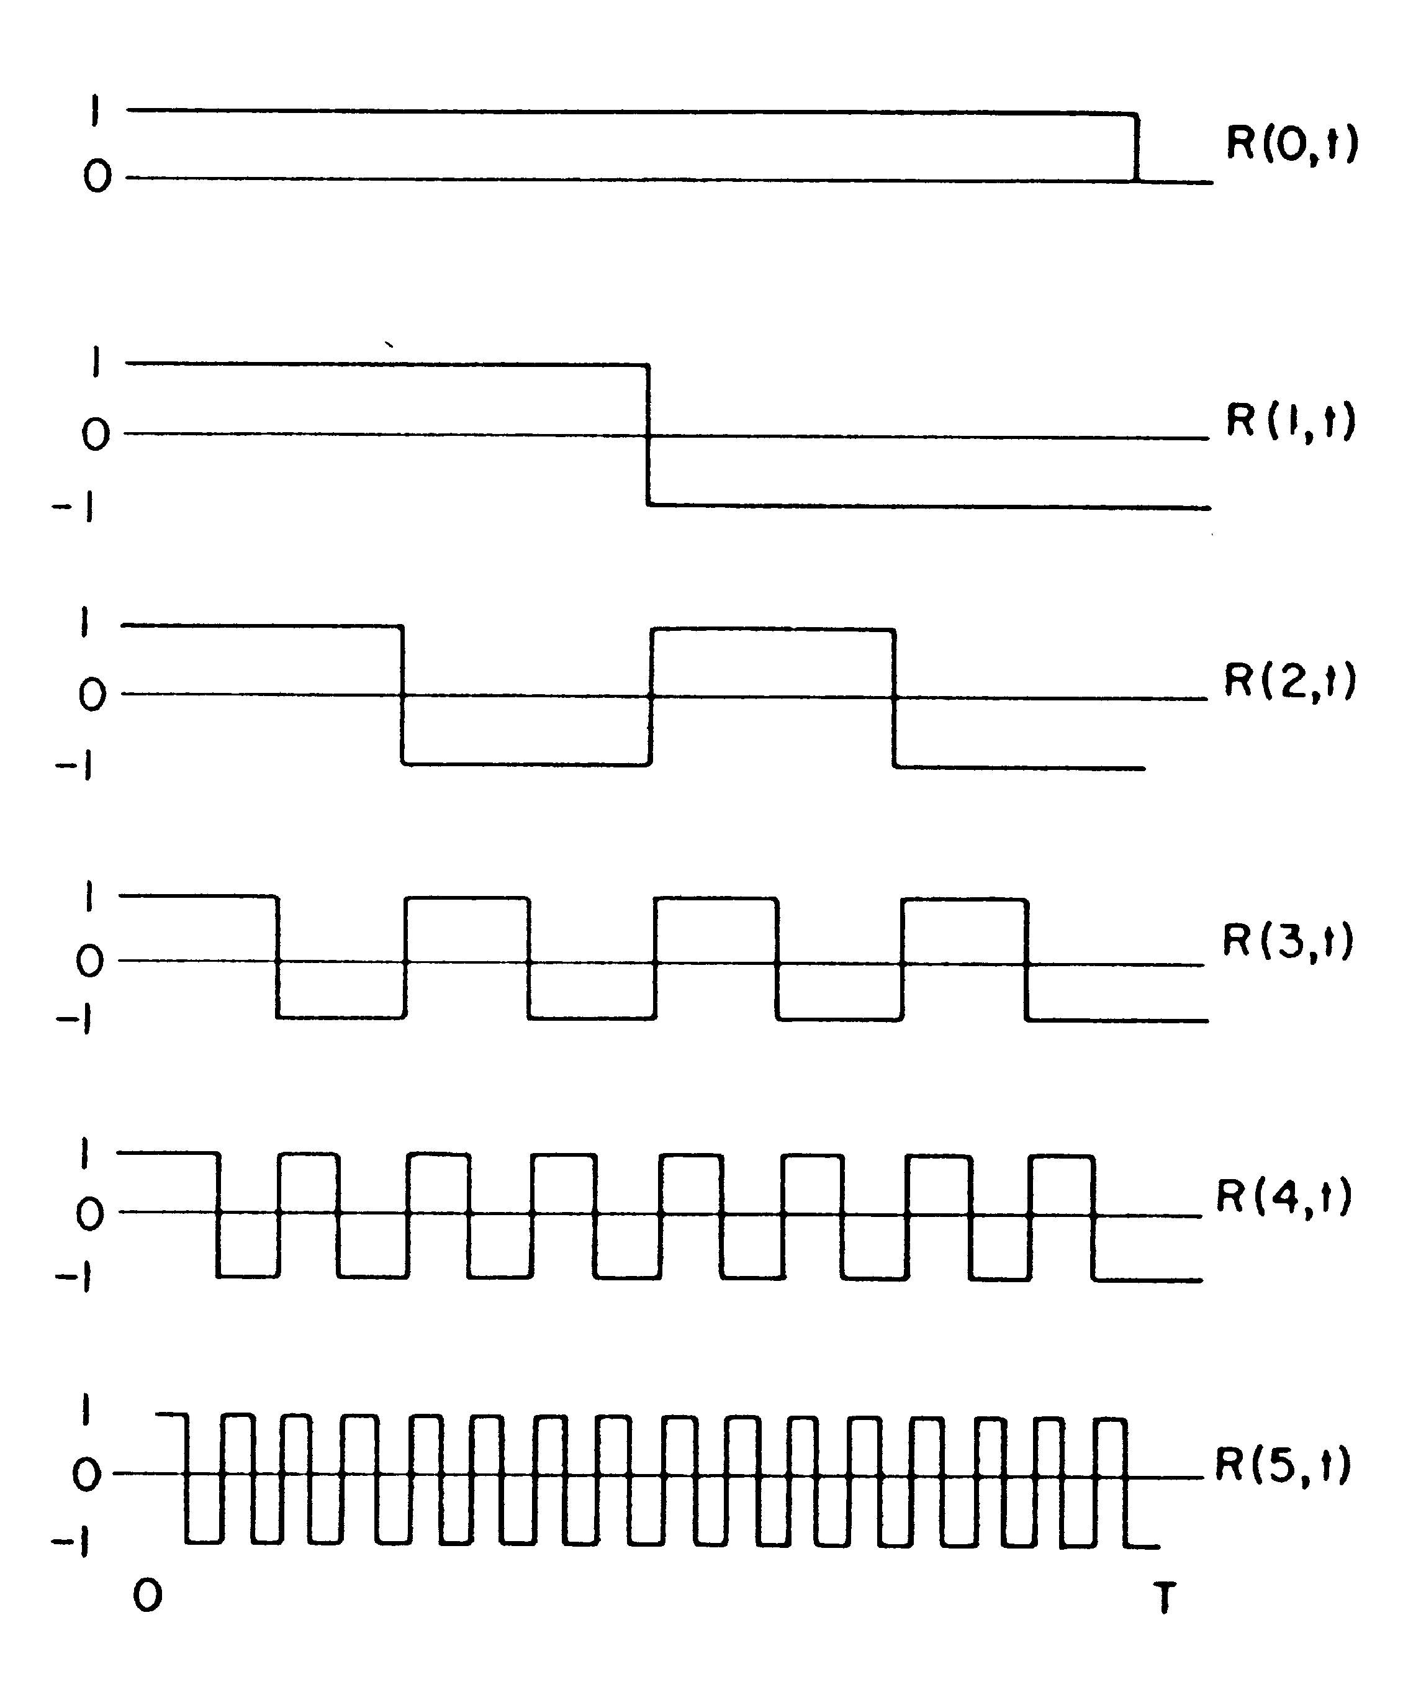
Figure 1: Rademacher-functions $φ_{0}$ to $φ_{5}$

With the help of the system Φ of Rademacher-functions the system $Ψ=\left\{ψ_{n}:n=0,1,2,\text{.}\text{.}\text{.}\right\}$ of Walsh-functions $ψ_{n}:[0,1)→$R is defined by
$ψ_{n}(x):=[φ_{n_{0}}(x))^{n_{0}}[φ_{n_{1}}(x))^{n_{1}}\text{.}\text{.}\text{.}[φ_{n_{k}}(x))^{n_{k}}$ (2)
where the integer n is represented by $n=n_{0}2^{0}+n_{1}2^{1}+\text{.}\text{.}\text{.}+n_{k}2^{k}$ (Walsh 1923).
Walsh-functions are, as we see, finite products of Rademacher-functions. To give an example, for $n=2^{0}+2^{2}$ (n=5) the Walsh-function $ψ_{5}$ is given by $ψ_{5}=φ_{0}φ_{2}\text{.}$

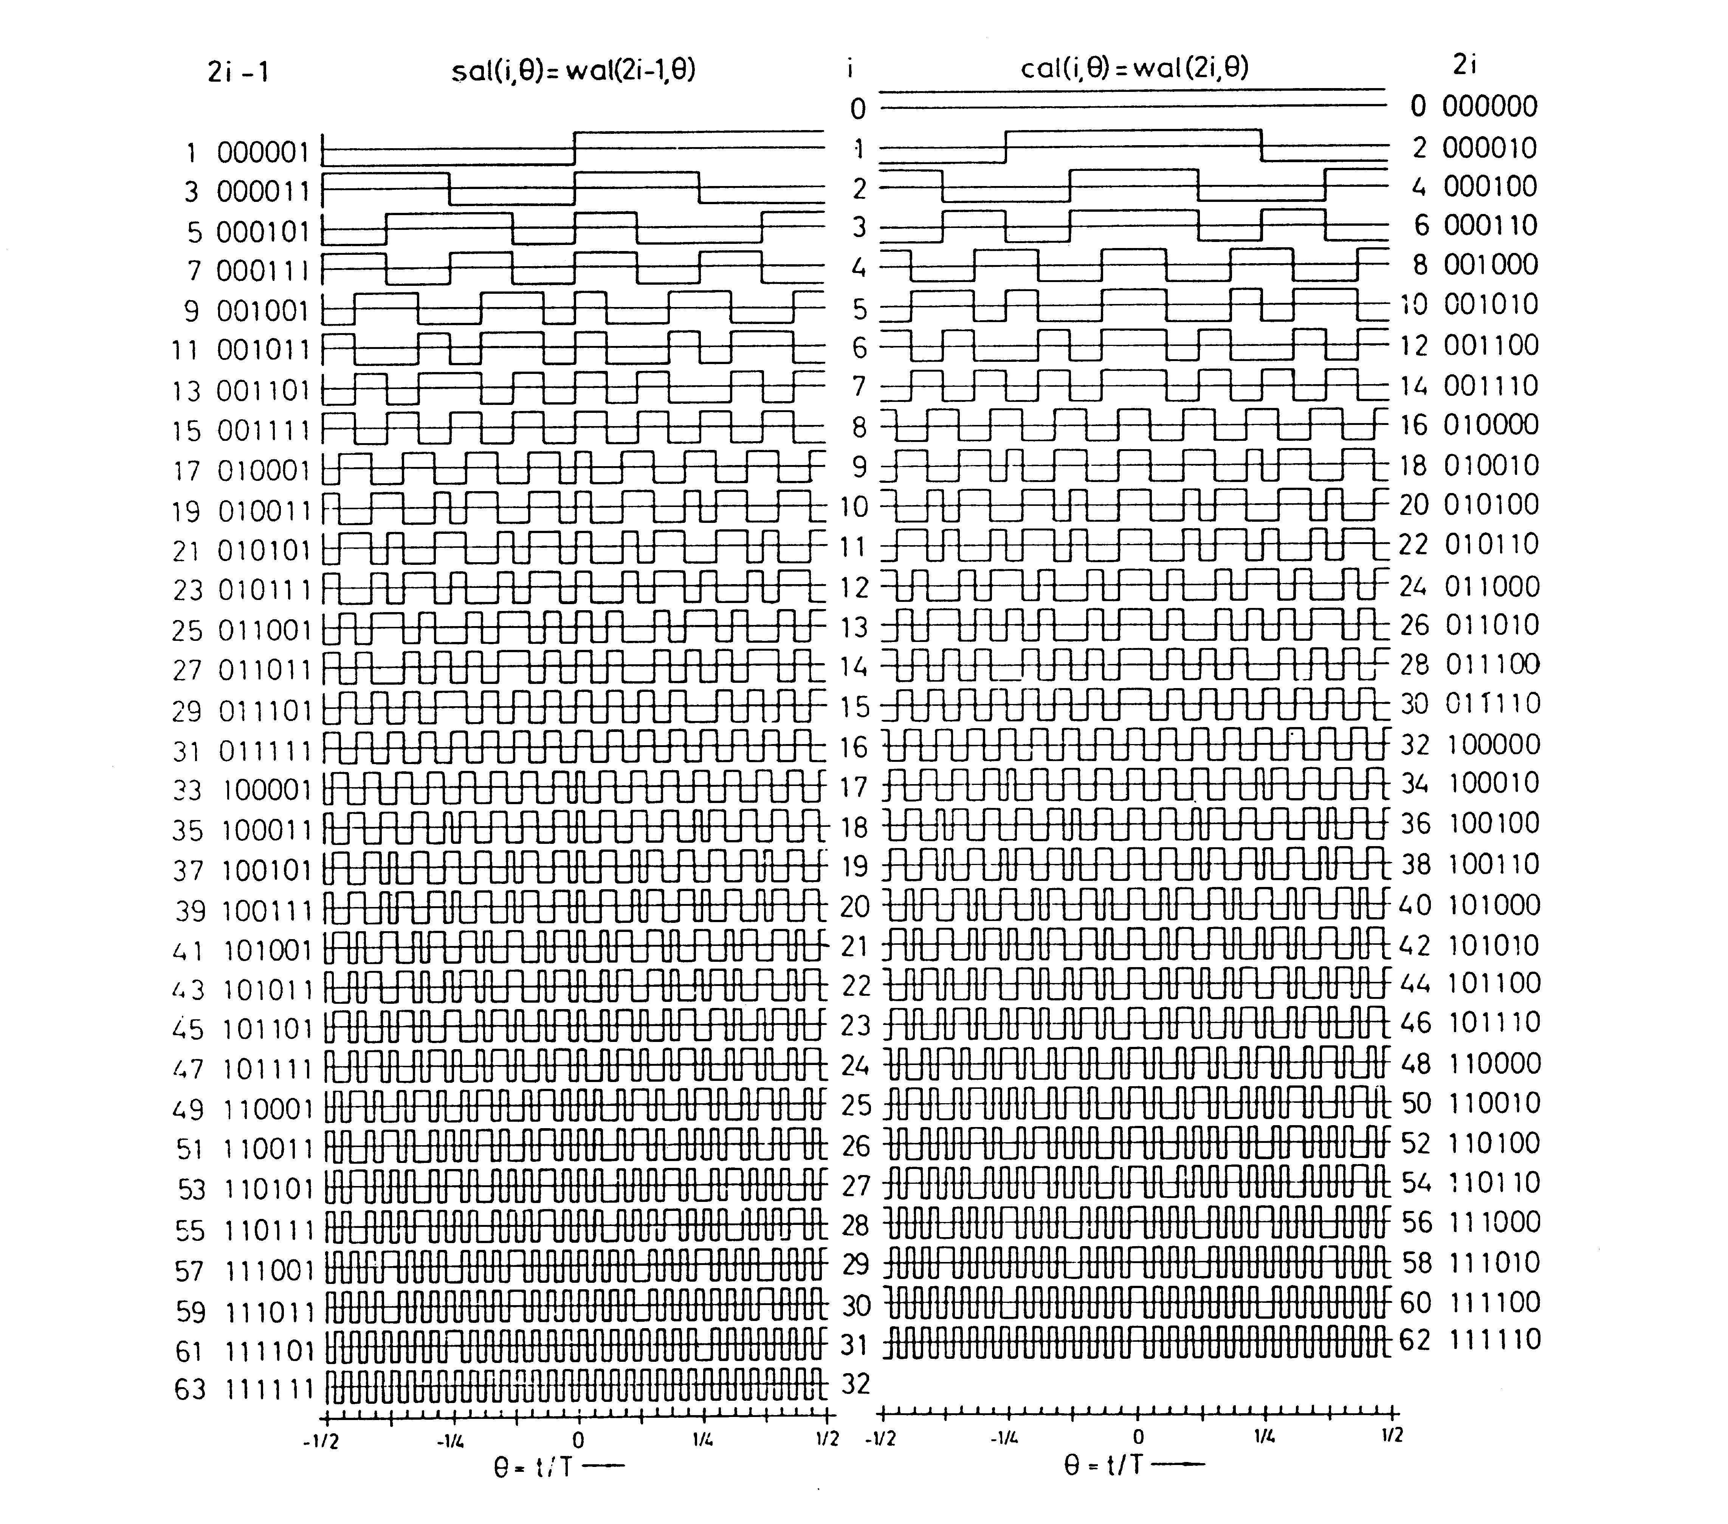
Figure 2: Walsh-functions $ψ_{n}\left(0≤n<\text{63}\right)$ in sequency-order and divided into even functions cal(i,.) and odd functions sal(i,.) on the interval (-1/2, +1/2)
It is well known, that the Walsh-functions $Ψ$constitute a complete orthogonal system for the Hilbert-space $L_{2}[0,1)$. Consequently for each square-integrable function $f:[0,1)→$R we have a Walsh-Fourier representation in the form of
$f=\sum_{n=0}^{∞}{\hat{f}(n)}ψ_{n}$ (3)

The coefficients $\hat{f}(n)$ of (3) define a discrete function $\hat{f}:$N₀→R. $\hat{f}$ is called the Walsh-Fourier transform of $f$. The assignment $f↦\hat{f}$ defines the Walsh-Fourier transformation $\text{WT}$; $\text{WT}(f)=\hat{f}$ .
The field of Abstract Harmonic Analysis establishes in mathematics a general theory for functions defined on topological groups. In this context Walsh-functions can be identified as character-functions of the dyadic group D which is defined by the set of 0-1 sequences $\left\{\left.(x_{1},x_{2},x_{3},\text{.}\text{.}\text{.}):x_{i}∈\left\{0,1\right\}\right\}\right.$ with the addition modulo 2 (component-wise taken) as group-operation (Fine 1949, Vilenkin 1947).
For the identification of the Walsh-functions with the character-functions of D we use the map $\text{bin}:[0,1)→$D which maps a real number $x=x_{1}2^{−1}+x_{2}2^{−2}+x_{3}2^{−3}+\text{.}\text{.}\text{.}$ to the binary sequence $\text{bin}(x)=(x_{1},x_{2},x_{3},\text{.}\text{.}\text{.})$ (dyadic rational numbers are represented by a finite sum).

Finite Discrete Walsh Functions
In a large number of applications of orthogonal functions in science and engineering it is sufficient to use finite many functions. In the case of Walsh-functions we take as domain the set N(n)=$\left\{0,1,2,\text{.}\text{.}\text{.},2^{n}−1\right\}$ of integers and define the discrete Walsh-functions w(i,.):N(n)→{+1,-1} of order n for iN(n) by
$w(i,k):=(−1)$^{||bin(i)  bin(k)||} (4)
where $\text{bin}(i)$ and $\text{bin}(k)$denote the binary representation of the integers i and k, respectively
( is the „addition modulo 2” of binary numbers, $\left\|b\right\|$ is the Hamming weight of a binary number $b$).
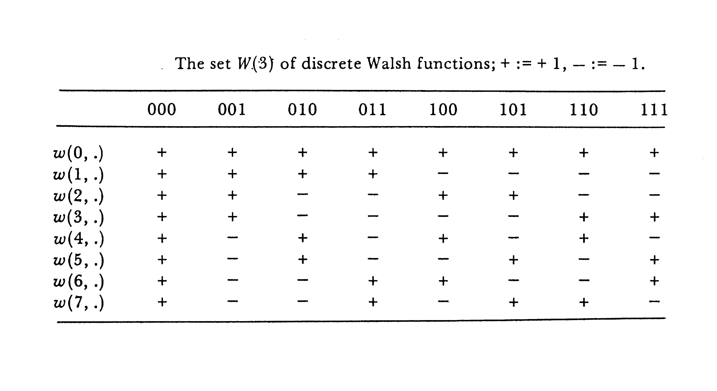
Figure 3: Discrete Walsh-functions $w(i,\text{.})$ for n=3

The system $W(n)$ of discrete Walsh-functions of order n can be identified with the character-functions of the dyadic group D(n)=(B^{n},), where B(n) denotes the set of binary numbers of length n. D(n) is isomorphic to the n-fold direct product $Z_{2}⊗Z_{2}⊗⋯⊗Z_{2}$ of the cyclic group $Z_{2}=(\left\{0,1\right\},⊕)$.

Generalized Discrete Walsh Functions
Besides of the Walsh-functions $ψ_{n}$ originally introduced into mathematics by Walsh (1923) there exist also “generalized” Walsh-functions as considered by Levy (1944) and Vilenkin (1947).
Generalized discrete Walsh-functions in this sense can be identified with the character-functions of finite abelian groups $G=Z_{k(1)}⊗Z_{k(2)}⊗…⊗Z_{k(n)}$ (here $Z_{k(i)}$denotes the cyclic group of order k(i)). For the special cases $G=Z_{n}$ and $G=Z_{2}⊗Z_{2}⊗…⊗Z_{2}$ (n-fold) the generalized discrete Walsh-functions become discrete sinusoidal functions of order n and discrete Walsh-functions of order n, respectively. By this interpretation, generalized discrete Walsh-functions can also be considered as n-dimensional discrete sinusoidal functions of order k(1), k(2),..., respectively k(n). Consequently, discrete Walsh-functions w(i,.) of order n can then be interpreted as n-dimensional discrete sinusoidal functions $s(i,\text{.})=\text{exp}(jπi(\text{.})$of order 2.
This viewpoint helps to consider generalized discrete Walsh functions and (ordinary) discrete Walsh functions not as exotic mathematical constructions but to be closely related to the (classical) discrete sinusoidal functions.

Fast Transform Algorithms
It is well known that for the case of discrete sinusoidal functions s(I,.) of order we have algorithm, the “Fast Fourier Transform” algorithm FFT, to implement the Fourier transformation FT which is credited to Good (1958) and Cooley-Tukey (1965).
A similar effective algorithm to implement the discrete Walsh-transformation $\text{WT}$ of order n has been found by Whelchel (1968) (“Fast Walsh Transform” algorithm; $\text{FWT}$).
For the case of the generalized discrete Walsh functions the development of the corresponding “Fast Generalized Walsh Transform” algorithm $(\text{FGWT})$ to implement effectively the generalized Walsh transformation $\text{GWT}$ has been discovered by Nicholson (1971).
The implementation of the FGWT is covered by Kunz (1977) and also by Fellner (1982); the integration of the FGWT into common tools for digital image processing has been made by Scharinger (1995).

3. Applications in Signal Processing

The existence of the Fast Walsh transformation algorithm $\text{FWT}$ was essential for the applications of Walsh-function in signal processing. Pioneering work on that topic is reported in Ahmed-Rao (1975). The concept of a wave-filter which operates in the domain of the Walsh-Fouriertransform was firstly introduced by Harmuth (1964). The accompanying description of such filters by dyadic convolution was established by Pichler (1968). The theory of optimization of such filters (Pichler 1970) needed the introduction of the concept of the dyadic autocorrelation function (DAKF) and the formulation of the Wiener-Chinchin theorem for the case of Walsh-Fourier analysis. In the context of dyadic filtering it was necessary to introduce the “sampling theorem” of Walsh-Fourier analysis, as a true analogon to the famous sampling theorem of Shannon (Pichler 1970).

4. Characterisation of Nonlinear Functions

Walsh Functions (as originally defined by J. Walsh) have interesting properties in approximation of polynomial functions (and therefore also for functions which a represented by Taylor series expansions). The fundamental theorem in this respect has been found by R. Liedl (1964) and independently also by B. T. Polyak and Y. A. Shreider (1962) which states that in the Walsh spectrum $\hat{f}$ of a polynomial function f of degree n all $\hat{f}(i)$ for which the associated Walsh function $ψ_{i}$ consists of more than n Rademacher functions $φ_{k}$ are equal to zero; $\hat{f}(i)=0$. In consequence, to give a simple example for the application of this theorem, any (periodic) linear function f with f(x)=a+bx can be presented by the constant Walsh function $ψ_{0}$ and a series expansion of Rademacher functions $φ_{k}$; $f(x)={aψ}_{0}(x)+b_{1}φ_{1}(x)+b_{2}φ_{2}(x)+\text{.}\text{.}\text{.}$ .
In Signal Processing there have been different approaches to make use of this interesting property of Walsh Fourier series expansions. One of it was the definition of so called “multiplicity filters” which can be characterized as sequency comb filters which filters out signals according to their degree of nonlinearity (D. Roth (1973)).
Another important application of this theorem has been found in the field of Cryptography. We will explain this in the following.

Secure transmission of information by digital data can be achieved by mixing the data sequence with a random sequence (key sequence). Claude Shannon has shown that “stream ciphering” is cryptographically absolutely secure if the key sequence is purely random and is used only once (“one time key system”). Since the key sequence has also to be applied for demixing at the receiver station, an effective realization of stream ciphering has to be based on pseudo random noise generation by a finite state machine PNG (Pseudo-Noise Generator). To achieve an high degree of security the key sequences generated by a PNG has to approximate pure random noise in a “cryptographic best manner”.
In practice, to get a cryptographic strong PNG, n sequences of $x_{1},x_{2},…,x_{n}$ of weak quality are coupled by a certain operation C (the combiner) to result in a strong key sequence $y=C(x_{1},x_{2},…,x_{n})$. In the case of binary sequences a (static) combiner C can be represented by an Boolean function C:B^{n}→B.

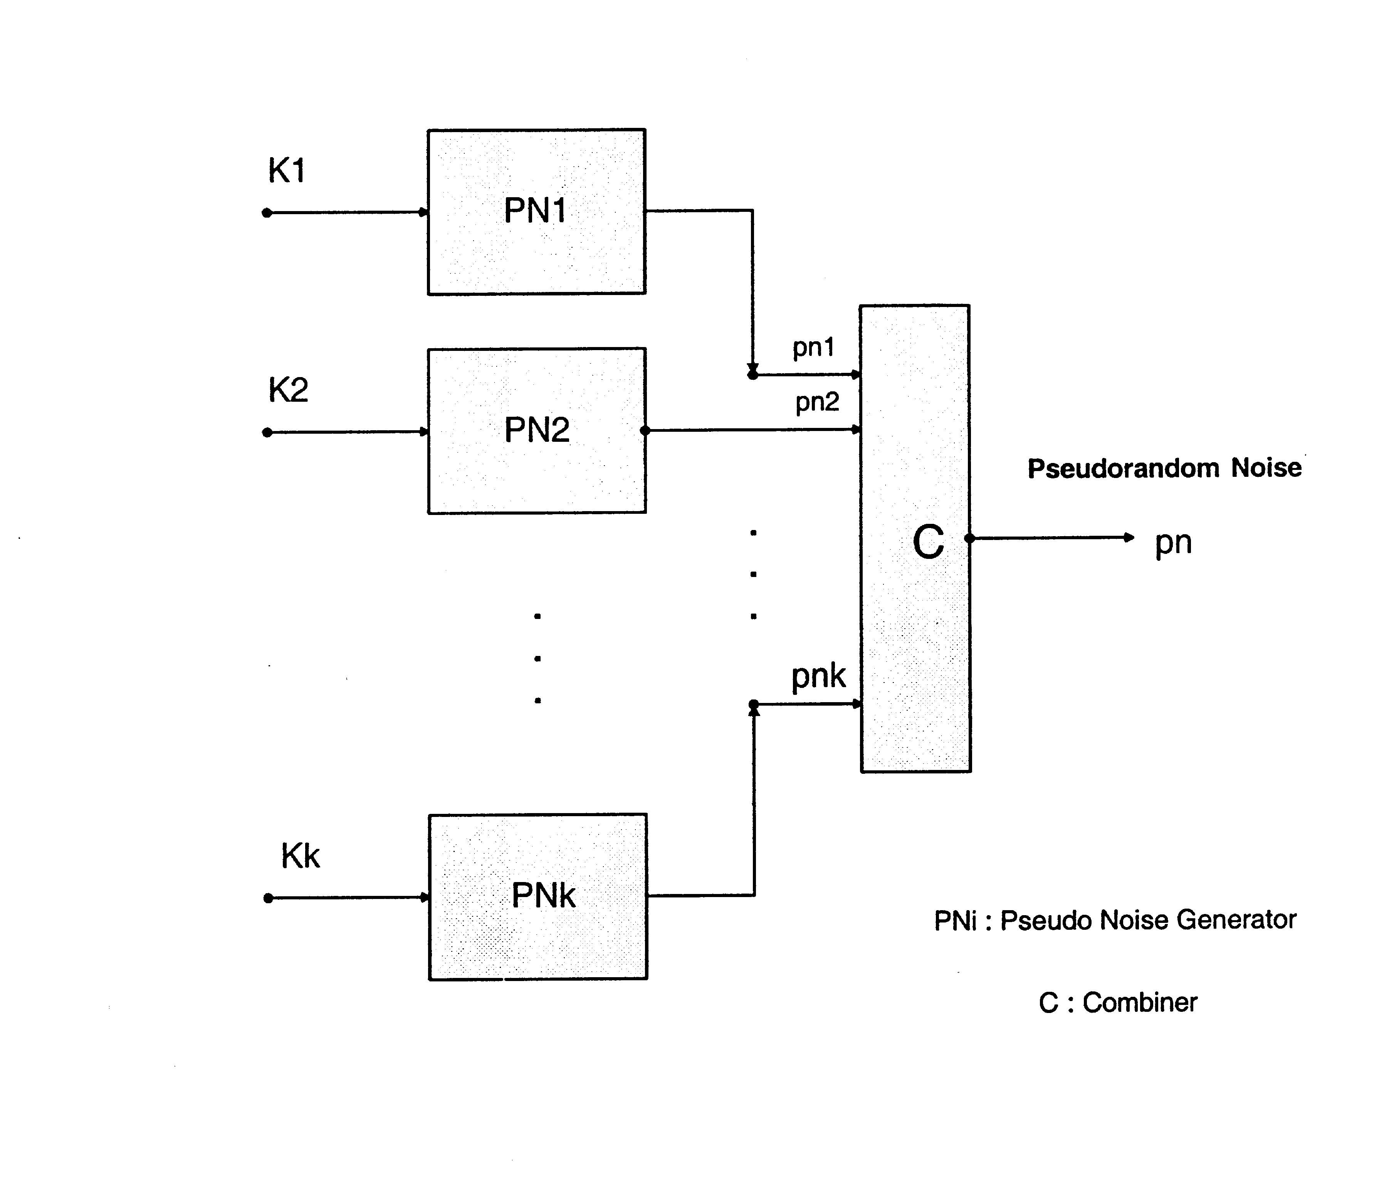
Figure 4: Architecture of a Pseudo Random Noise Generator PNG with Combiner C

The cryptological quality of a pseudo random noise sequence has to be determined by different statistical tests. Such tests relate to certain attacks to break the system. For PNG with an architecture according to Fig. 7 the so called correlation attack tries to identify the individual “weak” sequences $x_{1},x_{2},\text{.}\text{.}\text{.},x_{n}$ from observing the key sequence $y=C(x_{1},x_{2},\text{.}\text{.}\text{.},x_{n})$ by a “divide and conquer” method using statistical tests and computer simulation. A PNG is robust with respect to the correlation attack if the combiner C possesses a certain degree of “correlation immunity”. For boolean combiners C the following theorem was proved by Xiao-Massey (1985): A boolean combiner C:B^{n}→B is correlation immune of degree m if and only if the Walsh transform WT(C) of C has the following spectral property:
WT(C)(x)=0 for all x with $0≤\left\|x\right\|≤m$ ($\left\|x\right\|$ denotes the Hamming weight of x; we identify B^{n} with N(n)).
Siegenthaler (1986) showed by algebraic methods how a boolean combiner C of sufficient high degree of correlation immunity can be constructed. Pichler (1985) established such a construction by means of Walsh-Fourier analysis. An extension of these results for (dynamic) combiners C realized by state machines with finite memory can be found in Pichler (1988). As a further recent publication to the topic of Boolean combiner design uses the Walsh transform we refer to Dobertin (1995).

5. Sequency Multiplexing Transmission System of Harmuth

The successful promotion for the application of Walsh functions in communications engineering is due to Henning F. Harmuth, as well as the contribution of important papers during the years from 1960 to 1970 and of his book (Harmuth 1971). In the following we want to refer to some of the treatises as experienced by the author during his cooperation with H. Harmuth. Harmuth started with discovering the Walsh functions as a useful orthogonal code and their application in wireless communication (Harmuth 1960). This was followed by a patent of the concept of a multi-channel transmission system with Walsh functions as carriers (Harmuth 1964). Harmuth considered mainly – with respect to the state of the art at this time – analog transmission systems with time-continuous signals to represent information.
To develop a valid mathematical basis for such systems Harmuth contacted the Institute of Mathematics of the University of Innsbruck, Austria, where mathematical research in Walsh function was under way (R. Liedl, P. Weiss). The contribution of the author (Pichler 1967, 1968, 1970) helped to give a mathematical and systemstheoretical basis for the work of Harmuth. The symposia which were organized by Harmuth in Washington D.C. (from 1969 on) roused international interest. They reported about applications in information technology and inspired further research. As a result Walsh functions and their applications are today well known in communication engineering and in signal processing. They have found important applications in modern digital information technology. As a conclusion we may say, that Henning F. Harmuth established a milestone in the development of information technology by his work on the application of Walsh functions as an alternative to sinusoidal functions.
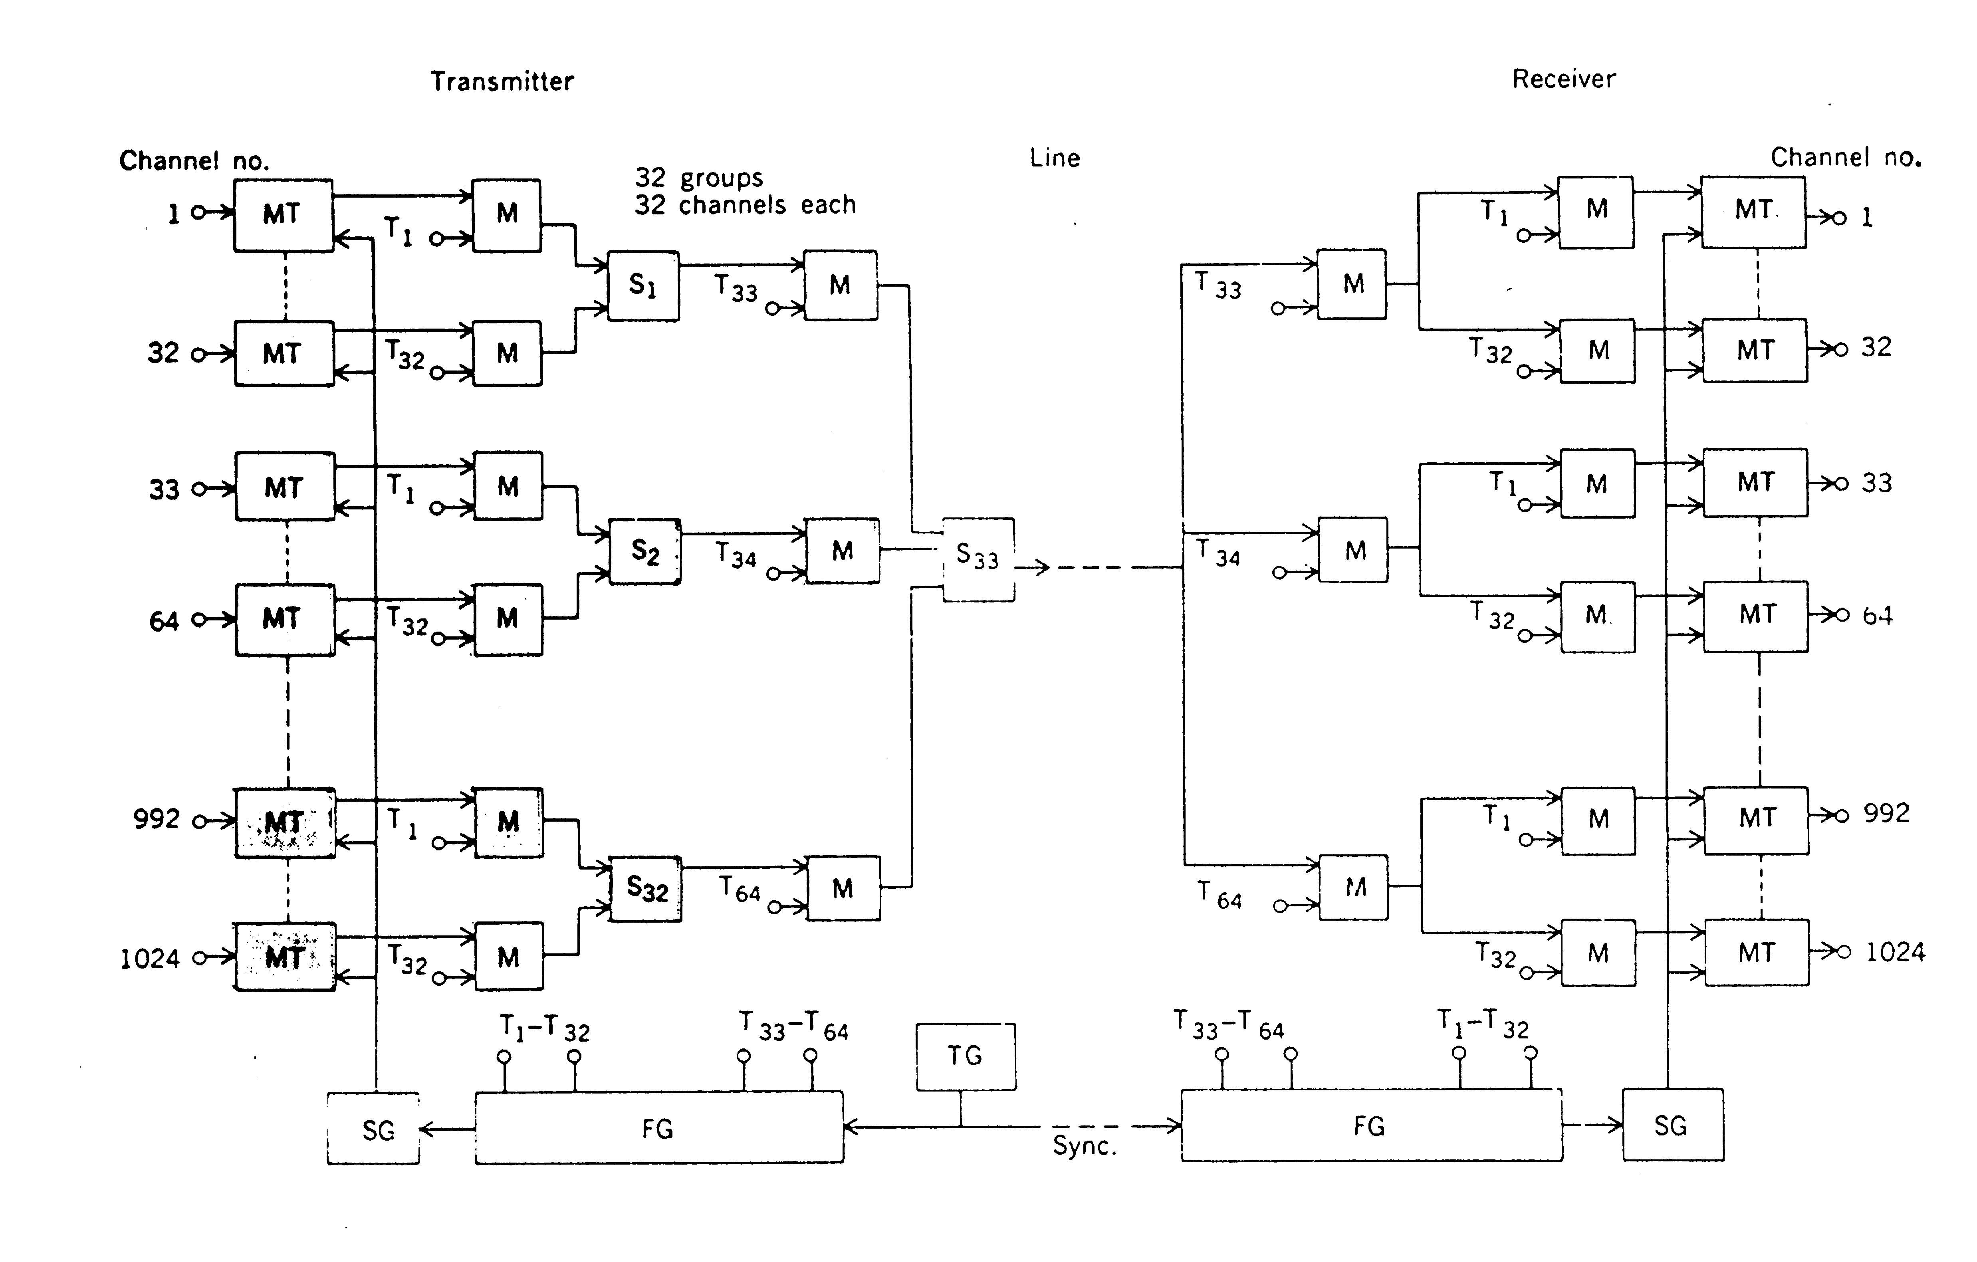
Figure 5: Block diagram of a sequency-multiplex system for 1024 analog telephony channels (after H.F. Harmuth)
6. Concluding Remarks and Outlook

The paper tries to present a survey of the history of the development of the application of Walsh functions in signal processing and communication engineering. We saw that Walsh functions and the method of Walsh-Fourier transformation can be used in a similar way as in the case of sinusoidal functions. From a mathematical point of view this is not surprising: Both function systems are special cases of character functions of a topological group and the existing general method of Fourier transformation covers essential parts of the specific methods of the Walsh transformation and respectively the Fourier transformation. An example is given by the sampling theorem in signal processing. Kluvanec (1965) showed the validity of this theorem in abstract harmonic analysis, special cases of it for dyadic harmonic analysis and for real harmonic analysis are known from Pichler (1970) and Shannon (1948).
The application of Walsh functions and related concepts in modeling systems for signal processing and communication were – according to the state of art – originally developed for the case of analog information technology. Their realization used basic elements like resistors, coils, capacitors, operation amplifiers and sampling and hold circuits. The introduction of digital information technology, specifically the development of integrated microelectronic circuits, microprocessors and computers, requires new approaches for modeling. For the processing of digital signals by digital systems new concepts and methods for dealing with hardware and software had to be developed. Examples for the case of hardware are the development of the theory of switching functions (boolean functions) and the theory of sequential switching circuits (finite automata). The different concepts and methods for analog signal processing and analog information transmission which exist for Walsh functions can be adapted to digital system by restriction to the set of discrete Walsh functions of order n. This is analogous to the approach of adapting concepts and methods of analog signal processing (for example by digital filters) by the use of the system of discrete sinusoidal functions of finite order.
Walsh functions are today used in modern digital systems for mobile communication as carrier signals in multiplexing. The specific CDMA system of Qualcomm Ing. uses for the forward link this approach (Qualcomm Inc. 1992).

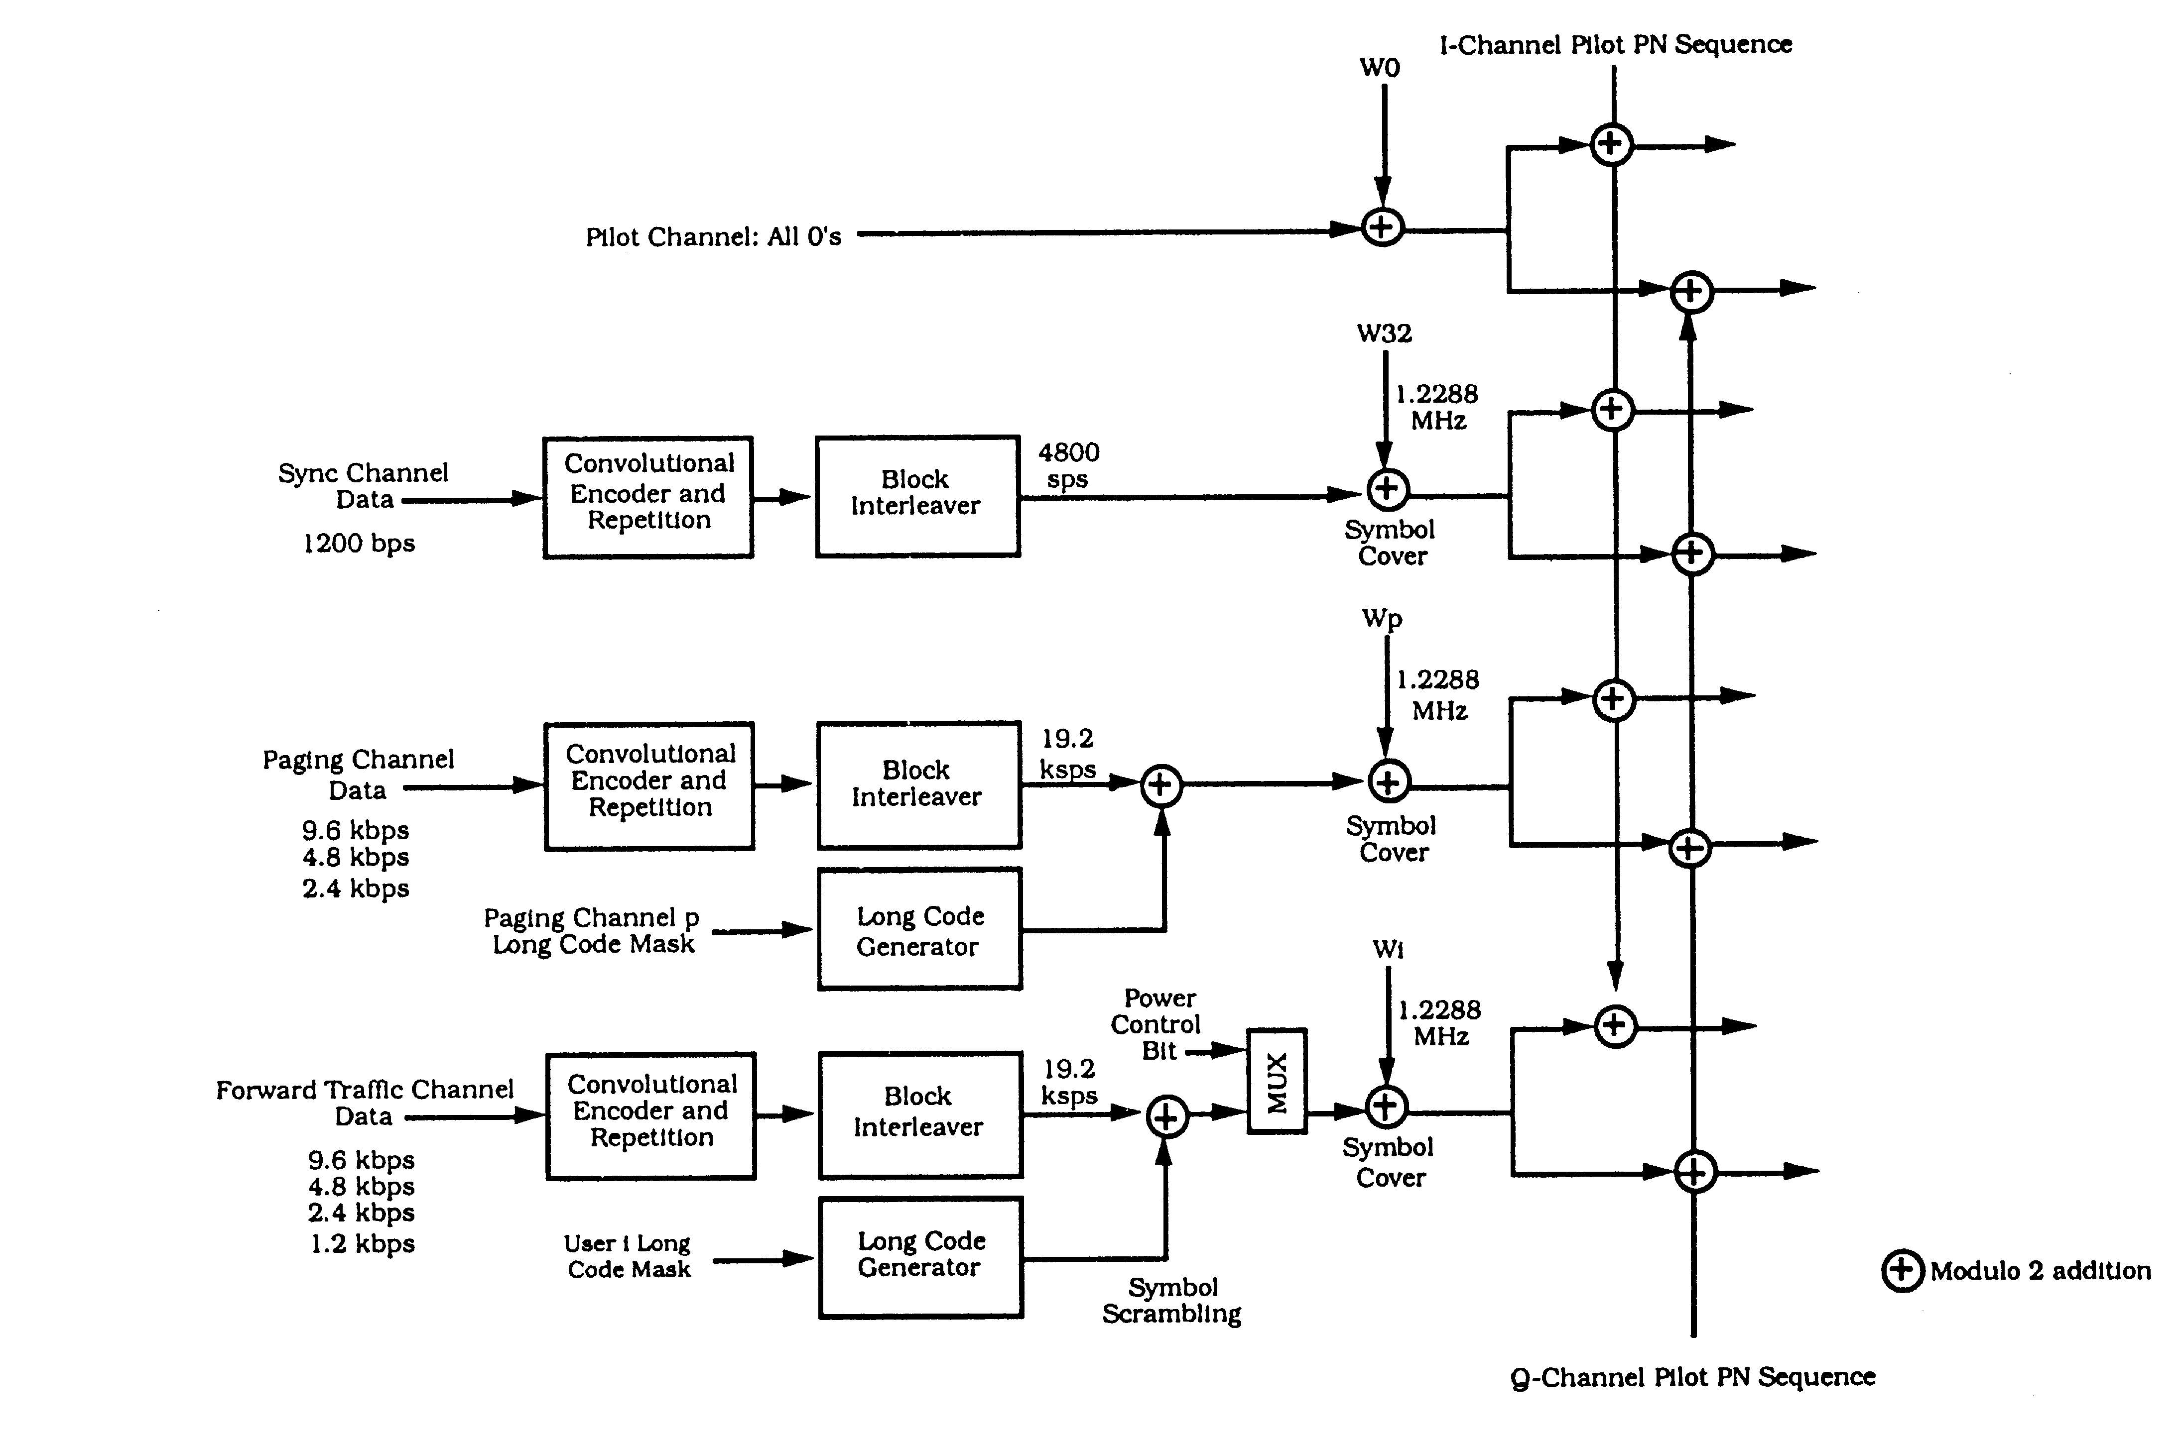
Figure 6: Sequency-multiplex system for 62 digital mobile telephony channels
(after Qualcomm Inc. 1992)

The forthcoming UMTS also makes use of multiplexing signals by Walsh functions and provides by it the adaption of bandwith according to user needs. Another interesting recent application of Walsh functions which is based on fundamental historical roots is given by the idea of “Sequency-Hopping” which is a generalisation of the known method of frequency hopping.
The fundamental idea of the method of frequency hopping to achieve a secure communication by a wireless system is, that the carrier frequency of the transmitter and the receiver changes in time using a pseudo random pattern. It “hops” within a certain (broad) frequency band. The Austro-american actress and movie star Hedy Lamarr (born Hedy Kiesler) known as the “most beautiful woman of the world”, is considered together with George Antheil (“bad boy of music”) as the inventor of frequency hopping (US patent 2,292.387 of 1942). Following Harmuth (1971) we can replace the parameter “frequency” by “sequency” if we use a communication system based on Walsh functions as carrier. In this case “sequency hopping” is a method for secure information transmission. As a further generalization “code-hopping” can be introduced, when we use arbitrary orthogonal code sequences as carriers. The development of a code-hopping system in combination with a direct sequence CDMA system is currently under investigation (Pichler-Scharinger-Schütt 2000).
References
Ahmed, N., K.R. Rao: Orthogonal Transforms for Digital Signal Processing. Springer Verlag Berlin-Heidelberg-New York, 1975.
Bramhall, J.N.: Bibliography on Walsh and Walsh related functions. In: Applications of Walsh Functions and Sequency Theory (H. Schreiber ed.) IEEE 1974, pp. 416-460.
Cooley, J. W. and J. W. Tukey: An Algorithm for the Machine Calculation of Complex Fourier Series. Math. Computation 19 (1965), pp. 297-301
Dobertin, Hans: Construction of Bent Functions and Balanced Boolean Functions with High Nonlinearity. in: Fast Software Encryption (Bart Preneel (ed.)), Lecture Notes in Computer Science, Vol 1008, Springer-Verlag Heidelberg,1995, pp. 61-74.
Fellner, H.: Realisierung der allgemeinen Faltung durch die schnelle verallgemeinerte Fouriertransformation. master thesis, Institut für Systemwissenschaften, Universität Linz, January 1982
Fine, N. J.: On the Walsh Functions. Trans. of the Amer. Math. Society, Vol 65, 1949, pp. 372-414.
Gibbs, J. E. and H. A. Gebbie: The application of Walsh functions to transform-spectroscopy. Nature, London, Vol. 224, 1969, pp. 1012-1013.
Gibbs, J. E. and F. R. Pichler: Comments on Transformation of “Fourier” Power Spectra into “Walsh” Power Spectra. in: 1971 Proceedings Application of Walsh Functions, AD 727 000, Naval Research Lab., IEEE-EMC Group, University of Maryland, Washington D.C., 1971, pp. 51-54.
Good, I. J.: The interaction algorithm and practical Fourier-analysis. Journal of the Royal Statistical Society, Vol. B20, 1958, pp. 361-372.
Green, J. and R. San Soucie: An Error-Correcting Encoder and Decoder of High Efficiency. Proc. IRE, 46 (1958), 1741-44.
Harmuth, H.: Grundzüge einer Filtertheorie für die Mäanderfunktionen $A_{n}(0)$. Archiv elektr. Übertragung 18 (1964), 544-554.
Harmuth, H. F.: Radio Communication with orthogonal time functions. Transactions AIEE. Communications and Electronics 79, 1960, pp. 221-228.
Harmuth, H. F.: Die Orthogonalteilung als Verallgemeinerung der Zeit- und Frequenzteilung. Archiv elektr. Übertragung, 18 (1964), 43-50.
Harmuth, H. F.: Transmission of Information by Orthogonal Functions. Springer-Verlag New York, 1971 (2nd edition).
Kluvanec, I.: Sampling theorem in abstract harmonic analysis. Matematicko fyzikalny Casopisa, Sloven. Akad. Vied. 15 (1965), pp. 43-48.
Kunz, H.: Approximation optimaler linearer Transformationen durch eine Klasse schneller, verallgemeinerter Fourier-Transformationen. Diss. ETH. Juris Zürich, 1977.
Levy, P.: Sur une generalisation des fonctions orthogonales de M. Rademacher. Comment. Math. Helv. 16 (1944), pp. 146-152.
Liedl, R.: Übere ine spezeielle Klasse von stark multiplikativ orthogonalen Funktionensystemen. Monatshefte für Mathematik 68, 1964, pp. 130-137.
Nicholson, P. J.: Algebraic Theory of Finite Fourier Transforms. J. of Comp. and Systems Science 5 (1971), pp. 524-547.
Pichler, F.: Synthese linearer periodisch zeitvariabler Filter mit vorgeschriebenem Sequenzverhalten. Archiv elektr. Übertragung 22 (1968), 150-161.
Pichler, F.: Walsh-Fourier Synthese optimaler Filter. Archiv elektr. Übertragung 24 (1970), 350-360.
Pichler, F.: Walsh functions and Linear Systems Theory. Techn. Report, Department of Electrical Engineering, University of Maryland, Washington D.C., Appendix B-1 to B-11, Sampling Theorem with Respect to Walsh-Fourier Analysis, April 1970
Pichler, F.: Walsh Functions-Introduction to the Theory. In: Proceedings Nato Advanced Study Institute on Signal Processing, Loughbourough, U.K., 1972, p. 18.
Pichler, F.: Zur Charakterisierung korrelations-immuner Schaltfunktionen mittels Walsh-Fourieranalyse. Techn. Bericht, Institut für Systemwissenschaften, Universität Linz, 1986
and
„On the Walsh-Fourier Analysis of correlation-immune switching functions”. in: Abstracts of papers, EUROCRYPT’86, Linköping, May 20-22, 1986, 4.5 A.
Pichler, F.: Konstruktion korrelationsimmuner Schaltfunktionen und Schaltwerke mittels Walsh-Fourieranalyse. in: Contributions to General Algebra 6 (G. Pilz, ed.), Verlag Hölder-Pichler-Tempsky, Wien 1988. pp. 213-222.
Pichler, F., J. Scharinger, D. Schütt: Digitales Vielkanal CDMA Code-Hopping Übertragungssystem. Technischer Bericht, Institut für Systemwissenschaften, Universität Linz, 10 pages, December 2000.
Qualcomm Inc.: An Overview of the Application of Code Division Multiple Access (CDMA) to Digital Cellular Systems and Personal Cellular Networks. Document Number EX60-10010. QUALCOMM Incorporated 1992, USA.
Rademacher, H.: Einige Sätze von allgemeinen Orthogonalfunktionen. Math. Annalen 87 (1922), 122-138.
Roth, D.: Digitale Vielfaltfilter. Archiv für Elektronik und Übertragungstechnik, Vol. 27, 1973, pp. 72-78.
Scharinger J.: Integration of various spectral transforms into KBVision. Technical report, Institute of Systems Science, Johannes Kepler University Linz, Austria, 1995.
Siegenthaler, Thomas: Methoden für den Entwurf von Stream Cipher Systemen. Diss. ETH Nr 8185, ADAG Administration Druck AG, Zürich, 1986.
Trappl, R., W. Horn and P. Rappelsberger: Fast Walsh versus Fast Fourier Transform: A Comparison in the Analysis of Seizure EEG. in: Progress in Cybernetics and Systems Research (R. Trappl, L. Ricciardi, G. Pask eds.), Hemisphere Publishing Corporation, Washington D.C., 1982, pp. 97-102.
Vilenkin, N. J.: On a class of complete orthogonal systems. (in russian). Izv. AN, SSSR, ser.matem.11 (1947, pp. 363-400.
Viterbi, A.J.: Phase-Coherent Communication over the Continuous Gaussian Channel. in: Digital Communications with Space Applications (ed. Solomon W. Golomb), Prentice Hall, Englewood Cliffs, N.J., 1964, chapter 7.
Walsh, J.: A closed set of orthogonal functions. Amer. J. of Mathematics 45(1923), pp. 5-24.
Whelchel, J. E. and Guinn. D. F.: The fast Fourier-Hadamard transform and its use in signal representation and classification. Techn. Report. PRC 68-11. Melpar Inc. Falls Church, Va 22046, 1968.

