To be presented at EMCSR 2004, Vienna, April 13-16, 2004, Symposium “History of Cybernetics, Information Technology and Systems Research”
On the University Studies of Nikola Tesla in Graz and Prague

Franz Pichler
Institute of Systems Theory and Simulation
University of Linz
A-4040 Linz
Austria
e-mail: pichler@cast.uni-linz.ac.at

Abstract
The paper discusses the studies of Nikola Tesla at the Technische Hochschule Graz from 1876 to 1878 and at the University of Prague in 1880 as they are known by official documents. During academic year 1876/1877 he absolved his studies very successfully, getting more than double of the credit hours of an usual student. In the second academic year 1877/1878 he reduced his efforts, but the result on credit hours was still acceptable. In the third academic year of his studies in Graz, however, he did not get any credits and since he did not pay the required tuition fee for the fall term of 1877/1878 he had to leave the Technische Hochschule Graz. The paper explores the causes for this unfortunate situation of Nicola Tesla. Furthermore a detailed description of the course on “Engineering Physics” which Tesla attended in Graz is given. The content of this course shows that his teacher Professor Poeschl dealed with the subject on the level of the state of the art. Nikola Tesla got by his studies in Graz a modern engineering education based on scientific grounds. After the return from Graz to his parents in Gospic in Croatia he continued his University studies in Prague. The catalogues of the University of Prague show that Tesla registered several courses (given in Czech or German language) but did not get credits for it. After his stay in Prague, Nikola Tesla took a position with the telefone company in Budapest. After that followed his immigration to the United States of America to join there the Edison Company.
All in all it can be argued that the University studies of Nikola Tesla in Graz and Prague provided him with the essential scientific education to become later the famous inventor in the field of Electricity and in Wireless Telegraphy as we know him best until today.

- Introduction
Nikola Tesla (1856-1943) can be considered as one of the most important inventors and scientists of modern electrical engineering. His contributions to the technology of alternating current, especially to the development of the induction motor and his concepts and inventions in the field of Wireless Telegraphy are well known. Many books dealing with biographical issues and with his work have been published. We like to mention here the biography of John J. O’Neill, the well illustrated new book of Margaret Cheney & Robert Uth, the important book of Slavko Bokšan and last but not least the autobiography of Nikola Tesla.
For the discussion of the time of Tesla’s studies in Graz (1875-1878) and Prague (1880) the main source has been his autobiography [Nikola Tesla]. He describes there in short form the years in Graz, he mentions his teachers Allé and Rogner (both in mathematics) and Poeschl (physics) and tells some episodes from his experiences as a student. Also he states that by the promises given to his father he continued after Graz his studies in Prague.
Nikola Tesla has today in the USA sometimes the nimbus of an inventor similar to Thomas Alfa Edison. However, the conclusion that Tesla was similar to Edison a kind of autodidact must be rejected.
By the documents that we will present in this paper we can prove that Tesla got in Graz a proper scientific education, which enabled him later to base his patent papers and publications on solid scientific grounds. In addition we can shown that Tesla was enrolled at the University of Prague taking lectures there. However, as it is known, he did not finish his studies in a regular manner getting an academic degree.
Tesla himself kept his memories to the years in Graz and Prague alive and telegrams show that he felt very honoured when later in 1936 on occasion of this 80th birthday he got finally the degree of a doctor honoris causa from both places.

2. Tesla’s studies in Graz 1875/1876 and 1876/1877
In fall 1875 Tesla came to Graz to register there at the Polytechnic School for studies in “Mechanical Engineering”. The curriculum required a time of 4 years for this studies. As Tesla tells us in his autobiography he took his studies from the beginnings very seriously. Every day, including also the weekend he worked from 7 a.m. to 11 p.m. He finished the 1st year 1875/76 with exceptional success taking 11 different courses of together 46 hours weekly. He finished all courses with the best grade “vorzüglich” which compares to the grade A+ in american colleges. The following table, which has been assembled by original documents as they exist in the archive of the Graz University of Technology, show in detail the kind of courses.

Vorlesung Std Professor Note
Mathematik I 7 Rogner vorzüglich
Mathematik II 7 Allé vorzüglich
Experimentalphysik 5 Pöschl vorzüglich
Organische Chemie 5 Maly vorzüglich
Anorganische Chemie 5 Maly vorzüglich
Zoologie 5 Graber vorzüglich
Allgemeine Botanik
samt Demonstration 3 Leitgeb vorzüglich
Populäre Maschinenlehre 2 Bartl vorzüglich
Französische Sprache 3 Plisnier vorzüglich
Cubatur der Flächen 2 2 Rogner vorzüglich
Politische Arithmetik 2 Rogner vorzüglich

Table 1: Lectures and Results in 1875/76

Tesla certainly absolved in the first year a task which usually would need the time of 2 years.
In the year 1876/1877 Tesla registered 11 courses, however he absolved only 5 of them with together 18 hours. The achieved result can be considered as satisfying but in no way comparable to the success in the year 1875/1876. In table 2 we show the results of 1875/1876 in detail.

Vorlesung Std Professor Note
Mathematik III 6 Allé vorzüglich
Technische Mechanik 5 Stark vorzüglich
Analytische Mechanik 2 Stark nicht gemeldet
Technische Physik 3 Pöschl vorzüglich
Mineralogie 3 Rumpf ---
Elemente der
Wellentheorie 2 Pöschl ---
Theorie der
Kegelschnitte 2 Pelz ---
Franz.Sprache II 2 --- ---
Englische Sprache 4 --- ---
Über Congruenzen
Der Zahlen 2 Rogner gut
Über ausgewählte
Probleme der
politischen Arithmetik 2 Rogner gut

Table 2: Lectures and Results in 1876/77

We will discuss later possible reasons why Tesla reduced his efforts in the 2nd year of his studies and also why he finally in the 3rd year was forced to leave the Polytechnical School Graz.

3. Course on “Engineering Physics”
Tesla’s favourite teachers in his first year in Graz were the professors Rogner, Allé and Poeschl. Dr. Moriz Allé, k.k. full professor in mathematics, took a special personal interest of Tesla and both shared long discussion on different projects. In experimental physics, Tesla was impressed by professor Jakob Poeschl. Tesla writes in his autobiography on page 57
“Prof. Poeschl was a methodical and thoroly grounded German. He had enormous feet and hands like the paws of a bear, but all of his experiments were skilfully performed with clock-like precision and without a miss”.

We might add that Prof. Poeschl was of tyrolian origin, coming from the small austrian village Niederndorf, close to the town of Kufstein in the tyrolian alps. For the farmers of this area it was necessary to be strong like a bear to make the living. Therefore, Professor Poeschl’s constitution might have been heritage from his forfathers living in the tyrolean alps.
For the better understanding of the kind of education which Tesla got in Graz it would certainly be helpful to investigate the content of the courses which he absolved there. We are in the fortunate position to have the notes of the course on “Engineering Physics” given by Prof. Poeschl in the year 1878/79 as prepared by his assistant Josef Schaschl.

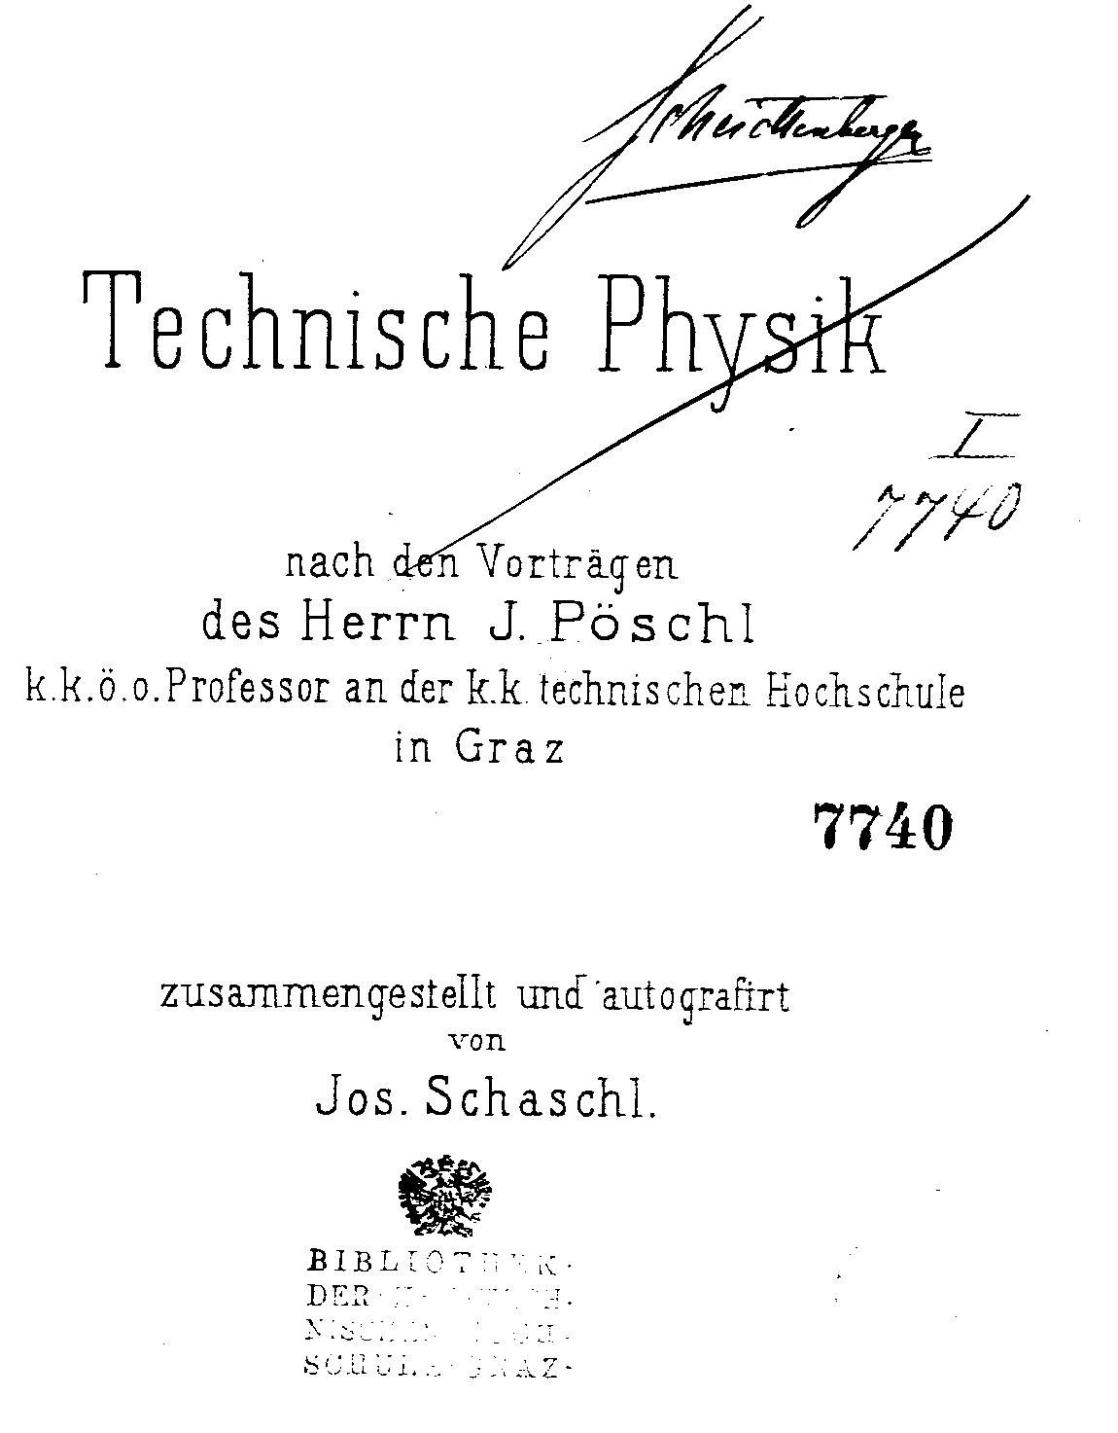

Figure 1: title page of the course on “Engineering Physics”

We can assume that the content of this course was similar to what Tesla experienced one year earlier in 1877/78. We will discuss some details of this course.
Poeschl announces in the beginning the following topics to be covered
“Applied Electricity”
“Applied Thermodynamics”
“Applied Optics”

The notes of Josef Schaschl include only the first two topics. Since the notes finish with date August 13, 1879 it can be assumed that Poeschl did not cover “Applied Optics” in this year. In the chapter “Applied Electricity” (243 pages) Poeschl deals with the following topics:
Electrical Telegraphy
Electrical Clocks
Electro-Magnetic Machines
Galvanoplastic
Construction of Lightning Conductors
Electrical Ignition Methods for Underwater Mines

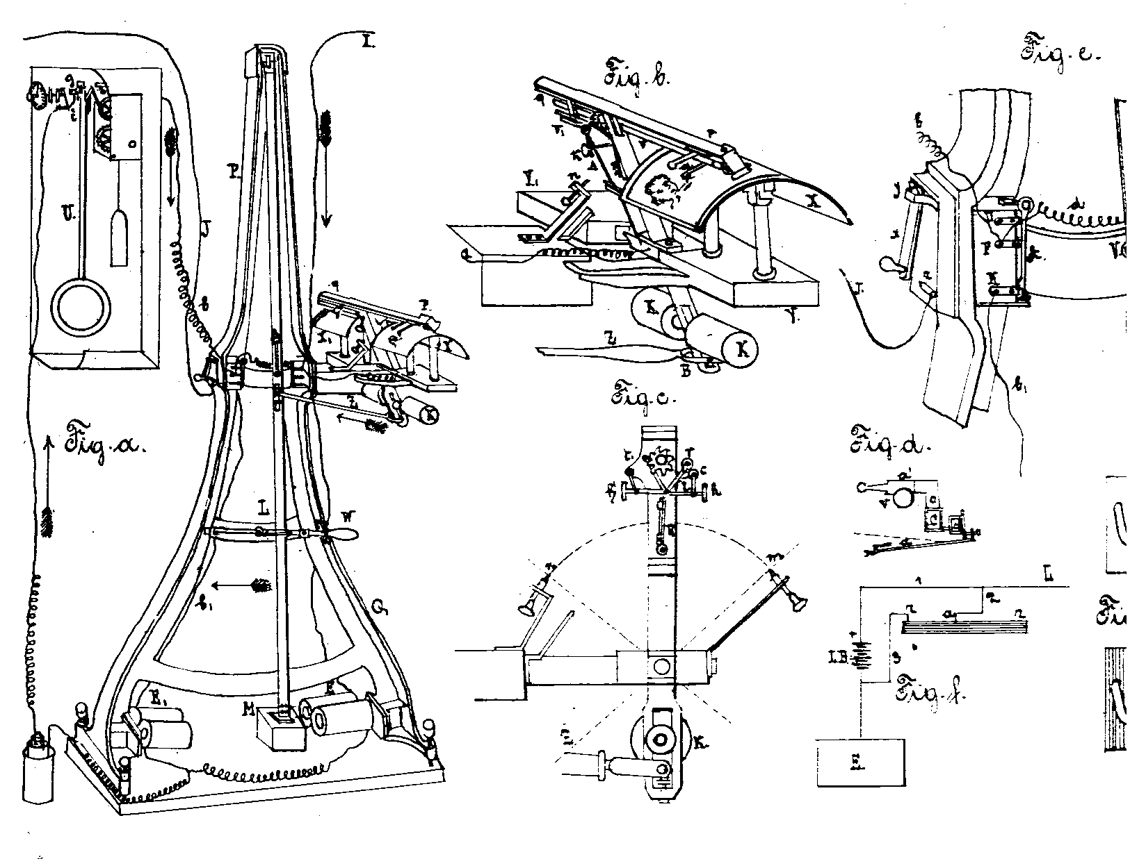
Figure 2: pantelegraph of Caselli

In “Applied Thermodynamics” the lectures of Prof. Poeschl cover the following topics:
Lesson on Fuel
Dynamics of Gases in Tubes
Theory of Tunnels and Chimneys
Stoves and Fireplaces, Gas-Generators
Dynamics of Heat, Emission and Transmission
Boilers and Steam-Generators
Drying- and Evaporation Apparatus
Heating and Ventilation of Houses

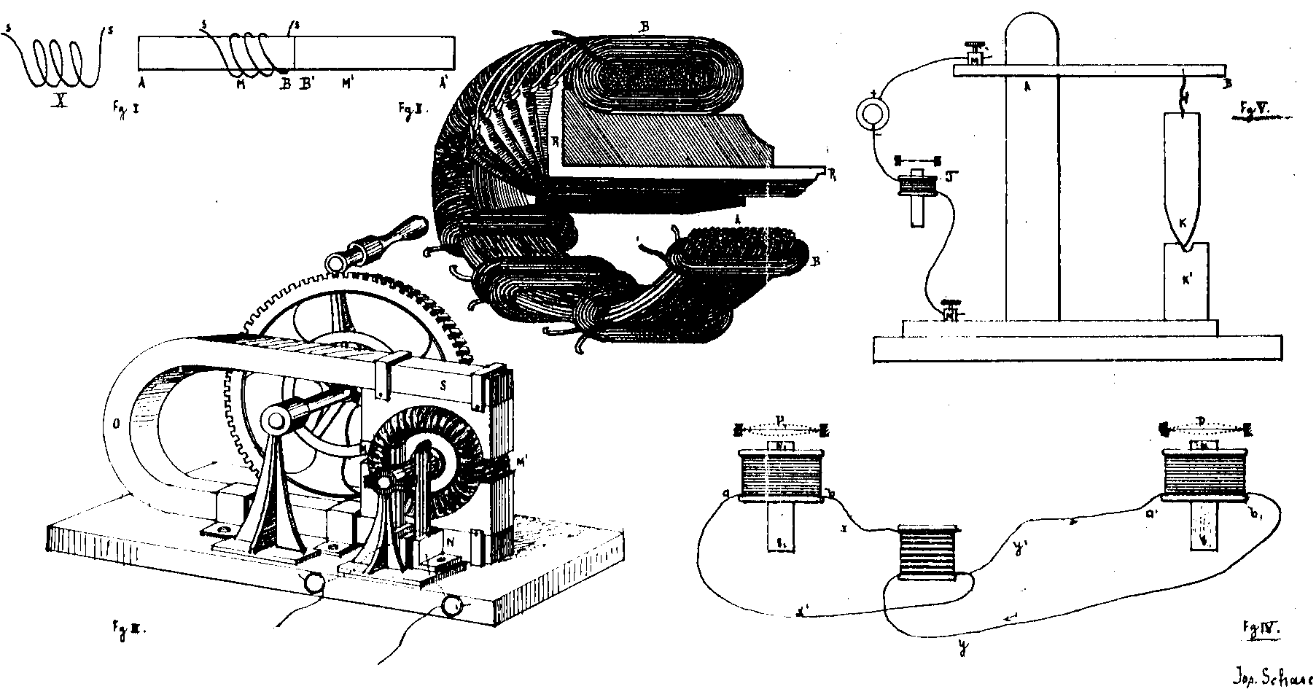

Figure 3: magnet-electric machine of Gramme,
telephon of Bell, microphon of Hughes
The lecture notes of Josef Schaschl prove a high scientific standard of this course on Engineering Physics given by Prof. Poeschl. Besides of a fundamental treatment of electricity (galvanic batteries, electrical measurement methods etc.) they cover also the field of Electrical Telegraphy (needle telegraphy of Wheatstone, Morse-telegraphy), Magneto Electrical Machines (machine of Gramme) and include also the most modern applications of electricity such as the transatlantic cabel, the chemical telegraph of Bakewell, the pantelegraph (both for the electrical transmission of written documents and drawings) and the telephone of Graham Bell.
Nikola Tesla received by his attendance in the course on “Engineering Physics” of Prof. Poeschl without any doubt an excellent scientific education in the application of electricity, an education which helped him later to be successful with his inventions and to perform the pioneering experiments for which he is famous until today.

4. The year 1877/78
In the third year 1877/1878 of his studies in Graz Nikola Tesla registered for 10 different courses. However, the registration form of the k.k. Polytechnical Institute notes that Nikola Tesla did not show up with the professors and that his registration was cancelled because he did not pay the required tuition fee for the winter term of 1877/1878. What happened to him? We can explore this question on hand of documents which exist in the archives of the Polytechnical Institute (today Graz University of Technology).

Vorlesung
Angewandte Mathematik bei den
Mathematik III B Professoren
Determinanten Theorie nicht gemeldet;
Theorie der Kegelschnitte wegen
Analytische Mechanik Nichteinzahlung
Allgemeine Theoretische des
Maschinenlehre Unterrichtsgeldes
Spezielle Theoretische für das
Maschinenlehre 1. Semester
Physikalische Geographie 1877/78
Französische Sprach II B gestrichen
Englische Sprache

Table 3: Registration for the winter term 1877/78

By a letter of September 22, 1876 the “K.k. General Command in Agram (today Zagreb, the capital of Croatia) Department of Education” states that Nikola Tesla will receive for the duration of 3 years a scholarship in the annual amount of 420 Gulden, starting with the year 1876/1877. The letter states also, however, that this scholarship has the requirement that Tesla has to join after his studies the military services for another 8 years. We see that Nikola Tesla’s studies in Graz were financially completely covered by financial means given to him from by the austrian military authority.
We can assume that the tuition for the first year 1875/1876 was paid by his father and that the scholarship of the K.k. Army was received by him because of the excellent results in the first year of his studies.
What were the reasons that Tesla did not show up for the lectures during the winter term of 1877/1878 and why did he not pay the necessary tuition fee for this period of time? We can only make a guess to that questions. We take it as guaranteed that Tesla got already in 1876/1877 into a passion for gambling (playing cards, billiard, chess). From this it can be conjectured that Nikola Tesla lost by gambling the money which he received from Agram and could therefore not pay the necessary tuition for the winter term 1877/1878.

In the biography of Margaret Cheney “Tesla: Man Out of Time”, New York 1989, we read in this context “But now Tesla’s money had run out. He tried in vain to borrow and when this failed, he began to gamble”. This gives the impression that Nikola Tesla was forced to gamble in order to make his living and to finance his studies, However, by letters exchanged between the military authorities in Agram and the rectorate of the Polytechnical school in Graz it can be proven that Tesla received the money for the given scholarship from Agram until January 1878. The series of letters deal with the following issues:

Letter of March 12, 1878: The rectorate of the Polytechnical School informs the military authorities in Agram that Nikola Tesla has been cancelled from the catalogue of students.

Letter of March 31, 1878: Agram asks the rectorate to report until what date the scholarship has been paid to Tesla and whether it is true that Tesla would lay ill in an hospital, as his father would assert.

Letter of April 15, 1878: The rectorate informs Agram that Tesla received the scholarship until January 1878. There is no indication that Tesla was in a hospital and that he still sticks around in Graz.

Letter of May 4, 1878: The military authorities in Agram tell the rectorate to stop the payment of the scholarship and they ask the rectorate to inform Tesla about this decision.

With this, the stay of Nikola Tesla in Graz has come to an unlucky end, a stay which has started so successfully. In summer 1878 Tesla went back to his parents in Gospic and took a brake to recover.

5. Tesla in Prague
Tesla writes in his autobiography, page 59
“In 1880 I went to Prague, Bohemia, carrying out my father’s wish to complete my education at the University there”.
We are here interested to explore the kind of studies which Tesla took in Prague. A “family legend” as reported by Tesla’s nephew, Nikola Trbojevich, tells, that “his mother got the money together for him to go to Prague, where he spent two years. He might have gone to the university unofficially, but the records show he was not enrolled in any one of the four universities in Czechoslovakia” (from [Margaret Cheney & Robert Uth] on page 10).
However, our investigations have shown that Tesla was actually enrolled at the K. k. University of Prague during the spring term 1880. He registered there lectures in mathematics, physics and philosophy in the amount of altogether 7 hours per week. The University catalogue however does not confirm that Tesla got credits for absolving these lectures. Furthermore there is no indication that he paid the necessary tuition.

Vorlesung Std Professor
Analytische Geometrie des Raumes 2 Durege
Cviceni v experimentálni fysike 2 Domalip
Zahlenlotterie 2 Puchta
Über David Hume`s
“Untersuchung des
menschlichen Verstandes” 1 Stumpf

Tabel 4: Lectures of Nikola Tesla in Prague during the summer term of 1880

In table 4 we see that Tesla took besides of lectures in German language also a lecture of Prof. Domalip in the Czech language. In that period of time both languages, German and Czech were used at Prague’s University. Since we know no other detail on Tesla’s studies in Prague we can assume that he got also in Prague no University degree. We know that Tesla went after his stay in Prague to Budapest, Hungary, to work there with the local telephone company.
This obviously concluded for Nikola Tesla the time of receiving an academic education.

6. Conclusion
Our paper deals with the studies of Nikola Tesla in Graz during the time from 1875 to 1878 and in Prague in 1880. By the lectures which he absolved there we are convinced, that Tesla got a valuable academic education which enabled him later to base his inventions and engineering work a solid scientific grounds. For such reasons we cannot share the idea that Nikola Tesla was like Thomas Alfa Edison an autodidact. Neither Tesla can be considered as a self-taught scientist, similar to Michael Faraday.
On occasion of his 80th birthday in the year 1936 many European universities honoured the life-work of Nikola Tesla. He received from the Technische Hochschule Graz (Graz University of Technology), the follower institution of the Polytechnical School in Graz and also from the University of Technology of Prague, the academic degree of a “Doctor Honoris Causa” (Dr. h.c.). With this, finally, Tesla’s academic studies have come formally to a successful end.
Thanks: The author is grateful to the archive of the University of Technology in Graz and to my former student Dr. Radim Sara, Prague (he found in the archives of Prague the registration form of Nikola Tesla) for providing copies of original documents. Furthermore to my colleague Professor Augustinus Asenbaum, University of Salzburg, for his help in assembling the earlier german version of this paper [Franz Pichler, Augustinus Asenbaum].

References
[John J. O’Neill]: Prodigal Genius: The life of Nikola Tesla inventor extraordinary. Neville Spearman LTD, London 1968.
[Margaret Cheney & Robert Uth]: Tesla. Master of Lightning. Metro Books, New York 1999. ISBN 1-5866-3187-X.
[Slavko Bokšan]: Nikola Tesla und sein Werk. Deutscher Verlag für Jugend und Volk, Leipzig-Wien-New York 1932.
[Nikola Tesla]: My Inventions. Barnes & Noble Books, New York 1995. ISBN 0-76070-085-0.
[Franz Pichler, Augustinus Asenbaum]: Zum Studium von Nikolaus Tesla in Graz und Prag. In: PLUS LUCIS 2/96, pp. 9-13, Vienna 1996.

