A basic framework for modeling the flow of water by cellular automata

Franz Pichler
Johannes Kepler University
Systems Theory and Information Technology
A-4040 Linz, Austria
pichler@cast.uni-linz.ac.at

- Motivation

The starting point to consider this topic was the invitation of Peter Weibel (ZKM Karlsruhe, Germany) to contribute with a paper on “Victor Schauberger and the turbulence of water” in the publication of the exhibition “Surroundings Surrounded” in the year 2001.
There the hypothesis was presented to model water clusters by means of strange attractors of a hydrodynamical H₂O model defined on a molecular level. Besides of a set-theoretical formulation of the local dynamics in the style of general dynamical systems theory, no further detail was given. Here we try to continue this work. We propose to model the local dynamics of H₂O by a finite state machine and extend it in spatial direction by the concept of cellular finite state machines (cellular automata).
The cellular state machine is assumed to realize a chaotic process caused by shear-forces at its boundaries. On a hydrodynamical level this chaotic process is assumed to correspond to turbulence. Clusters of water molecules are associated with possible strange attractors of the H₂O chaotic process.

- H₂O Modeling

Natural water, that is chemical purified water (aqua destillata) together with other embedded substances (gases, metals, minerals, acids etc.) has , as it is known, an extremely complex structure. To model natural water – depending on the stated problems – different disciplines have to be consulted and have to contribute in the modelling task. The integration of different domain oriented models (to get a single multidisciplinary model) can be established by the usage of the concept of a multi-level model, where each level (in systems theory called “stratum”) models natural water on a certain kind or degree of abstraction. For the purpose of this paper we want to assume a four-level model as shown in Figure 1.

chem/phys makromodel Level A

hydrodynamical model Level B

cluster-dynamics model Level C

molecules-dynamics model Level D
Figure 1: Four-level model of natural water

Level A gives a description of natural water in the form of chemical and physical properties such as molecular constitution (H₂O), dissolved substances, pH value, temperature, volume, weight and others.
Level B models natural water from the viewpoint of hydromechanic. For any unit of volume of natural water the geometrical position and a gradient to define a vector dynamics is given by the partial differential equation of Navier-Stokes. Associated constants (like the Reynold number R) describe hydrodynamical properties of the global state of natural water on that level.
Level C is the level for the modeling of natural water which attracts our utmost attention in this paper. The model on this level should reflect the cluster structure of the molecules. The clustering (if it ever exists) should by hypothesis provide special qualities of natural water essential for human consumption or technological use.
Level D should represent natural water as a dynamical system which models the dynamics on molecular level. The forces which are assumed on this level can be divided in external forces (kinetic forces applied to molecules via the environment of the water tank together with the influence of its specific geometrical form) and in internal forces (electro-static forces, magnetic forces, electro-dynamical forces, Van der Waal’s forces and possible others). By means of such forces a local generative model for the molecular dynamics has to be formulated. State machines in the form of specific Petri-nets or cellular automata (Wolfram 1986) are considered as appropriate systemstheoretical concepts for that modeling task.

- Modeling H₂O by cellular automata
3.1 Cell geometry and cell topology
Our goal is to make a proposal for the construction of a cellular automaton which can serve for experimentation by computer simulation to get first results for the dynamic behaviour of liquid water. Here the basic question is how to define the finite state machines of the individual cells. We take for a first approach as geometrical form of each cell the regular cube. By the dipol characteristic it is suggested that the H₂O molecule which is situated in a cell is geometrically modelled by a triangle where the two H-atoms are situated on the opposite edges of a plane of the cubic cell and the position of the 0-atom is diagonally on the opposite edge. Since there are 4 regular triangles for each plane which can be determined in this way this gives 24 different ways to define for an H₂O molecule a geometric orientation.
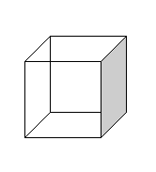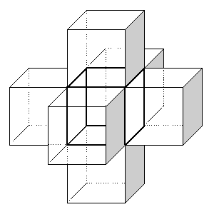
Figure 2: Cubic cell and associated von Neumann neighbourhood

In consequence we assume for each cell the existence of 24 state position components to describe the different possible geometrical positions and directional moments of the H₂O molecule in a cell.
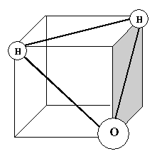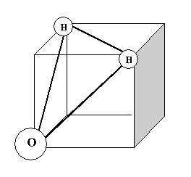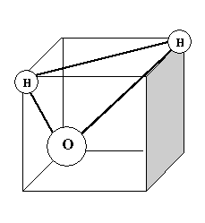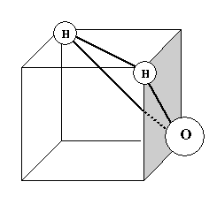
Figure 3: State position components defined by the location of the H₂O molecule in a cell
(O-atom rotating clockwise in the bottom plane)

From a mathematical point of view it is suggested to assume in the set X of 24 state position components a mathematical structure by $X:=\text{GF}(8)×\text{GF}(3)$ such that state transitions can be described by algebraic operations to give a chance to apply known theoretical results from the field of discrete structures.
In addition to the position components x of a cell-state q we assume also for the H₂O molecule a directional moment y which is described by a binary vector $y=(y_{0},y_{1},\text{.}\text{.}\text{.},y_{5})∈\text{GF}(2)^{6}$.

In conclusion the state set Q of each cell-machine c is defined by $Q:=\left\{\right\}∪X×Y$ where X (the set of the 24 different geometrical positions of a H₂O molecule in a cell) is given by $X:=\text{GF}(8)×\text{GF}(3)$ and the set Y (the set of the cube-specific directional moments) is defined by $Y:=\text{GF}(2)^{6}$. The state ∅ means that no H₂O molecule is in the cubic cell. Any state $q≠∅$is represented by a vector q=(x₁,x₂,y₀,y₁,…,y₅) where $x_{1}∈\text{GF}(8)$ gives the location of the 0-atom at one of the 8 edges of the cell-cube, $x_{2}∈\text{GF}(3)$determines the location of the corresponding H-atoms at the 4 possible diagonally opposite edges and $y_{0},y_{1},\text{.}\text{.}\text{.},y_{5}$ are the directional moments of the H₂O molecule corresponding to the six different possible directions determined by the cube-planes.
The neighbourhood of the cell c consists of the six cells $c_{0},c_{1},\text{.}\text{.}\text{.},c_{5}$ which interface directly with the planes of c (we assume a “von Neumann” neighbourhood).

3.2 Construction of the cell-state machines
For any cellular state machines the construction of the state transition function of the cell state machine is the crucial part in modelling. It compares in modelling continuous dynamical systems to the determination of the associated partial differential equation system. Our approach is to take a most simple construction of the state transition function and improve this by simulation experiments.
In our approach it is sufficient to define the state transition function $δ:Q×Q^{6}→Q$ for a cell machine only for its state q=∅. The next state $q^{'}=δ(φ,q_{0},q_{1},\text{.}\text{.}\text{.}q_{5})$ is determined as one of the state q₁,q₂,…,q₅ of the 6 neighbouring cell-machines. The selection is done by a function $α:Q^{6}→Q$ such that $q'=α(q_{0},q_{1},\text{.}\text{.}\text{.},q_{5})$. In terms of systems theory such a type of state transition is referred as a register flow dynamics. A specific exception for the state transition function has to be made at boundary cells as we will see later, when we discuss the complete cellular state machine.

3.3 Discrete event control of the cell automata
Since a state transition takes only place for a state q in case when q=∅ it is suggested to consider not a clock-control of the cellular machine but a discrete event control. This allows also a more effective implementation for simulation. Since the state transition of an individual cell machine depends only from locally given conditions it is sufficient to define the events which cause state transitions for the case of an individual state machine. In addition to our cellular automata model we make here also use of an associated Petri net model. This allows us to treat conflicts in a more systematic way.
q₁₁

q₇
q₃
q₆
q₁₀

q₄
q₀
q₂
q₉
q₁₆
q₈
q₁
q₅
q₁₂
q₁₅

q₁₇
q₈
q₉
q₁₃

q₁₄

Figure 4: Section of a 2-dimensional cellular machine

In Figure 4 we show a section of a 2-dimensional cellular machine which we will use to explain our method of discrete event control and our concept for conflict solution. The same approach can also be applied to our 3-dimensional case of cellular machine for H₂O modelling.
Let us assume that $q_{0}=∅$ and also $q_{6}=∅$ and that in addition $α_{0}(q_{1},q_{2},q_{3},q_{4})=q_{2}$ and also $α_{6}(q_{2},q_{\text{10}},q_{\text{11}},q_{3})=q_{2}$. Then we have a conflict in determining the next states of q₀ and q₆ respectively by its associated state transition values $δ_{0}(∅,q_{1},q_{2},q_{3},q_{4})$ and $δ_{6}(∅,q_{2},q_{\text{10}},q_{\text{11}},q_{3})$.
We solve this conflict by defining an order relation ≤ on the set of all cells c_{i} of our cellular state machine which are in a conflict and use this order relation to determine the cell machine which is allowed for executing the state transition.
Let us assume that sell c_{i} and c_{k} are in conflict to each other, then the following should be valid.
(1) $c_{i}≤c_{k}$ if c_{i} is “below” of c_{k}
(2) $c_{i}≤c_{k}$ if c_{i} and c_{k} are on the same level but for c_{i} the Manhattan distance to the “central” cell of the level is smaller than for c_{k}
(3) in case that for c_{i} and c_{k} no decision whether $c_{i}≤c_{k}$ or $c_{k}≤c_{i}$ by (1) or (2) can be made we select one of it randomly

The conditions (1)-(3) determine a function $β:C_{0}→C_{0}$ on the set C₀ of cell machines which are in conflict to each other by selecting a minimal member of it.

For demonstration on our example of Figure 4 let us assume that besides of c₀ and c₆ also c₉ “point” by its selection functions α₅ and α_{q} respectively to the state q₂. Then $C_{0}=\left\{c_{0},c_{6},c_{9}\right\}$. Then $q_{0}≤q_{6}$ and $q_{9}≤q_{6}$. If c₄ is the central cell of the associated level then $q_{0}≤q_{9}$. Therefor $β(c_{0})=β(c_{6})=β(c_{9})=c_{0}$. The order relation ≤ of this example can be represented by the graph as shown in figure 5.
C₆

C₉

C₀

Figure 5: Order relation of the conflicting cell machines of the example of figure 4

We see, that in our cellular state machine C the state transitions are controlled by discrete events which select the cell machines with state q=∅ and allow a state transition by a shift of a neighbouring state q’ (selected by α) which avoids a possible conflict with other cell machines.

3.4 Petri-net model
For simulation studies it is desired to have for the cellular state machine an associated Petri-net model available. This allows the application of existing Petrinet tools for the different desired experiments. We assign to our cellular state machine C in the following way a marked Petri-net PNC in the kind of a condition/event net (C/E net):

(1) each cell c of C is interpreted a place s of PNC
(2) the different directional channels between the cells are the arcs with one transition t of PNC
(3) the marking μ of PNC is given by $μ:S→\left\{0,1\right\}$ with $μ(s):=0$ if the associated cell machine c is in state q=∅; $μ(s):=1$ if the associated cell machine c is in state $q≠∅$ (S is the set of all places of PNC)

In figure 6 we show by a 2-dimensional example a section of a cellular state machine and the associated marked Petri-net.
q₆
(a)
q₃
∅
q₅

q₄
q₂
∅

q₁

(b)
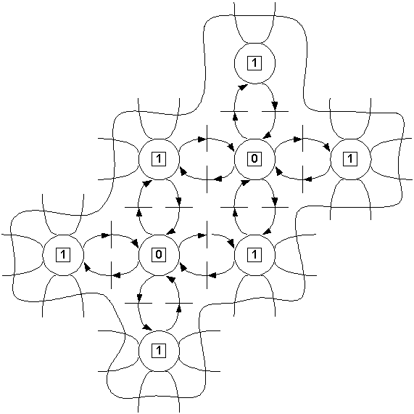

Figure 6: Section of a cellular state machine (a) and associated marked Petri-net

3.5 Cellular automata for H₂O modelling: Geometry and Boundary Conditions
For studying the dynamics of the H₂O molecules by means of a cellular state machine it is necessary to determine the geometrical form and also of the boundary conditions to be assumed. For simplicity reasons we will consider a conical water container which is open on both sides to allow an input and an output of water. In figure 7 we sketch such a container. We assume that the water in the container flows from the top to the bottom driven by gravitational forces. The cellular finite state machine C which we would like to construct, has to model the geometry of the container, that means that it has to be filled by cubes in figure 2, with appropriate molecular size. C is certainly a complex model and for simulation effective programming methods and powerful computing facilities are required. Of essential importance are the boundary conditions which we have to assume. At top of the cone we assume the existence of an input layer of cells which receives at every time step randomly their states. For the cell layer below we assume that the selection map α of each cell machines
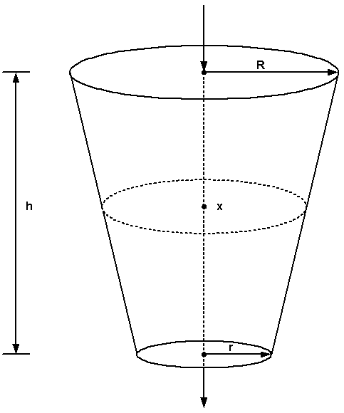
Figure 7: Conical container

selects at each time step for the next state the state of the cell from the input layer above. A similar arrangement is considered for the output process of the cellular machine C. We assume for C the existence of an output layer of cell machines which are at every time step in state q=∅. The associated selection map α of the cell machines of the output layer determines the cell machines above to “absorb” their state. By this kind of definition of the boundary conditions on top and at the bottom of the cellular machine C a flow “through” C from top to bottom is realized. In order that this flow becomes eventually chaotic, which is our goal, specific boundary conditions have to be assumed for the cell machines on the cone walls.
The physical facts are given by shear-forces which contribute in hydrodynamical models to turbulence phenomena. To model such forces in our cellular machine C we assume for the cell machines c which are situated on the cone wall a specific state transition function $\bar{δ}$ which includes in addition to the “propagation part” of shifting also collision.
$\bar{δ}(∅,q_{0},q_{1},\text{.}\text{.}\text{.},q_{5})=δ_{c}(δ(∅,q_{0},q_{1},\text{.}\text{.}\text{.},q_{5}))$ where $δ_{c}:Q→Q$ models collision.
To model a dependence of $δ_{c}$ from the height (level) x of the cell machine we might assume that $δ_{c}$ depends on x; $δ_{c}=δ(x)$. Then, it should be possible also to take different cone-types such as for example the hyperbolic cone of Walter Schauberger (compare with Radlberger [6]) into account.

- Dynamical behaviour of the H₂O model

The ultimate goal of our modelling effort is to give a description of state changes for the cellular automaton globally in time and space. Let us repeat the assumption which we have to take into account in this task: We assume that the cellular arrangement realizes on I/O process modelling the flow of water. Furthermore we assume that the boundary conditions provide the forces in changing the dynamical behaviour. Physically we associate boundary condition with forces (mechanical, electrical, van de Waal etc) which results in specific input values to the cells which are situated close to the boundary. Of specific interest are boundary conditions which cause a chaotic dynamic behaviour of the cellular automaton which means on hydro dynamical level turbulence. From a physical point of view such boundaries have to contribute to a turbulent flow of the H₂O molecules. This is the case if the flow is confronted with sharp edges and barriers. The modelling of such an effect on the level of cellular automata requires boundaries which cause sharp changes of the generated input values.
In cellular automata dynamics this should result in a chaotic regime such that strange attractors appears. Obviously, the proof of such a situation cannot be done in a mathematical analytical way but has to be realized by computer simulation.
On a hydrodynamical level strange attractors can be associated to H₂O clusters of different size. Mathematically such clusters might be derived by computer simulation from specific Poincaré maps taken from strange attractors.

However, the construction and implementation of a simulation model for the cellular finite state machine C (=CFSM) is outside of the scope of this paper. Nevertheless let us state the main steps which have to be taken to construct a simulation model and to provide the necessary experimental frame to run experiments.
Step 1: Determination of the actual size of the water container to be modelled by C. This results in the complexity of C measured by the number of necessary cell machines in C.
Step 2: Construction of C and “open” implementation to be able to experiment with different possible boundary conditions for the cell machines at the cone wall and to find a valid state transition function δ for the cell-machines (determination of α and in addition of δ_{c} for the “cone wall” cell machines)
Step 3: Simulation experiments to determine a valid state transition function for the cell machines
Step 4: Simulation experiments to determine the boundary conditions (determined mainly by the collision part δ_{c} of the state transition function of the boundary cell machines) such that a turbulent flow is observed
Step 5: Visualisation of the flow in C such that possible strange attractors can be identified and observed
Step 6: Experiments with suitable Poincaré maps to project strange attraction to geometrical objects of cluster type to propose approaches for physical measurements on real flows of water

The achieved results should be of help to construct an appropriate model to describe the dynamics of water on level C of our figure 1. However, the clustering of liquid water observed by physical measurements so far proves only as a short time effect. Translated this fact into the language of esoterically oriented papers this means that water has only a “short time memory”.

- Physical measurement methods for H₂O structures

Experimental research done by physical measurements have shown the existence of H₂O clusters. Such measurements are realized by different existing diffraction methods based on X-rays or on ultra-/hyper acoustic waves. Others make use of properties of the infrared-spectrum or are based on the determination of the dielectricity constant. Also the nuclear magnetic resonance method is known for the determination of clusters. It is not a goal of this paper to discuss this topic in greater detail.

- Resume and Conclusion

We presented a possible construction of a 3-dimensional cellular automaton C for the modelling of liquid water. The individual cells c of C are geometrically defined as cubes which have a “von Neumann” neighbourhood consisting of the adjacent 6 cubes. Mathematically each individual cell c is a finite state machine $c=(Q,A,δ)$ which receives as its input the state values of the neighbouring cells $c_{0},c_{1},\text{.}\text{.}\text{.},c_{5}$ . For the state transition $δ:Q×A→Q$, to describe propagation, we assume a shift of states from a neighbouring cell. Only the cell machines on the boundary of the cone wall have in addition a collision part.
To generate a chaotic flow in C certain highly unsteady boundary conditions have to be assumed. By our hypothesis this should result in the appearance of strange attractors which can be associated to clusters derived from appropriate Poincaré maps.
Although our approach in modeling liquid water for the computation of chaotic flows in a cellular automaton does not yet meet finally valid physical requirements it may provide a starting point for our modeling task. Future work in modeling liquid water has to take physical facts for the determination of the propagation and collision operation to provide a heuristics for the determination of the state transition function of the cell machines stronger into account.

- References
[1] Pichler, Franz: Victor Schauberger and the Turbulence of Water. in: Surroundings Surrounded (ed. Peter Weibel), ZKM Karlsruhe Publication Program, ISBN 3-928201-26-3 (to be published by MIT Press 2002), page 452-462.
[2] Wolfram, Stephen: Theory and Applications of Cellular Automata. World Scientific, Singapore, 1986.
[3] Casti, John L.: Complexification. Harper Collins Publishers, New York, 1994.
[4] Badii, R. and A. Politi: Complexity – Hierarchical structure and scaling in physics. Cambridge University Press 1997.
[5] Gaylord. R.J. and K. Nishidate: Modeling Nature. Cellular Automata Simulations with Mathematica. Springer Verlag New York, 1996.
[6] Radlberger, Claus: Der hyperbolische Kegel. PKS Verlag, Bad Ischl, 1999.

