On the Development of the Lieben Vacuum Tube (LRS-Relais)

Franz Pichler
Department of Systems Theory and Information Engineering
University of Linz
A-4040 Linz
Austria
e-mail: pichler@cast.uni-linz.ac.at

- Introduction
The invention of the vacuum tube for the electronic amplification of telephone and radio signals marks a milestone of information technology. Two independently working research-groups made their contribution to it. In the US the patents of the inventor Lee de Forest and the following research at Western Electric (AT&T) under the leadership of Harold D. Arnold supplied the basic results for the start of the production and the use of the high vacuum tube in long distance telephony by the end of 1913. Based on the patents of Robert von Lieben and his research associates Eugen Reisz and Sigmund Strauss in Austria in 1911, a successful demonstration of the LRS-Relais for the amplification of telephone signals was performed. From 1913 on the “Lieben Konsortium” including the companies Siemens, AEG and Telefunken, started the manufacturing of the “Lieben-Tube”, an electronic amplification device based on low vacuum which still needed residual quantities of mercury vapor.
This article deals with the pioneering work in the early years of the Vienna Laboratory in Vienna compared with the parallel development of the high vacuum tube in the US.
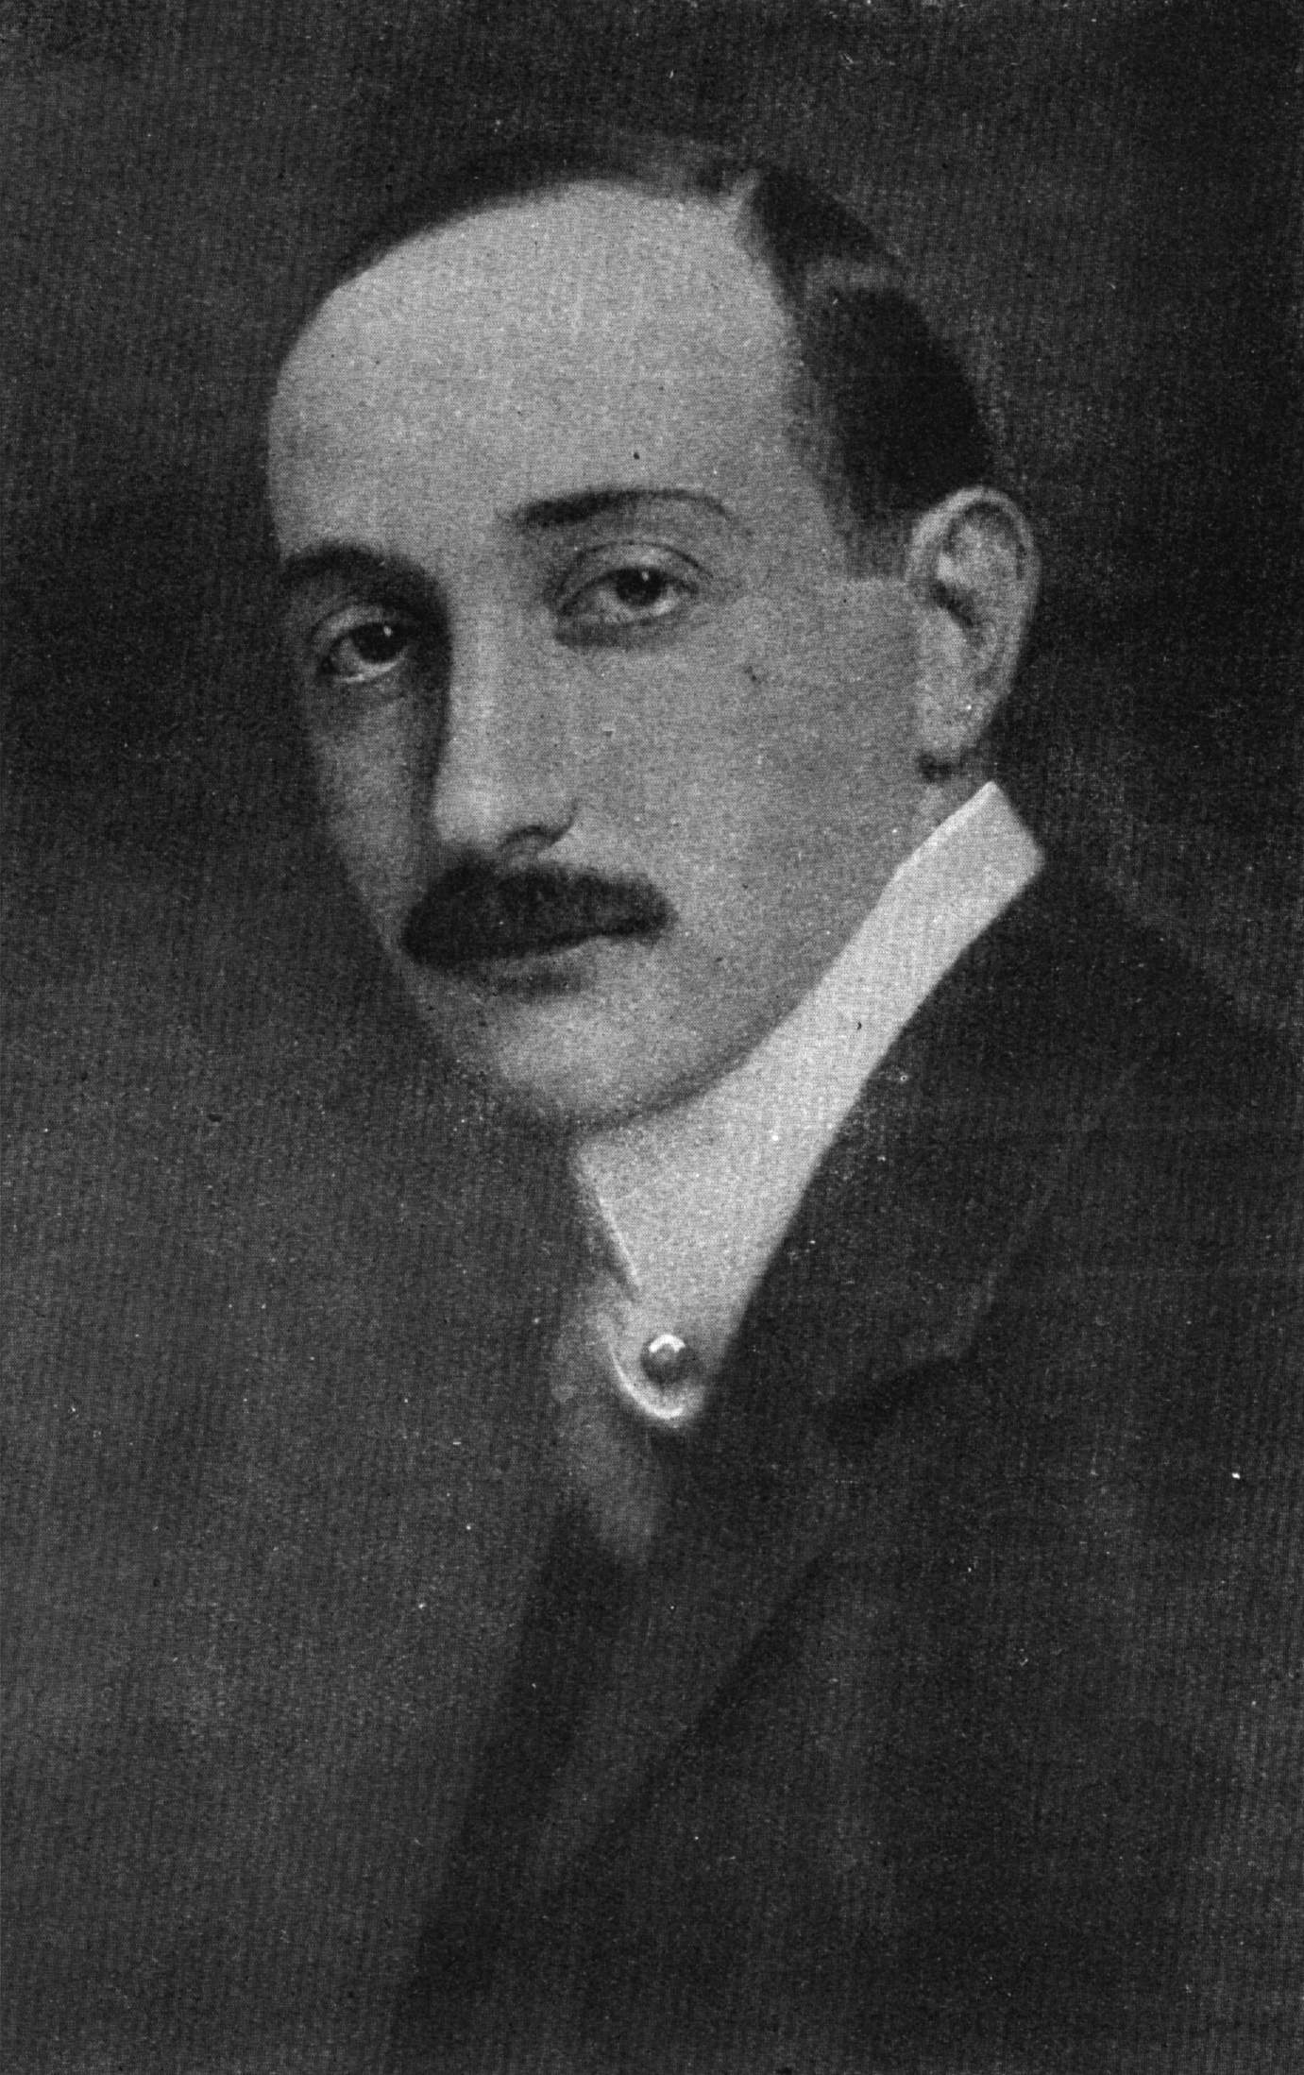

Figure 1: Robert von Lieben (1878-1913)
- The “Kathodenstrahl-Relais” of 1906
Robert v. Lieben, who was financially supported by his wealthy parents, purchased in 1904 the telephone factory of the company “Berliner” in Olmütz in Moravia. In consequence that made him explore the possibility of electronic amplification of telephone signals, a technology which was urgently required in those days. From his promoter Prof. Nernst in Göttingen, he acquired the knowledge of the latest research of Prof. Whenelt on how to emitter electrons by hot alkalic cathodes.
In 1906 he applied successfully for a patent to construct a electronic device (called “Kathodenstrahl-Relais”) to allow the amplification of electrical current by means of cathode-rays (electrons) emitted by a hot cathode using electromagnetic of electrostatic control. He established a laboratory in the 1st floor of his parents home in Vienna 1, Oppolzergasse 6 for experimentation. For the preparation of the cathode, which got a parabolic shape to focus the emitted cathode rays, he contracted the chemist Dr. Richard Leiser of the University of Vienna. Dr. Leiser was also responsible for the installation and operation of the vacuum pump.
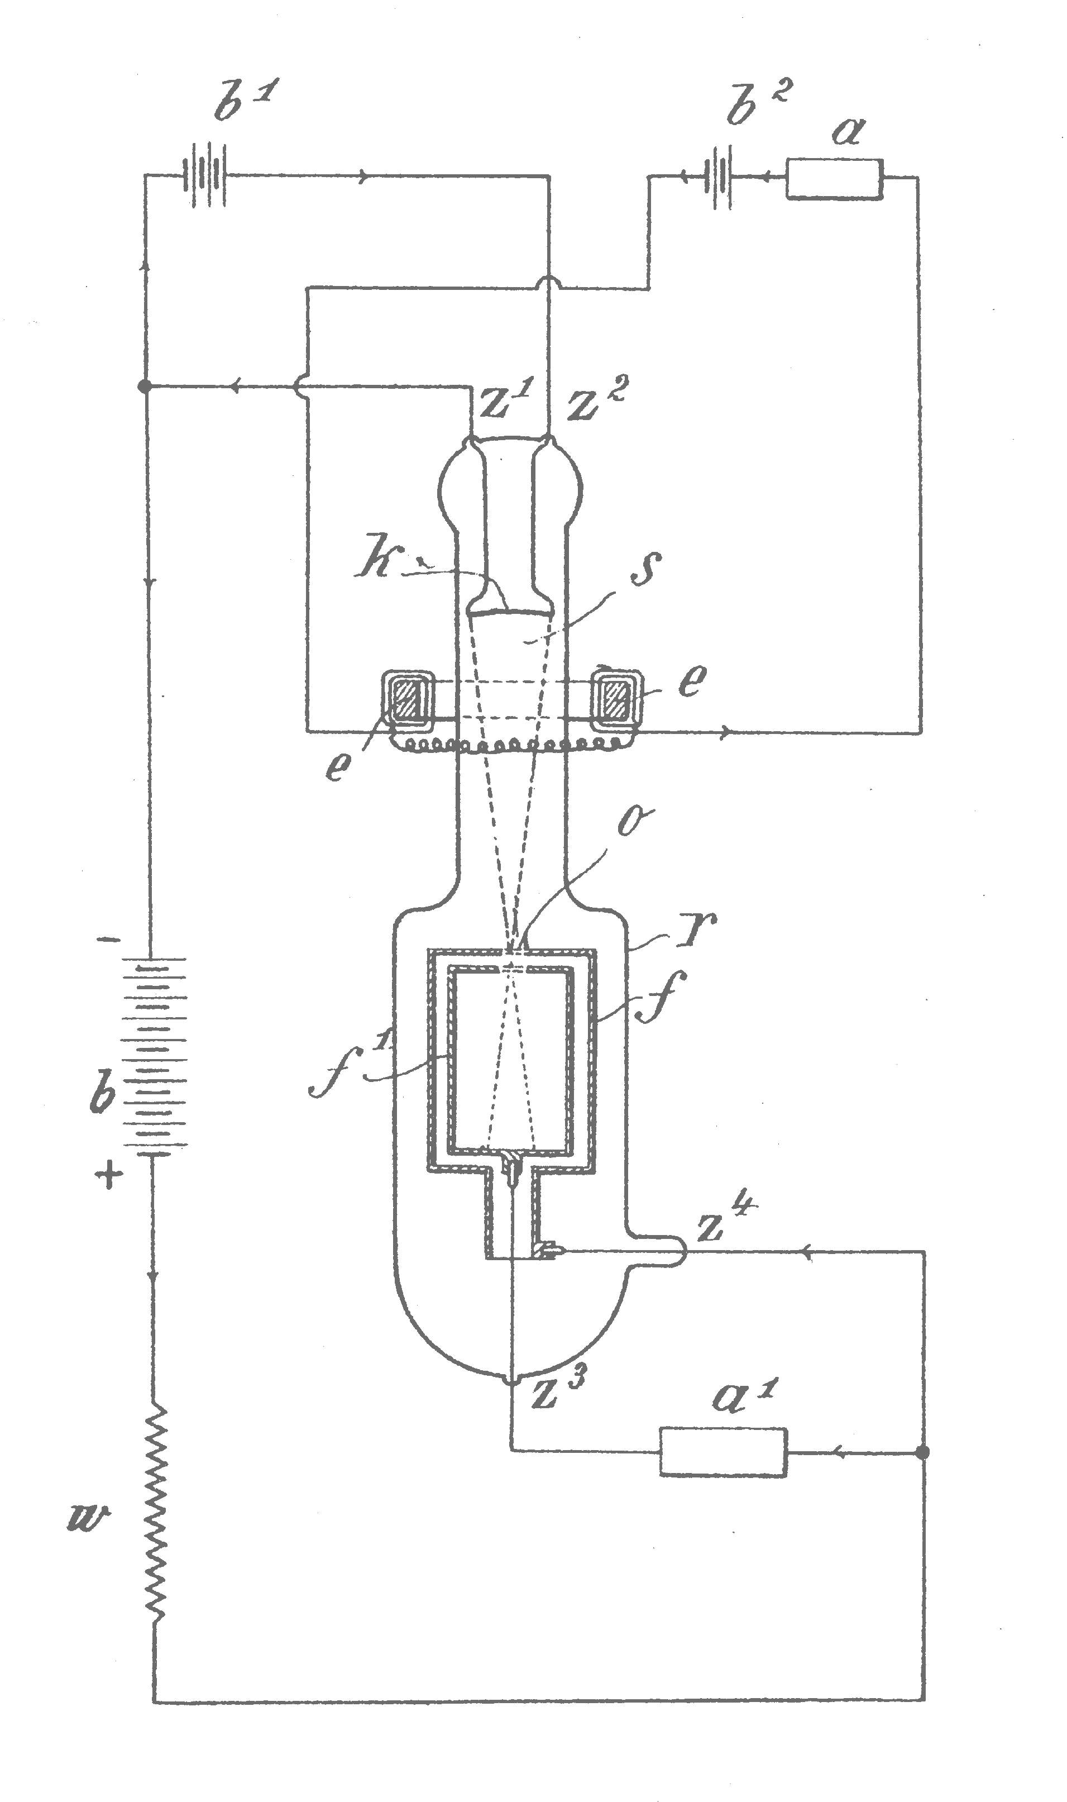
Figure 2: The “Kathodenstrahl-Relais” Patent 1906
From letters written by Robert v. Lieben to Dr. Leiser we know that the results of the amplification experiments were not too promising and focussing the cathode rays turned out to be difficult. Furthermore, v. Lieben placed confidence in Dr. Leiser to give him a hand in the design of the electrical circuit, a task which seemed to be difficult to perform for the chemist Dr. Leiser. Secondary sources report, that in 1907 a successful amplification of telephone speech could be carried out. However, the voluminous glass tube had to be all the time staying connected to the vacuum pump.

- The grid patent of 1910
In the spring of the year 1910 R.v. Lieben reported in a letter to Dr. Richard Leiser that together with his co-workers Dr. Eugen Reisz and Ing. Sigmund Strauss (both joined v. Lieben in Vienna as former employees of the Telephone factory in Olmütz) he discovered a new method to control the electronic current emitted by the hot cathode by means of a metallic grid. The group applied in the same year for two patents on “Relais für Undolierende Ströme” and prepared a demonstration-set for a two-way speech amplification. In August 1911 in Berlin a successful demonstration of the “LRS-Relais” (LRS should stand for “Laboratory Reisz and Strauss” and however as well could be interpreted as “Lieben, Reisz and Strauss”) was given. This was followed by the forming of the “Lieben Consortium” an interest-group for the exploitation of the LRS-patents. It consisted of the companies Siemens, AEG, Telefunken and Felten&Guilleaume. From 1913 on the LRS Relais was produced first by the Osram plants, a subsidiary company of the Siemens Corporation, later by the company TeKaDe, a subsidiary of the Felten&Guilleaume Karlwerk.
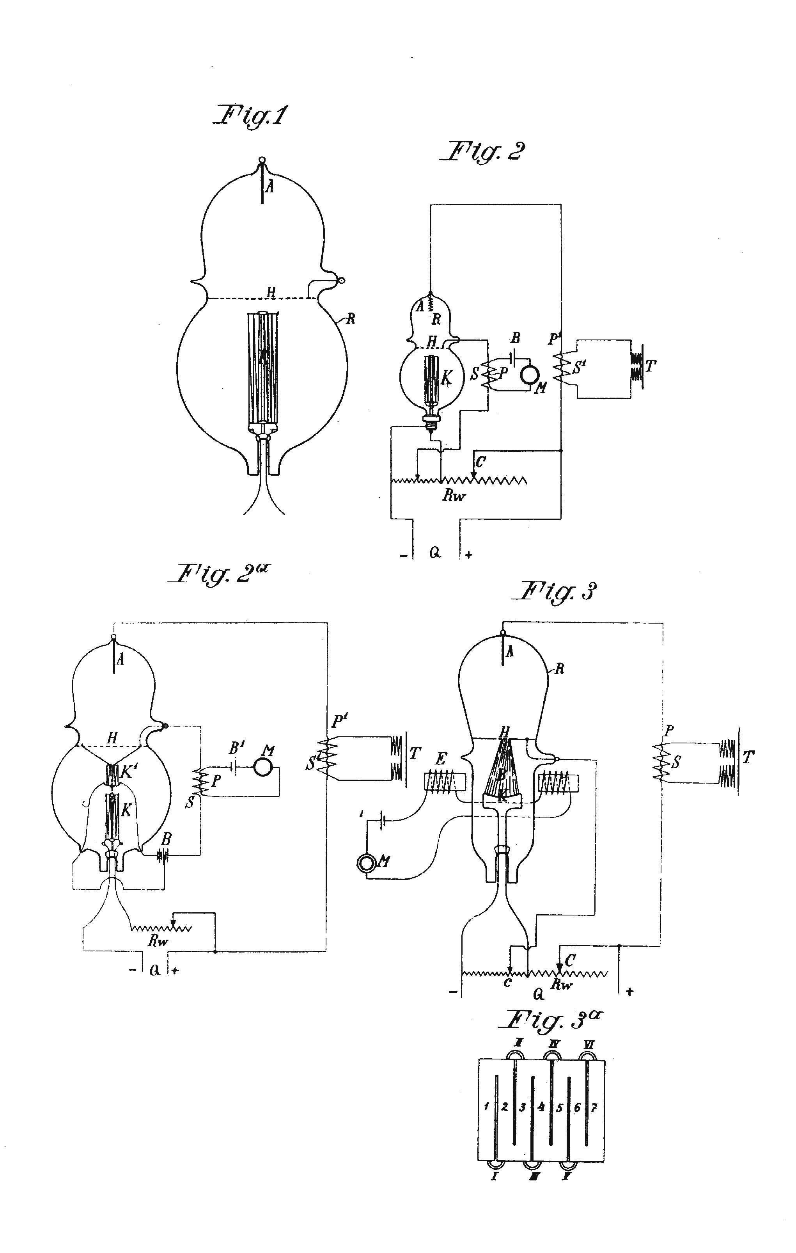
Figure 3: Gridpatent 1910
- Development of the High Vacuum Tube in the US
The American physicist and inventor Lee de Forest got in 1906 a patent with the title “Device for Amplifying Feeble Electrical Currents” in which he suggested a vacuum tube with three electrodes, placing a grid between the heated cathode and the opposite positioned anode. He named it the “Audion”. The circuit worked in receivers for wireless telegraphy and was used mainly by amateurs to replace other rectifying devices for demodulation such as the cohaerer or galenium crystals (“cats wisker”) and others. Lee de Forest however was not able to explain the function of the circuit as a amplifying device in physical terms. Lee de Forest made also no reference to the already existing vacuum diode of A. Fleming.

From the year 1912 on Lee de Forest got interested again in his Audion and its possible application as a telephone repeater. He tried to get in contact with AT&T, were such a device was urgently needed. At Western Electric, the supplier of AT&T, the young physicist Harold D. Arnold, a former student of Professor R. A. Millikan, started a research and development project to provide such an amplifier. In November 1912 Arnold got knowledge of the de Forest Audion and discovered immediately the importance of the concept and the associated patent for his project. Similar to Robert v. Lieben Arnold used an oxyd cathode for electron emission and discovered that no additional residual quantities of gas were necessary to generate a current of electrons (cathode rays) from the cathode to the anode.
This certainly paved the way to the successful development of the high vacuum tube. At the same period of time in February/March 1913 Eugen Reisz and Sigmund Strauss visited AT&T and offered the patent of their LRS Relais; however without success. AT&T got in July 1913 the rights for the de Forest Audion. Already in October 1913 a long distance telephone line between New York City and Washington equipped with repeater circuits based on high vacuum tubes (type A-repeaters) was put to operation.

- Manufacturing and Application of the LRS Relais
The Lieben Consortium agreed in sharing the costs for the further necessary research and development of the prototype and the associated circuitry provided by the Viennese Lieben group. Agreement was done on terms of 45%:45%:10% (AEG-Telefunken: Siemens und Halske: Guilleaume Karlwerk AG).
At the AEG Werk Oberspree in Berlin Eugen Reisz and Alexander Meissner soon devised circuits suitable for the practical application of the LRS tube in two-way telephone repeaters.
Dr. Meissner applied for a patent in April 1913 using the LRS tube in a transmitter and he was successful in establishing a radiophone connection between Berlin and Nauen, over a distance of about 40 km. During World War I different equipment for wireless apparatus using the LRS tube was developed and manufactured by Telefunken and TeKaDe (Felten and Guilleaume changed the name of the Karlwerk into “Süddeutsche Telephon Apparate, Kabel- und Drahtwerke AG” called TeKaDe for short).
When the US entered WW I they got a hold on the German steam ship “Vaterland” and found high frequency amplifiers and heterodyne oscillators realized by LRS tubes as part of its wireless equipment. The LRS tube also served during WW I in long distance telephone repeaters and as an amplifier for the intercepting of ground-telegraphy. To improve stability of the LRS tube, which depended strongly on a constant mercury vapor pressure, the tube was locked in a chimney to enable the control of the temperature by the cooling effect of the air current.
Although Telefunken started in summer 1914 strong efforts to develop a “hard” triode (high vacuum tube) under the leading of Hans Rukop and adopted the procedure to prefer high vacuum devices, the production of the LRS-tube at TeKaDe continued, with interruptions until 1920.

- Conclusion
The invention of vacuum tube with three electrodes and its use in the detection of radio waves is correctly credited to Lee de Forest with his Audion of 1906. However, Lee de Forest did not describe his circuit as an electronic amplifier. Robert v. Lieben described with his patent on the Kathodenstrahlrelais of 1906 an electronic amplifier where cathode rays between a heated oxyd cathode and the anode were controlled by magnetic or electrostatic influence. By the grid patent of 1910 a three electrode vacuum tube which still based its function on residues of mercury vapor was the finally achieved improvement of the Kathodenstrahlrelais of 1906 which led in 1911 to the LRS-Relais and to a successful demonstration of an electronic amplifier. The de Forest Audion led (by the important research of Harold D. Arnold (Western Electric) and I. Langmuir (General Electric) to the high vacuum tube in 1912 and to its application in electronic telephone repeaters in 1913.
The LRS relais however certainly deserves credit for the realization of the first electronic telephone repeater in 1911. Furthermore it proved to be valuable for the construction of the first electronic high frequency oscillator (Meissner 1913).
In conclusion we may agree to consider the contribution of Robert v. Lieben with his patent of 1906 on the “Kathodenstrahlrelais” and the subsequent invention and development of the LRS Relais in 1911 by his research group as an important milestone in the development of electronic amplification of telephone- and radiosignals.
In a second track the invention of the three-electrode vacuum tube by Lee de Forest of 1906 and the subsequent research work for AT&T by Harold D. Arnold led in 1912 to the high vacuum tube and to the kind of repeaters which served successfully in different systems for information transmissions and even in the first computers until their replacement in consequence of the invention of the transistor and the subsequently developed amplifiers.

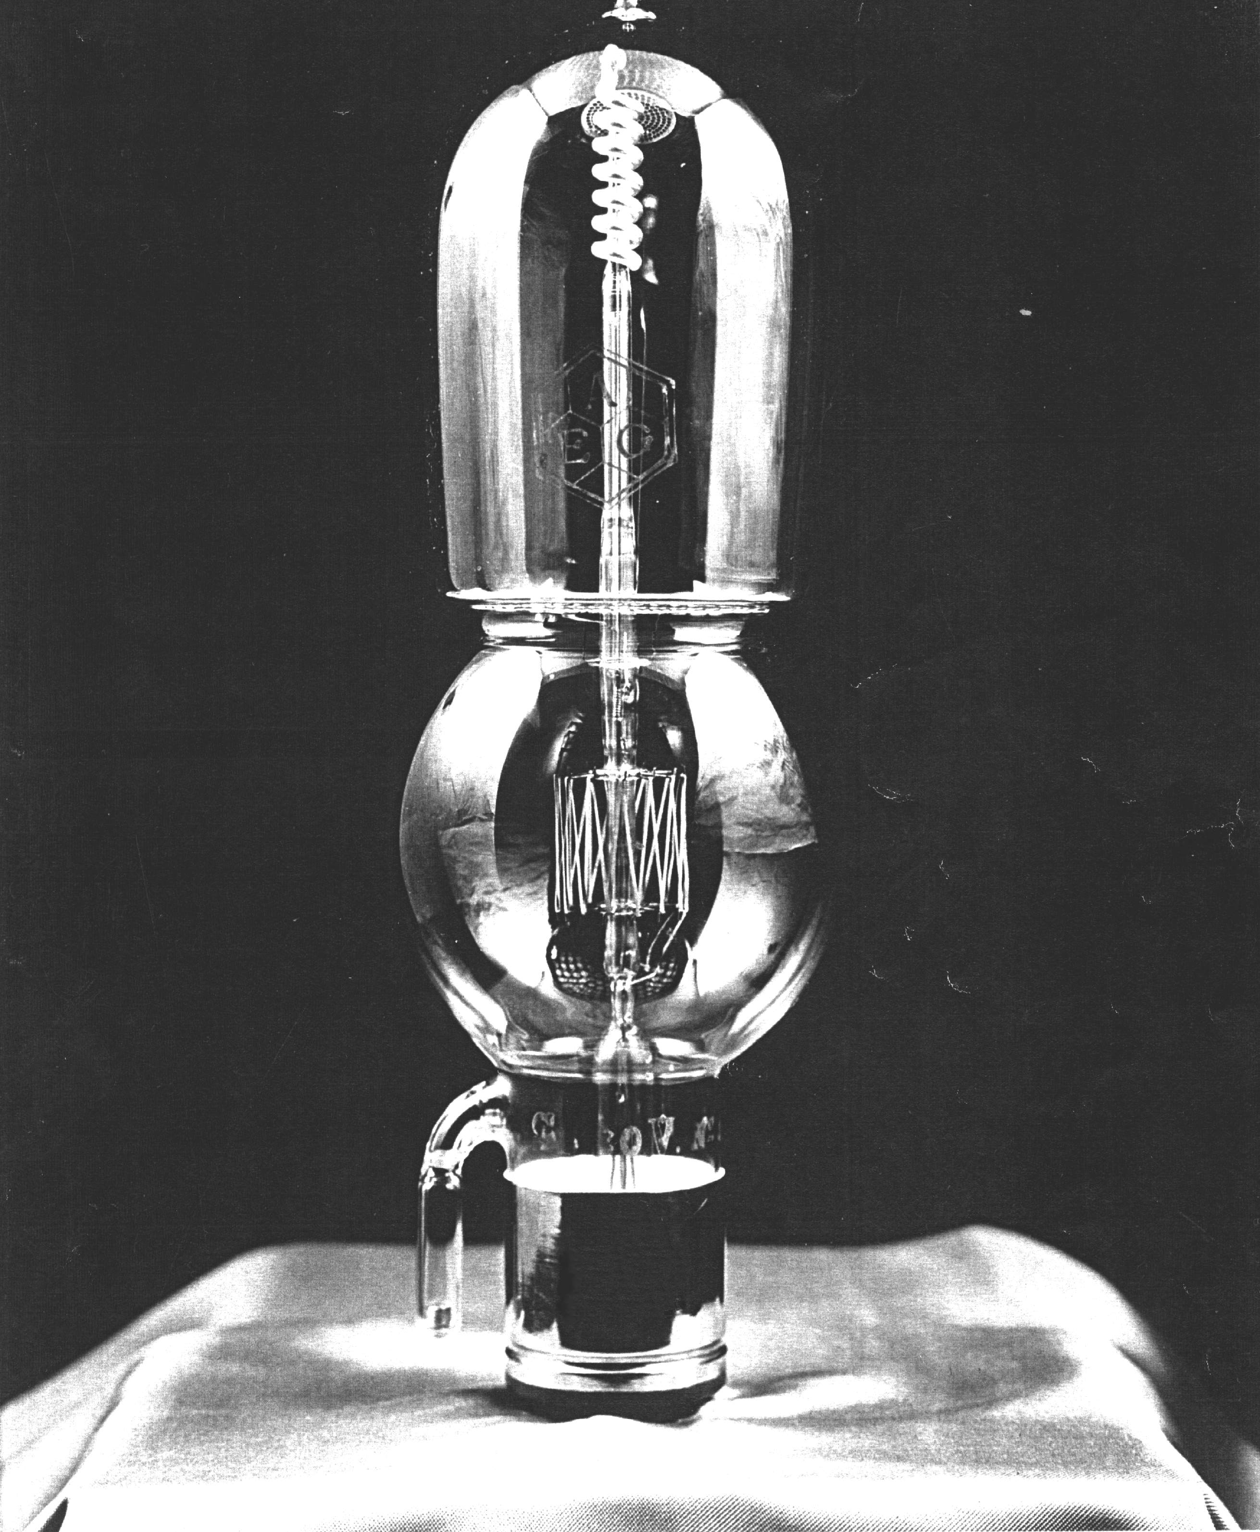

Figure 4: LRS-Relais

References
[Eugen Reisz, 1913]: Neues Verfahren zur Verstärkung elektrischer Ströme. Elektrotechnische Zeitschrift, 34. Jahrgang, Heft 45, S. 1359-1363, 1913.
[Karl Skowronnek, 1931]: Zur Entwicklung der Elektronenverstärker-Röhre (Lieben-Röhre). Archiv für Geschichte der Mathematik, der Naturwissenschaften und der Technik, Verlag von F.C.W. Vogel Berlin, 13. Band, S. 225-276, 1931.
[Rüdiger Walz, 1987]: Die Entwicklung der Liebenröhre. Funkgeschichte Nr. 52, S. 7-28, Jan/Feb 1987.
[Thomas H. Briggs IV, 1990]: The Triode that predated de Forest: Robert von Lieben and the LRS Relay. The AWA Review, Published by The Antique Wireless Association, Vol. 5, pp. 45-61, New York 1990.
[M.D. Fagen (ed.), 1975 ]: A History of Engineering and Science in the Bell System. The Early Years (1875-1925), Bell Telephone Laboratories, Inc., Indianapolis, USA, 1975.
[Leonhard S. Reich, 1985]: The Making of American Industrial Research, Science and Business at GE and Bell, 1876-1926. Cambridge University Press, Cambridge, USA, 1985.
[Franz Pichler, 2001]: Robert von Lieben und die Entwicklung der Röhrenverstärker. in: PLUS LUCIS 1/2001, Physik-Chemie, ISSN 1606-3015, pp. 29-33, 2001.

