Published in AWA Bulletin 2013,pp. 21- 35

Magneto-electric Dial Telegraphs- Invention and Development
Contributions of Wheatstone, Stoehrer and Siemens

© Franz Pichler 2013

ABSTRACT

A reason for the writing this paper was the discovery of a transmitter for a magneto-electric dial telegraph as invented in 1840 by the english scientist Charles Wheatstone. The details of this invention are presented together with the efforts of Cooke and Wheatstone to make their telegraph system known to investors for its use by the public. In addition also the later development of dial telegraphs which use a magneto-electric machine to generate the signals for the communicator are covered. As an addendum a short report on the restauration work for two original Wheatstone magneto-electric communicators for dial telegraphy is given. This paper relies in many parts on the content of the e-book of Steven Roberts ¹ and the fundamental paper of John Liffen on the history of the inventions of Cooke and Wheatstone in the field of telegraphy ²

INTRODUCTION

The needle telegraph of Cooke & Wheatstone in England and the electromagnet telegraph of Morse in the United Stated and in continental Europe contributed successfully to the installation of large networks for electrical telegraphy. As we know, both telegraph systems required the use of a telegraph code. In 1840 Wheatstone & Cooke got an english patent for the invention of a “dial telegraph”, where the knowledge of a telegraph code was not needed. The letters of the alphabet and the numbers could directly be determined at the sender for their transmission to the receiver, where they could be read. The disadvantage of the “dial telegraph” in comparison to the existing telegraph systems was the low speed of transmission. This paper deals with the invention and the development of a special kind of dial telegraph, the “magneto electric dial telegraph” which uses a magneto electric machine for the generation of the signals. The advantage of this type of dial telegraph was that no galvanic battery was needed for its function.

MAGNETO-INDUCTION TELEGRAPH OF GAUSS-WEBER (1833)

The invention of the first electrical telegraph which was of practical use can be attributed to the german scientists Gauss and Weber, both professors at the University of Goettingen. For the communication of scientific data of the magnetic field of the earth they designed in 1833 an electric telegraph, which used the new discovered effect magneto-induction (Faraday 1831) for the generation of the transmitted signal. The signals at the sending station were generated by moving a huge permanent magnet in a coil up and down. The receiver was a kind of mirror galvanometer. With a telescope the received signals could be observed by the moving of a light point. Earlier experiments to make use of a galvanic battery failed.
The book of Feyerabend ³ presents the historical facts on the telegraph of Gauss and Weber. The reader may also consult the important book of Shaffner ⁴ on the history of electrical telegraphy by

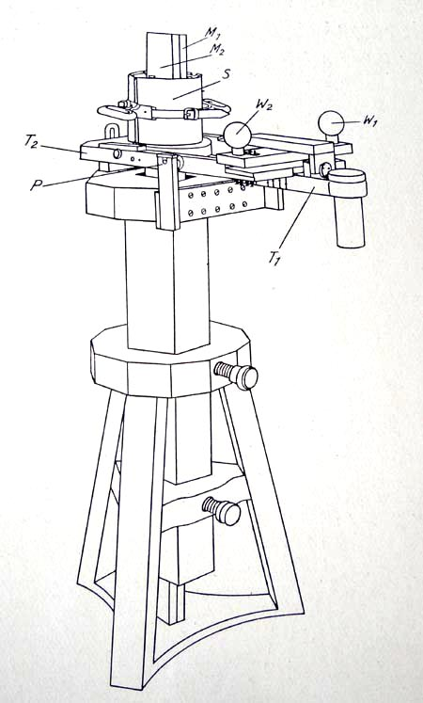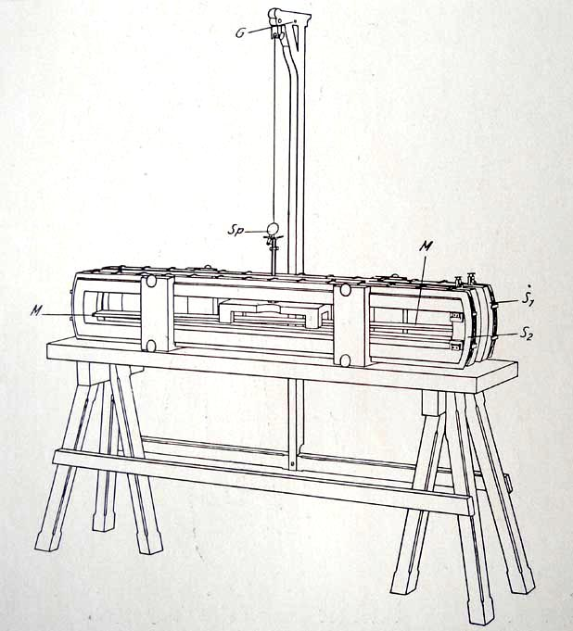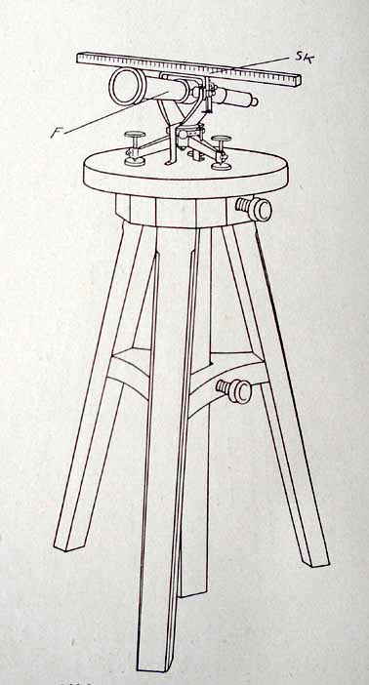

(a) transmitter (b) receiver (c) telescope

Fig 1: The telegraph of Gauss and Weber, (a) transmitter, (b) receiver, (c) telescope

THE DIAL-TELELGRAPH OF WHEATSTONE AND COOKE (1840)

The year 1837 brought the invention of the needle telegraph by the english inventors
William Fothergill Cooke and Charles Wheatstone followed immediate by the successful implementation of this electric telegraph at different english railways. In 1840 a new patent was added which introduced for the first time the concept of dial telegraphy by electrical currents ⁵. The patent covers different inventions of Wheatstone and Cooke. The “mechanical telegraph” of this patent considers a “communicator” which works as follows: By turning a wheel in the form of a capstan a contact gives electrical pulses to the line. The electricity is provided by a galvanic battery. On the periphery of the wheel the different letters of the alphabet and numbers are written. Their location on the wheel determines the related number of pulses to be sent. The original receiver, called the “indicator”, of the “mechanical telegraph” consisted of two electromagnets which move a pointer, when alternating energized, around. This movement is controlled by an escapement. The mechanical force is provided by a weight driven clock work. The “mechanical telegraph” of Wheatstone & Cooke needed in the original version three wires for its function, two wires over land, the third connection could be provided by the ground ⁶.

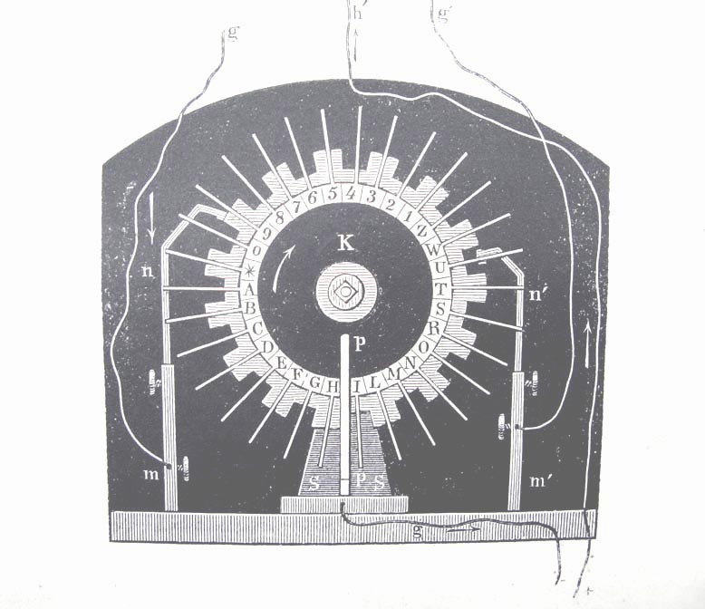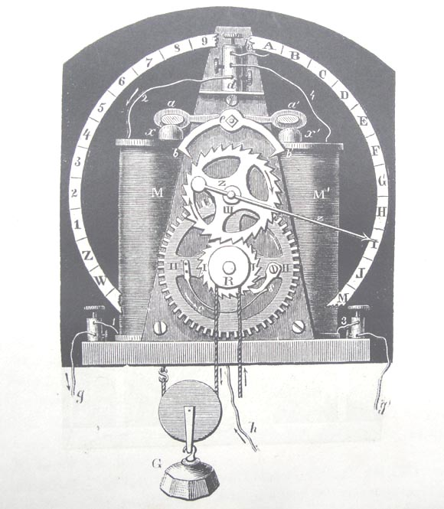

(a) Communicator (b) Indicator

Fig 2 Principle of the “mechanical telegraph” of Wheatstone & Cooke (1840)

The principle of the dial telegraph of this kind can already be found in the book of Halle 7.
There, however, the transmission of the signals is done there purely mechanical by turning a metallic shaft. It is obvious that such a dial telegraph works only for short distances. On ships, however, such telegraphs have found in the past application to give signals from the navigator to the machinist. For the mechanical transmission of the signals not a camshaft but a chain was used. The “mechanical telegraph” of Wheatstone & Cooke did in England not find
an application. However in France and Germany dial telegraphs of this kind was there in later years extensively used until the appearance of the Morse telegraph. The reader interested in more detail is advised to consult the book of Prescott.

The second concept of a dial telegraph, which can be found in the patent of Wheatstone & Cooke of 1840 deserves our strong interest. It deals with the “electro magnetic telegraph” which uses a magneto-electric machine to generate the pulses of the “communicator”. Let us give here the original text of the patent for its description

- A magneto electric machine, that may be used in connection with the signal apparatus above described. The current is made to circulate in one direction by means of a inlaid wooden disc on the axis of the armature, in connection with springs in metallic contact with the main wires; the disc is inlaid with two insulated metallic semicircles respectively in connection with each terminal of the armature coil; thus the to- and fro current generated by the machine is driven by a cog-wheel having twelve pins, so disposed that, by the motion of the wheel through a space equal to the distance between them, the armature moves through half a revolution. Twelve signals are thus made without the “communicator”, and are all this machine can make with the above described signal apparatus, as its electric current is only of momentary duration, and the electro-magnet cannot act a sufficient time to convey a signal by stopping the pointer.

As we can read, the patent suggests the use of a magneto-electric machine for the generation of the signals of a code-alphabet. In the known models of this “communicator” a battery of five horse shoe magnets give the necessary magnet field to generate by induction in turning of a 2-coil armature the electrical pulses. This type of construction of a magneto electrical machine was in 1840 not new. Already the machine of Clarke of 1835 show this design. A commutator on the armature wheel converted the AC waves into DC pulses. By a special contact only the peaks of the AC waves are taken. As receiver the “indicator” of the “mechanical telegraph” was taken. In later versions, which needed only two wires for the connection, a receiver with only one electromagnet was used. In its housing this receiver looked similar to a “Schwarzwaelder Kuckucks Uhr”(Cuckoo Clock from the Black Forest), as can be seen by pictures.

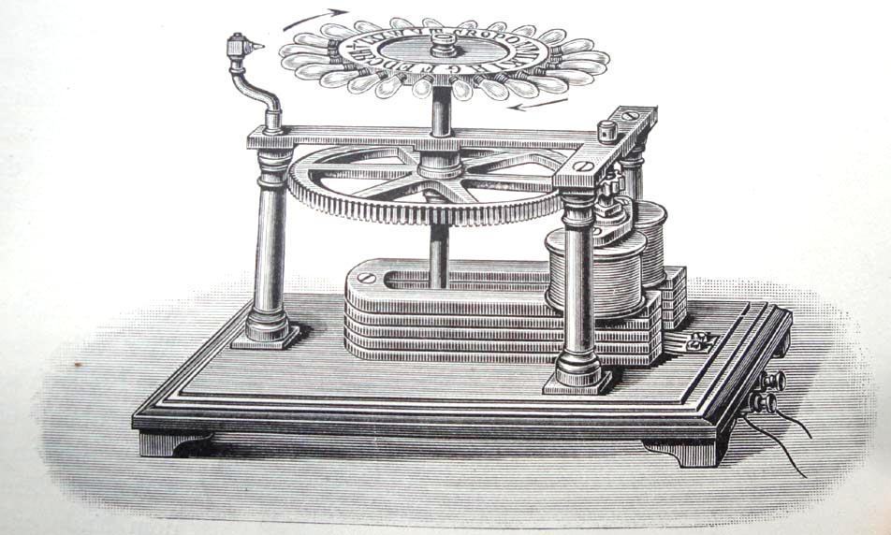

Fig 3: Demonstration the principle of the “communicator” of the
“electro magnetic telegraph” of Wheatstone & Cooke, 1840

The “electro magnetic telegraph” found in England some application as we will discuss later. The little acceptance of the dial telegraphy in England in the beginning does, however, not diminish the importance of the invention. The success in later years with the “Universal telegraph” of Wheatstone (1858) in England and the strong acceptance of magneto-electric telegraphs in Germany by the constructions of Stoehrer (1844) and Siemens (1857) on railways show this.

PUBLIC PRESENTATION OF THE COOKE & WHEATSTONE TELEGRAPHS
IN ENGLAND 1843/44

With the success of the installation of needle telegraphs by Cooke & Wheatstone on different english railways the plan arose to interest investors for the erection of a telegraph network for the public. For marketing Cooke engaged Thomas Home, a young man of only 18 years of age. On May 16, 1843 the track of the “Great Western Railway” between London-Paddington and Slough over a distance of 19 miles was chosen to show the function of their own different telegraph systems to possible investors.

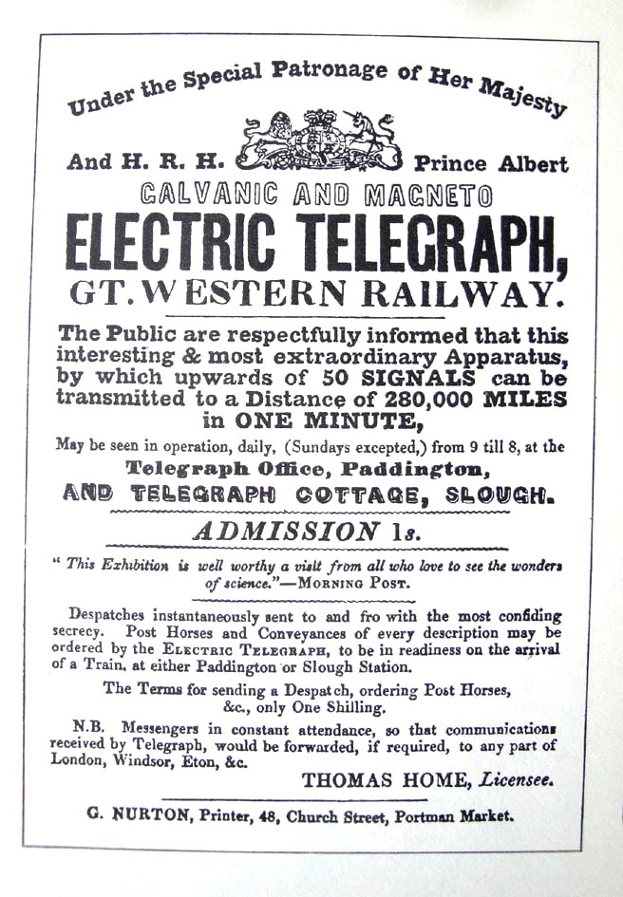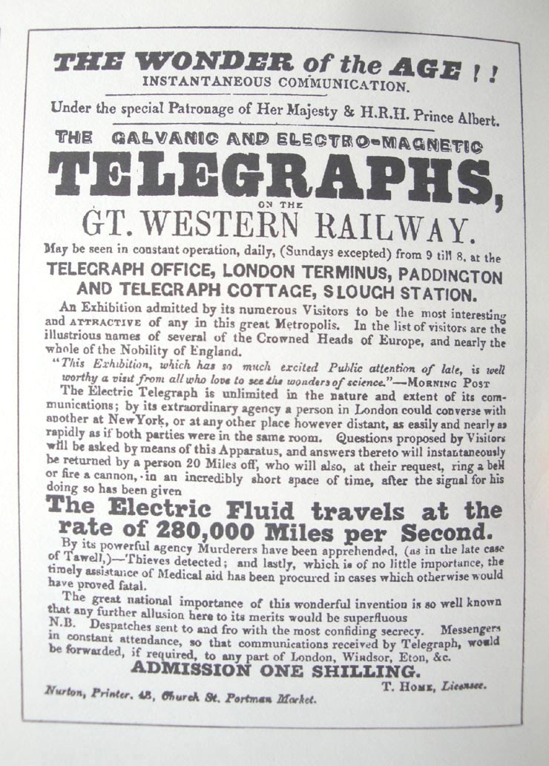

Fig 4: Posters announcing the presentation of the telegraphs of Cooke & Wheatstone 1843

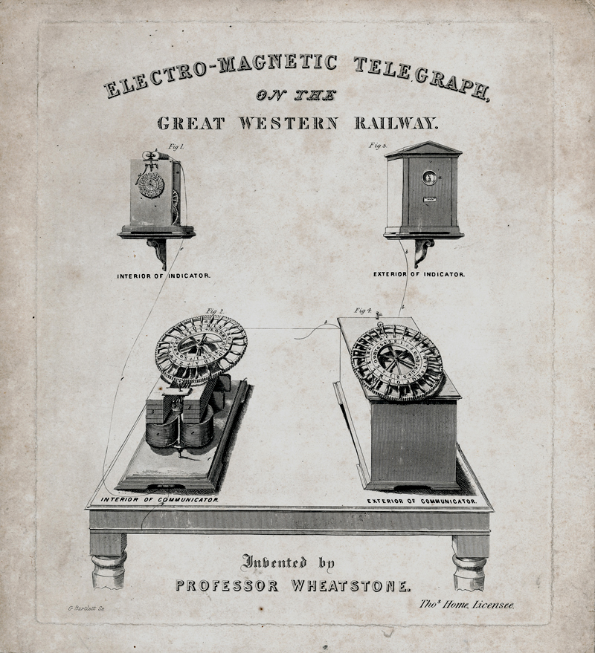

Fig 5: Promotion of the “electro magnetic telegraph” of Wheatstone at the
“Great Western Railway”

Visitors at the station Paddington and Slough could observe the operation of the 2-needle telegraph of Cooke. This type of telegraph was at this time in different railway systems already in use. In addition also the “electro magnetic telegraph”, the sort of dial telegraph which has our interest here, was shown and could be operated. It is reported that Wheatstone presented also his new invented printing dial telegraph there. The entrance fee to the presentation was 1 shilling and visitors could send and receive telegrams. Probably they were also allowed to operate the magneto electric dial telegraph of Wheatstone. The book of Steven Roberts 8 contains a list of different prominent visitors such as the HRH Prince Albert, the Russian Czar and the king of Prussia. From time to time Charles Wheatstone was present at Paddington and explained for the visitors the function of the instruments. From Gertrud Sullivan, a young lady of the London society exists a diary where the following text can be read

„We were taken into a small room, where were several wooden cases, containing different sorts of telegraphs“

and

“In one sort every word was spelt, and as each letter was placed in turn in a particular position, the machinery caused the electric fluid to run down the line, where it made the letter show itself at Slough, by what machinery he (Wheatstone) could not undertake to explain. After each word came a sign from Slough, signifying ´I understand´ coming certainly in less than one second from the end of the world”

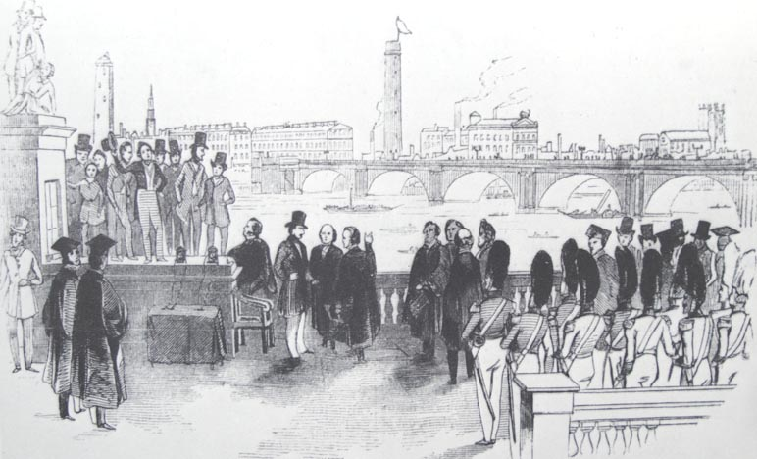

Fig 6 Presentation of the “electromagnetic telegraph” for Prince Albert

BREAK THROUGH OF THE ELECTRIC TELEGRAPH IN ENGLAND

In May 1845 Cooke could report to the English press that under his leadership the following railways are using his electric telegraph ⁹

- London & South-Western Railway- for the government, from the Admirality at Whitehall to Portsmouth, 90 miles
- London & South Western Railway- for commercial use, Nine Elms to Southhampton, 77 miles
- London & South Western Rauilway- for commercial use, Southhampton to Gosport,
21 miles
- London & Dover (South Eastern Railway)- Tunbridge to Maidstone (single line),
15 miles
- London & Croydon Railway, 9 miles
- South Devon Railway- Exeter to Plymouth, 52 miles
- London & Blackwall Railway (cable), 3 miles
- Great Western Railway- London to Slough, 18 miles
- Yarmouth & Norwich Railway (single line), 20 miles

In most of the cases the 2- needle telegraph of Cooke was used. The magneto electrical dial telegraph of Wheatstone continued to be only of experimental use. To promote its application on April 10, 1845 a competition in chess was arranged between the chess- champions of this time Howard Stanton and Hugh Alexander Kennedy, which stayed in the telegraph station of Gosport and six chess-amateur players on the other side 90 miles away in Vauxhall. The play started at 11:30 a.m. and got finished at 7 p.m.. After altogether 43 moves the play ended undecided. The magneto electrical dial telegraph which was used proved to be not reliable enough. Without having the assistance of Professor Wheatstone the play finally had to be finished by the use of the 2-needle telegraph of Cooke ¹⁰.

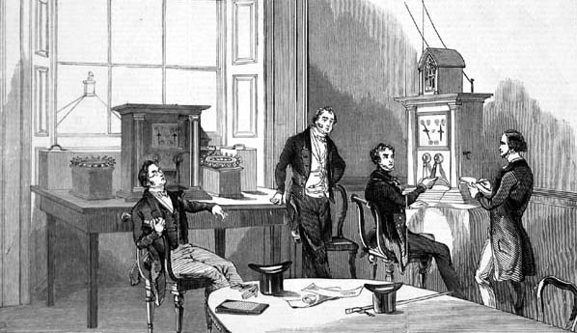

Fig 7 Telegraph station Nine Elms, 1847

SUCCESSFUL APPLICATIONS OF MAGNETO ELECTRIC TELEGRAPHY

Charles Wheatstone sold his telegraphy patents already in 1843 to Cooke. However he kept the rights for the countries in continental Europe with exception of Austria and Russia. A partial success in the application of the dial telegraph in the version of the “mechanical telegraph” of the patent of 1840 was reached in the Netherlands. There on May 25, 1845, the installation for the railway of the “Hollandsche Ijzeren Spoorwegmaatschappij”, the Holland Iron Railway Company, was finished. The work and the maintenance was done by the instrument maker Eduard Wenckebach from Amsterdam. A installation of the magneto electrical dial telegraph, the “electro magnetic telegraph” of the patent of 1840, was completed by Wheatstone between Paris and Versailles in 1845 and stayed in operation until 1850 ¹¹.

A great success for dial telegraphs, especially for the version “mechanical telegraph” of the patent of Wheatstone & Cooke of 1840 was acchieved in later years in France and Germany. In France the instrument makers Breguet and Froment , in Germany Fardely, Siemens and Kramer were the most important manufacturers of dial telegraphs. They needed for their operation the use of a galvanic battery. The reader interested in greater detail is advised to consult the books of Karras 12 or the already mentioned book of Prescott. In general it can be stated that the concept of the dial telegraph finally found great interest. In the book of Zetsche 13, which is fundamental for the history of electrical telegraphy, all together 28 chapters are devoted to that topic. All this proves that the idea of Wheatstone to design a electrical telegraph which allows the user to operate it by writing the telegraphic message directly by the normal alphabet was fruitful. As we know, this idea was later taken up again by the printing telegraphs of Hughes and House and in our times by the teleprinter. In the following chapter we discuss the further development of the magneto electric dial telegraph as invented by Charles Wheatstone in 1840 with his “electro magnetic telegraph”.

FURTHER DEVELOPMENT OF THE MAGNETO ELECTRIC
DIAL TELEGRAPH

The magneto electric dial telegraph of the patent of Wheatstone & Cooke of 1840 did not find practical acceptance. The main reason maybe was the low effectivity of the magneto electric machine. Later inventions and designs of Wheatstone in England and Stoehrer and Siemens in Germany brought improvements and finally the success.

The “Universal telegraph” of Charles Wheatstone (1858)

Charles Wheatstone, since 1834 Professor of Experimental Philosophy at King´s College in London, kept his interest for his “electro magnetic telegraph” alive, even by its low success in the past. He still pursued the plan to establish a telegraph network for the public which could easy be operated by people. To reach this goal he constructed the “Universal telegraph” which was patented in 1858. Let us discuss shortly in what way Wheatstone was able to improve his “electro magnetic telegraph” of 1840 by his new invention. While the design of the magneto electric machine in 1840 used a pair of coils for the armature, the new design of 1858 had four coils which were mounted on two batteries of horse shoe magnets. The armature was realized by a turning piece of soft iron. In later versions of the “ABC telegraph” of the General Post Office also the Siemens armature came into use. An early description of the “Universal telegraph” can be found in the Journal of the “Deutsch- Oesterreichische Telegraphen-Verein” of the year 1864 14. The marketing of the patent was given by Wheatstone to the “Universal Private Telegraph Company”. Within short time important cities in England got a telegraph network using this telegraph. Besides of the police and other governmental institutions which were interested also many private companies such as for example the news agency Reuter got connected. After 10 years of successful operation the “Universal Private Telegraph Company” came under control of the British Government. The responsibility for operation and maintenance of the whole network was transferred to the “General Post Office”. From this time on the “Universal telegraph” was called “ABC telegraph”.

The book of Steven Roberts devotes a whole chapter to the “Universal telegraph” and the “Universal Private Telegraph Company” 15.

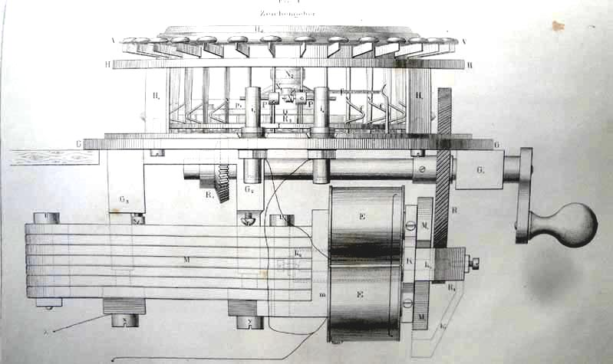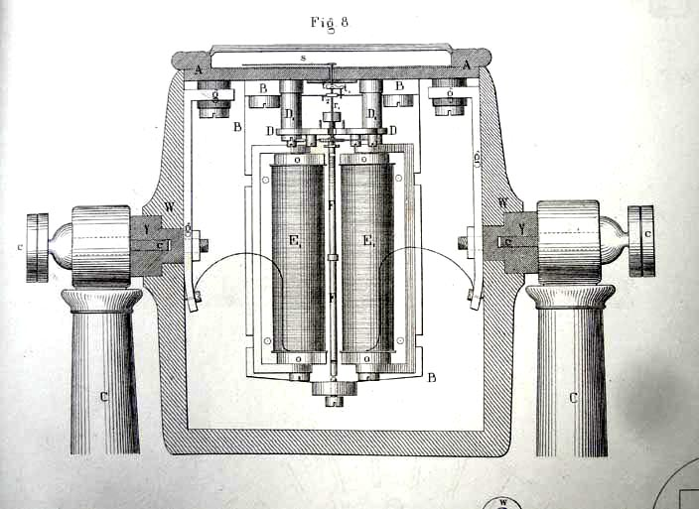

(a) (b)

Fig 8: Universal telegraph of Charles Wheatstone (a) communicator and (b) indicator

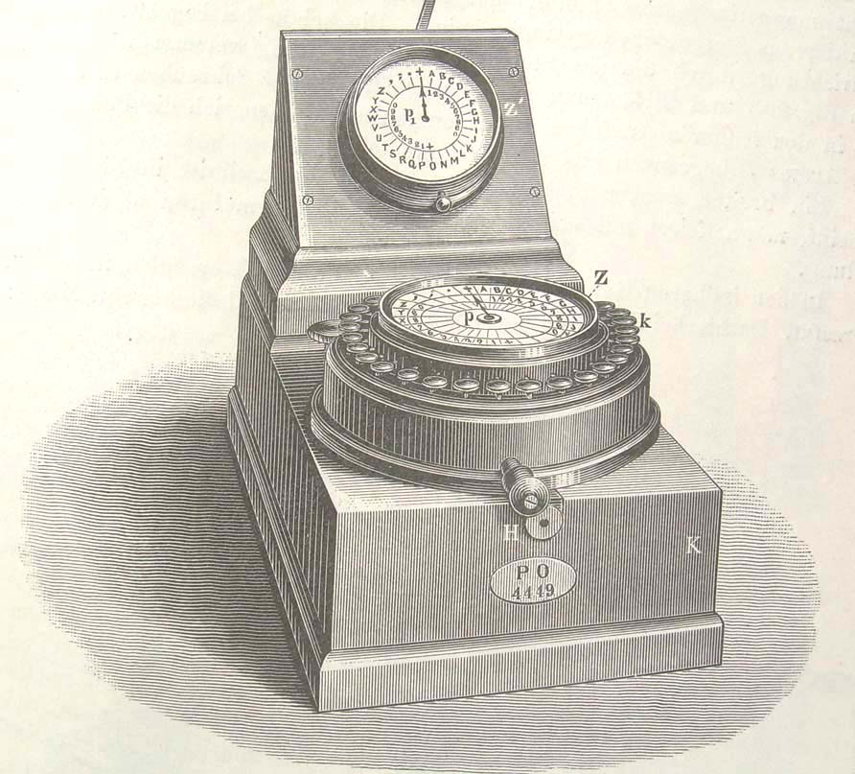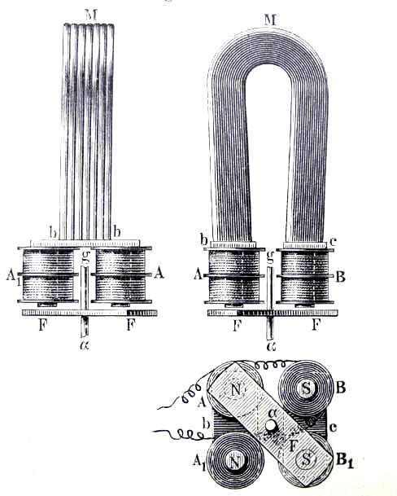

Fig 9: ABC telegraph of the General Post Office

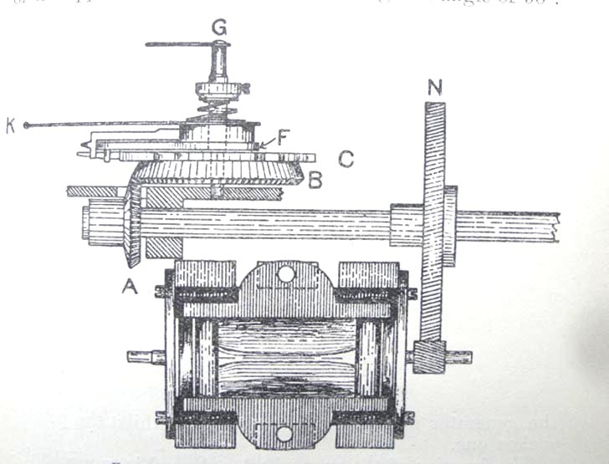

Fig 10: magneto electric machine of the ABC telegraph with Siemens armature

The Dial telegraph of Emil Stoehrer (1846) ¹⁶

Emil Stoehrer was born in 1813 near Leipzig, Germany. After school he was a apprentice
with the mechanic and instrument maker Johann Gottlieb Wiessner in Leipzig. Married to the daughter of Wiessner he was later the owner of the shop. Already from 1844 on Stoehrer made experiments with magneto electric machines. Their construction was similar to the machine of the american mechanic Joseph Saxton of 1835. From 1846 on Stoehrer used his machines for the construction of a magneto electric dial telegraph. He sold already in 1846 such telegraphs to the private line from Bremen to Bremerhaven and in 1847 for the railway from Leipzig to Altenburg in Saxonia. In 1850 Stoehrer was provided also the Bavarian railways with his telegraph where they stayed until 1857 in operation.

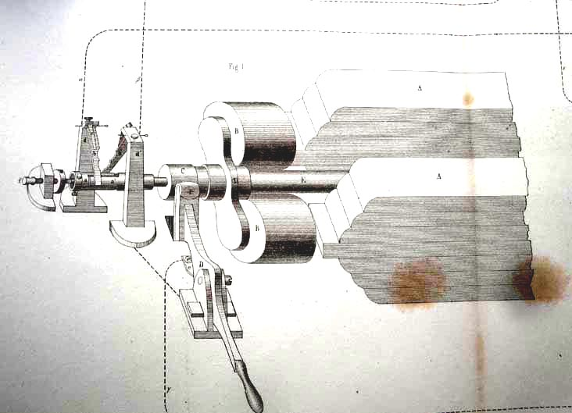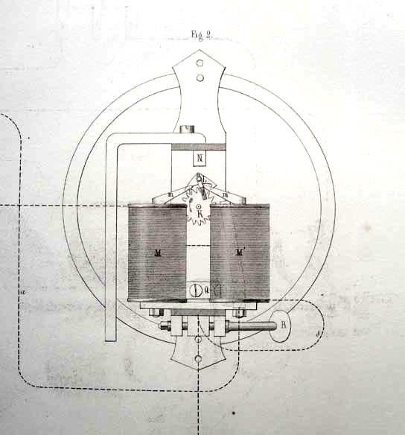

(a) (b)

Fig 11: Dial telegraph of Emil Stoeher (1846). (a) communicator and (b) indicator

The “Magnetzeiger” of Werner von Siemens (1857)

Werner von Siemens was one of the most important scientists, engineers and inventors of the 19th century in Germany. Besides of his technical and scientific skills he was also a talented businessman. He founded the company Siemens & Halske in Berlin, a company which exists until today as the “Siemens Corporation”. Already in 1848 he contributed with his “selfacting dial galvanic telegraph” to the art of telegraphy. In 1856 Siemens got a patent for his “double-T-armature” an important improvement for the construction of effective magneto electric machines. Early application of the new construction were found in railway signalling and in mining for magneto electric exploders. But Siemens, having knowledge of the inventions of Wheatstone, very soon used his improved magneto electric machine also for the construction of a dial telegraph, his “Magnetzeiger” of 1857. The Bavarian railways bought already in 1857 the new dial telegraph of Siemens, replacing there the dial telegraph of Stoehrer. For the rest of the 19 th century the Bavarian railways used Siemens dial telegraphs of this kind. The company Siemens & Halske, however, was also successful to sell their magneto electric telegraphs, the “Magnetzeiger”, to other countries, such as Sweden, Russia and Turkey. The author of this paper has in his collection a Siemens “Magnetzeiger” from Sweden from the year of about 1860. Its huge wooden case of pine-wood with a little door at the front to allow a look to the magneto system gave a visitor the idea to compare it with a “Hundehütte”, a dog-house, a comparison which can not be accepted for this existing wonderful historical piece. A documentation of the introduction of the telegraph in Sweden, where also this dial telegraph, in swedish language called “Visartelegraf”, is covered is given by the book of
Tahvanainen ¹⁷.

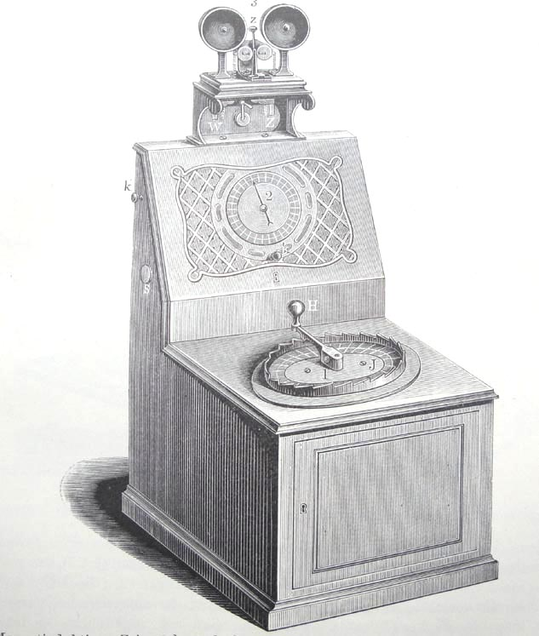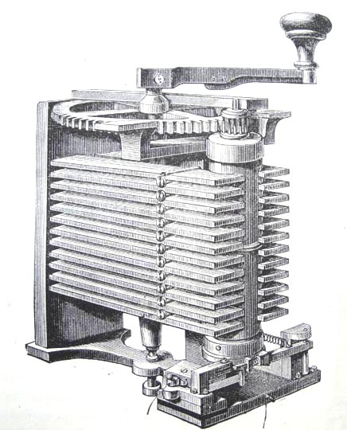

(a) (b)

Fig 12 (a) Magnetzeiger of Siemens & Halske 1857,
(b) Magneto Electric Machine with Double-T-Armature

SUMMARY

The paper tries to present the invention and development of the magneto electric dial telegraph as invented in 1840 by the famous british scientist and inventor Charles Wheatstone. The main reason to write this paper was for the author the discovery of an original communicator of the “electro magnetic telegraph” of Wheatstone in the version as described in the patent of 1840. Such types of communicators and the related indicators were used to advertise the telegraphs of Cooke & Wheatstone in 1843/44 to interest investors for establishing a public telegraph network. Although magneto electric dial telegraphs did not get a similar importance in England compared to the needle telegraph of Cooke & Wheatstone and to the telegraph of Morse in the U.S.A. and in continental Europe, they nevertheless represent an important part of the history of the electric telegraph.

THANKS

Many thanks go to Steven Roberts, London, for his help and provision of literature and pictures. John Liffen, Curator for Telecommunication, Science Museum London, made a search in the depots for pieces of magneto-dial telegraphs from the Wheatstone Collection of King´s College and provided pictures which have been very helpful for the restauration work. Ib received from Bill Burns, New York, valuable information on the auction of the British Telecom Museum in 2006.The machine shop of Gerald Paschinger gives help to replace the missing gears and manufacturing for the second communicator the capstan wheel with the full alphabet.

ADDENDUM

Report on the restauration work for two Wheatstone magneto dial transmitters

By ebay two original Wheatstone magneto dial transmitters have recently been found. They can be dated as manufactured in the 1840´is and meet the description as given by Wheatstone in his patent of 1840. Both were incomplete and restauration work was needed. In addition I have tried to find out from which place they originated. The two were originally of dentical construction. Both, let them call “Wheatstone 1” and “Wheatstone 2”, however had missing parts and needed some little wood repair. “Wheatstone 1” was nearly complete, only the gear wheel of the armature was missing. The capstan wheel of “Wheatstone 1” shows 11 letters and the cross +, which defines the initial position. The letters are given by ( counter clock wise ordered): B,D,F,H,K,M,O,R,T,W and Z each associated with a stick for turning the dial wheel. The dial wheel shows the engraving “C. Wheatstone Inv.” We observe, that from the full alphabet every second letter is missing. A dial wheel having only 11 letters for operation suggests that the telegraph was used together with a code book. The missing gear wheel of the device “Wheatstone 1” has been replaced and the function is now satisfying. At the second magneto transmitter “Wheatstone 2”, both the dial wheel with its capstan wheel and also the gear wheel of the armature are missing. The restauration work could not have been finished yet. It is planned to provide “Wheatstone 2” with a capstan wheel which shows the full alphabet of 23 letters.

Regarding the origin of the two Wheatstone magneto dial transmitters the following can be said. Both transmitters might have originally been in the possession of the former British Telecom Museum in London. When this museum was closed in 2006 most of the collection has been sold by a special auction, those which seemed to be not so attractive, might have been sold extra as a convolute or discarded. Both Wheatstone transmitters might have been a
part of it.

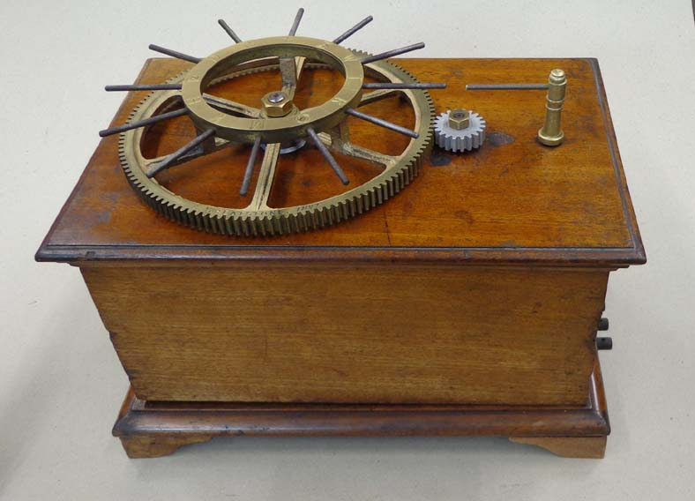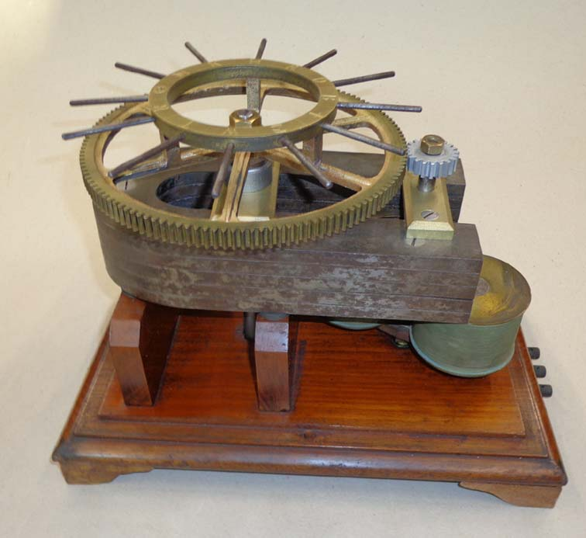

Fig 13a : “Wheatstone 1” closed Fig 13b: “Wheatstone 1” open

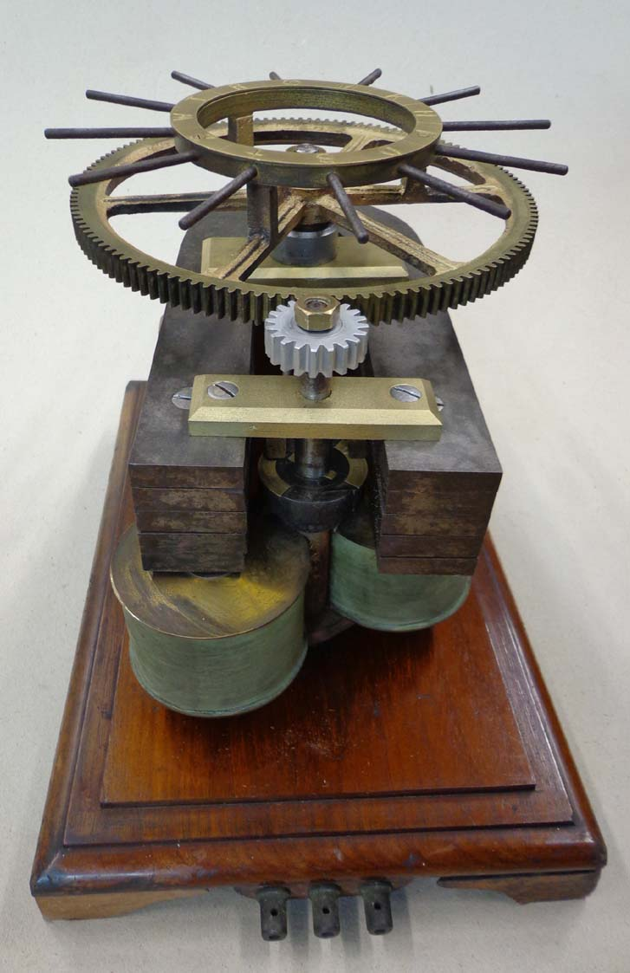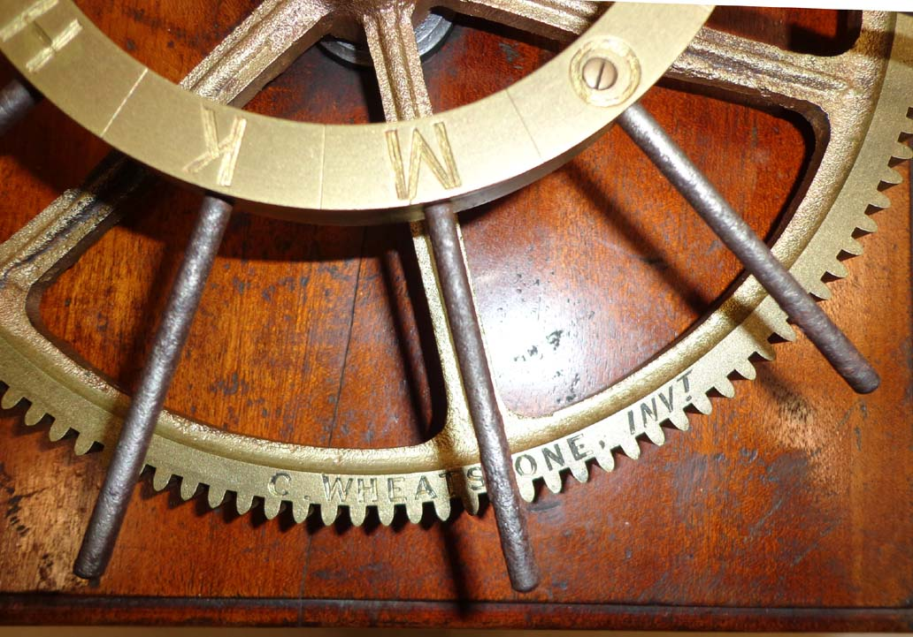

Fig 13c “Wheatstone 1” front Fig 14 Section of the capstan wheal of “Wheatstone 1”
with engraving “C. Wheatstine Inv,”

REFERENCE NOTES

Steven Roberts: Distant Writing. (o) 2006- 2012, electronic book available
by <distantwriting.co.uk>
2 John Liffen: The Introduction of the Electric Telegraph in Britain,
a Repraisal of the Work of Cooke and Wheatstone. Int. J. for the
History of Eng. & Tech., Vol 80, No.2, July 2010, pp. 268- 299.
³ E.Feyerabend: Der Telegraph von Gauß und Weber im Werden
der elektrischen Telegraphie. Reichspostministerium, Berlin 1933
4 Tal P. Shaffner: The Telegraph Manual. New York 1859
⁵ Wheatstone, Charles and Cooke, William Fothergill: Improvements of
giving signals and sounding alarm at distant places by means of electrical currents,
AD 1840, January 21, Patent No 8345
6 George B. Prescott: Electricity and the Electric Telegraph. Fourth Edition, New York 1881
7 Johann Samuel Halle: Magie, oder die Zauberkräfte der Natur, Zweyter Teil,
Berlin 1784, VII, pp. 141- 145.
8 Steven Roberts: Distant Writing. E-book (o) Steven Roberts 2006- 2012
9 Steven Roberts: Distant Writing pp. 12
¹⁰ for a detailed discussion we again refer to the book of Steven Roberts
on „Distant Writing“, pp. 11,12.
11 for details we refer again to “Distant Writing” pp. 13,14 and 120.
12 Th. Karras: Geschichte der Telegraphie. Braunschweig 1909
13 Dr. Karl Eduard Zetsche: Geschichte der Elektrischen Telegraphie, Berlin 1877
14 Zeitschrift des deutsch-oesterreichischen Telegraphen.Vereins, Jg. XI, (1864), pp. 64- 71
15 Steven Roberts: Distant Writing, chapter 4, pp. 120- 152.
16 we follow Zetsche: Geschichte der Elektrischen Telegraphie, Berlin 1877, pp. 250- 254.
¹⁷ K.V. Tahvanainen: Telegrafboken. Den Elektriska Telegrafen I Sverige 1853- 1996,
Telemuseum Stockholm, 1997.

PHOTO CREDITS

Fig 1: E.Feyerabend: Der Telegraph von Gauß und Weber im Werden
der elektrischen Telegraphie. Reichspostministerium, Berlin 1933
Fig 2: George B. Prescott: Electricity and the Electric Telegraph. Fourth Edition, New York 1881
Fig 3: Th. Karras: Geschichte der Telegraphie. Braunschweig 1909
Fig 4: C. MacKechnie Jarvis: The Origin and Development of the Electrical Telegraph.
in George Shiers (Ed.): The Electric Telegraph. An Historical Anthology,
Arno Press, New York 1977, pp. 588
Fig 5: by courtesy of Steven Roberts
Fig 6: by courtesy of Steven Roberts
Fig 7: by courtesy of Steven Roberts
Fig 8: Zeitschrift des deutsch-oesterreichischen Telegraphen Vereins,
Jg. XI, (1864), Heft 3,4 und 5, Fig. 1 and Fig. 8
Fig 9: Th. Karras: Geschichte der Telegraphie. Braunschweig 1909
Fig 10: T.E. Herbert: Telegraphy, London 1906, chapter XI, pp.357
Fig 11: Zeitschrift des deutsch-oesterreichischen Telegraphen Vereins,
Jg. II, (1855) , Bl. XIX
Fig 12: George B. Prescott: Electricity and the Electric Telegraph.
Fourth Edition, New York 1881
Fig 13, 14: author

