erschienen in “Tube Colletor”, Vol.11,No.2, April 2009,pp.3-11

Glassblowing for Long Distance Telephony

The high vacuum tubes of Siemens & Halske 1921-1926

Franz Pichler

Introduction

The LRS relay of the Austrian team v. Lieben, Reisz and Strauss realized in 1911 for the first time the electronic amplification of telephone signals. The “Liebenröhre” was manufactured from 1912 on by the german companies Telefunken, AEG, Felten & Guilleaume and Siemens & Halske. Its application was in amplifiers for telephony and of audio signals in wireless telegraphy but also for the realization of oscillators in heterodyne circuits. The high vacuum tube which followed the LRS relay was developed by the US companies Western Electric and General Electric. It provided the necessary technological improvement for the application in repeater circuits in commercial long distance telephony. Western Electric´s first high vacuum tube of type A (later named 101-A) made in 1915 the transcontinental telephone line from New York to San Francisco possible. In Germany different companies manufactured during the time of WWI high vacuum tubes for applications in military equipment. After the end of WWI the plan to establish a telephone network to connect the main cities of the european countries had to be realized. In Germany Siemens & Halske was the main supplier of the necessary repeater stations. The repeaters had, however, to be provided with high vacuum tubes of specific qualities, for example to have a long life. Such repeater tubes are in germany called “Weitverkehrsröhren” ( engl. transl. “long distance telephony tubes”) or also just “Poströhren”, since the german Reichspost was the owner of the telephone network.

In this paper we will discuss the “Poströhren” of Siemens & Halske of the years 1921-1926 which are remarkable in their construction by the outstanding handcraft work of the glass-blowers. Although the well known book of Gerald F.J. Tyne “Saga of the Vacuum Tube” describes those tubes in great detail, we hope that we can add some new facts of interest to tube historians and collectors and it is hoped that the pictures shown in this article are appreciated by the readers.

The first high vacuum tubes of Siemens & Halske

The first high vacuum tube of Siemens & Halske was manufactured from 1915 on. It was the type A as shown in Figure 1(a). With slight modification the A-tube was also manufactured from AEG and TKD. In Figure 1 the different versions are shown:

version (a): with a punched ladder grid
version (b): with a spiral grid
version (c): with a U-bent plate

The A-tube served in WWI in amplifiers for telephony and for earth-telegraphy.

Franz Pichler, Schallenbergerweg 7, A 4048 Puchenau, Austria. E-mail: <franz.pichler@jku.at>

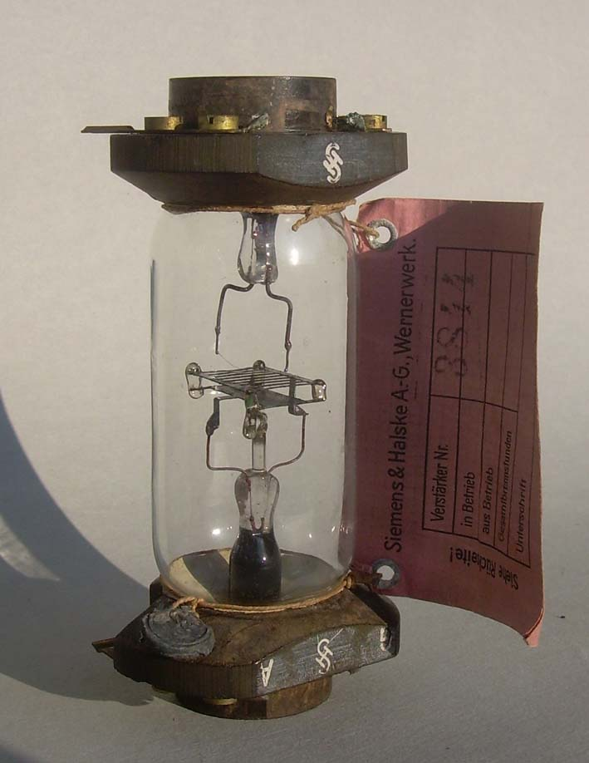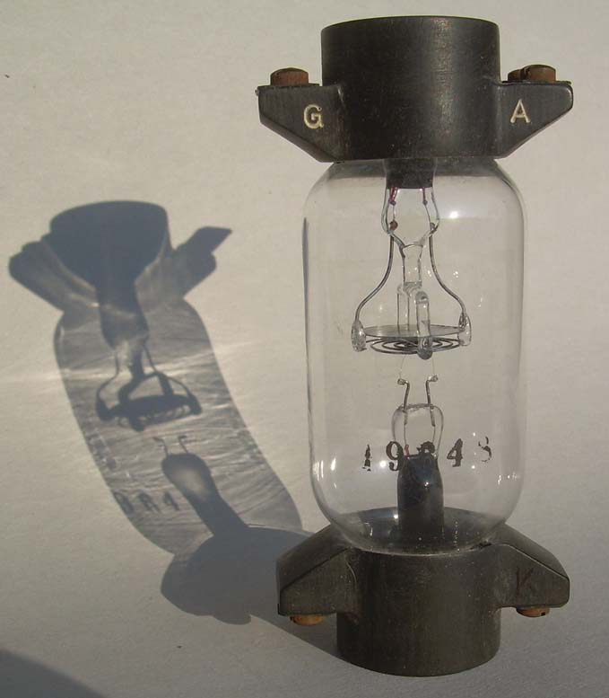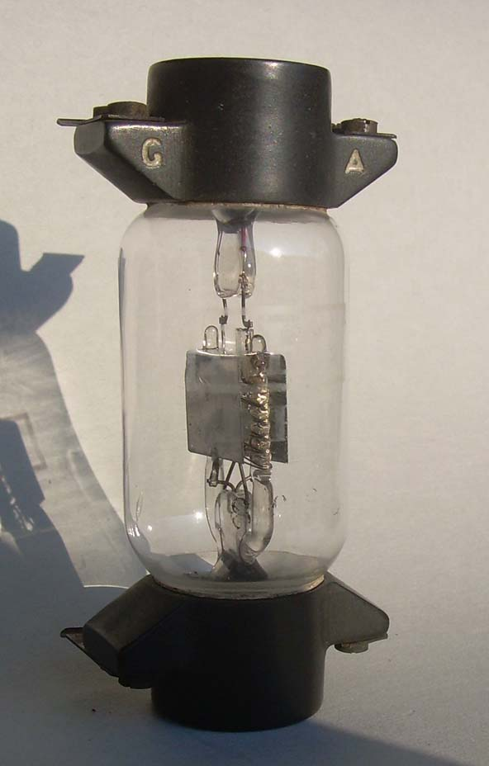
(a) (b) (c)

Figure 1: Different versions of A-tubes

From 1917 on Siemens & Halske manufactured the high vacuum tube of type Mc, which was by its construction an improvement of the A-tube. With a heating power of 8 Watt and a plate voltage of 220 Volt an output power of 60 mW was reached. The Mc-tube found during WWI application in 2-wire amplifiers for military telephone lines. Figure 2 shows the Mc-tube, Figure 3 shows the corresponding 2-wire amplifier of type Prls13 of Siemens & Halske.

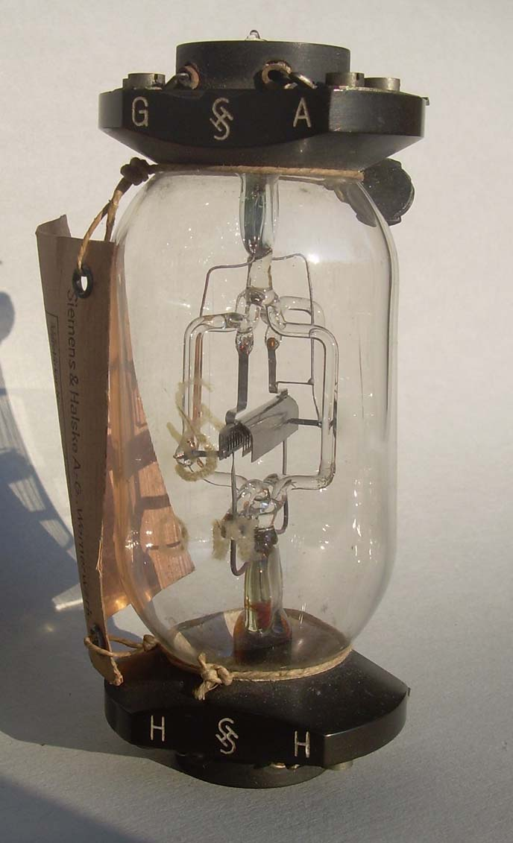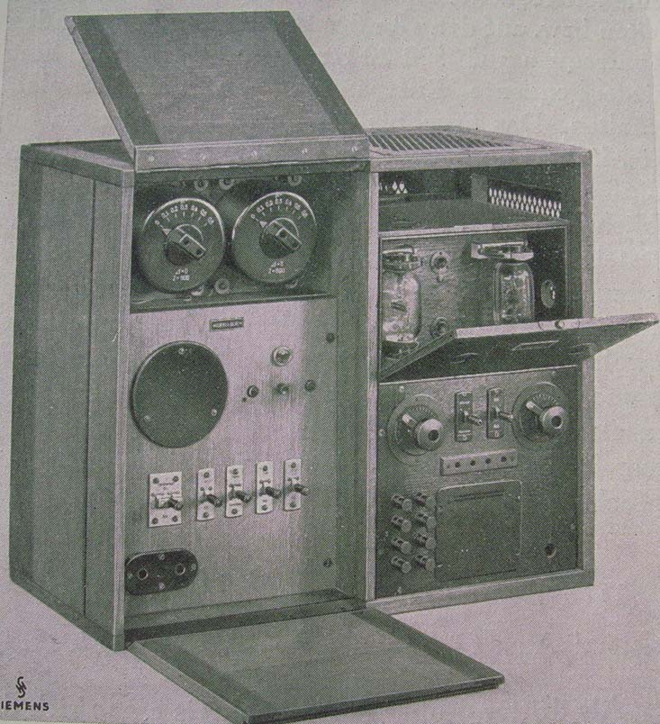

Figure 2: Mc- tube Figure 3: 2-wire telephone amplifier Prls13
of Siemens & Halske (picture taken from [3])

In 1915 the german physicist Walter Schottky discovered (independently from Irving Langmuir) the phenomenon of the space charge. As a consequence of this discovery Schottky invented the “Raumladeröhre” ( “space charge tube” ) by putting an additional grid between the filament and the grid. This additional grid reduced the negative effect of the space charge to the plate current and allowed so the operation with reduced plate voltage. For the mobile equipment of WWI this was certainly desired. In addition to the “Raumladeröhre” Walter Schottky developed in 1915 another “double grid tube”. It was the “Schutznetzröhre” ( “screen grid tube” ) with an additional grid between the control grid and the plate. Screen grid tube can be considered as a first step towards the “pentode”, which was invented by Holst and Tellegen of Philips in 1926. The introduction of a screen grid reduces the “Durchgriff” of the plate and increases so the amplification factor.

As the first “Raumladeröhre” Siemens & Halske produced the R-tube, later also the tube 110, which is shown in Figure 4. “Schutznetzröhren” manufactured by Siemens & Halske were the types SSI, SSII and SSIII (=114). The letter SS stands for “Siemens-Schottky”. SSIII is shown in Figure 4. The R-tube was applied for control in systems of multiplex telegraphy, SSI and SSII were used in mobile measurement devices, SSIII found application in telephone amplifiers.

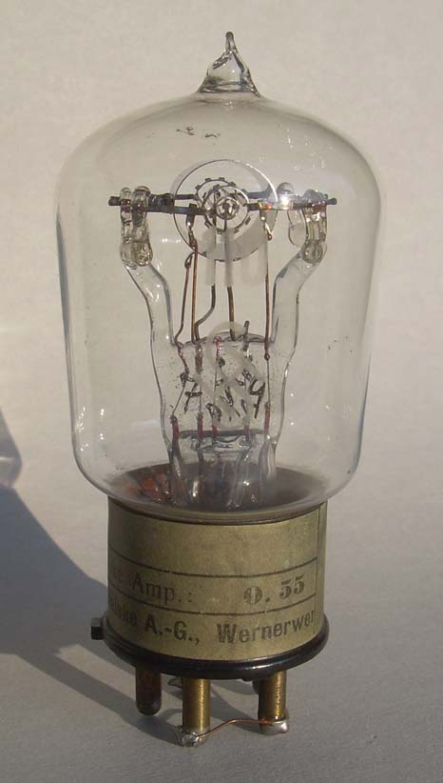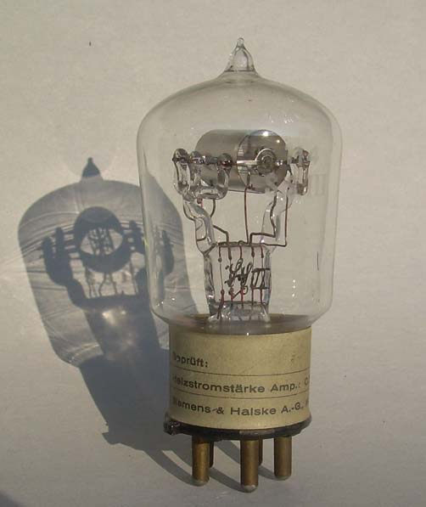
(a) (b)

Figure 4: The Siemens & Halske tubes 110 (a) and SSIII (b)

In Table 1 the characteristic data of the tubes R, 110 and SSIII, together with the data of the tubes BE and BF, which will be discussed later , are shown.

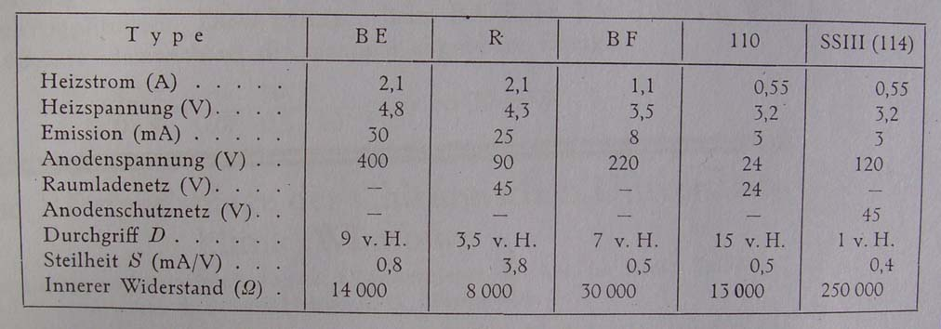

Table 1: Characteristic data of Siemens & Halske tubes ( from [1] )

3. Siemens & Halske high vacuum tubes for telephone repeaters

By the end of WWI it was desirable to improve the existing telephone network which connected the different cities in germany and in other european countries. This required the development of repeater stations. Siemens & Halske was for it the main supplier for the german “Reichspost”.
Together with the development of repeaters suitable high vacuum tube hat to be designed. The first type of such tubes was from 1920 on the type BF. For applications in multiplex telegraphy the type BE was manufactured by Siemens & Halske from 1922 on. By new discoveries in the production of oxide coated filaments in 1925, this “Wolfram-tubes” got a substitution by the types BO and OBE which had a oxide cathode. Other Siemens & Halske tubes with oxide cathode were OCB ( for buzzer circuits in telegraphy ), OCK ( 1925, for amplifiers in sea cable telephony ) and OR
( follower of the R-tube from 1926 on ). In Figure 5 the Siemens & Halske tubes of type BF and BO are shown. In Figure 6 an amplifier with BF- tubes is shown. Figure 7 shows the OCK-tube together with the type Ca, which followed.

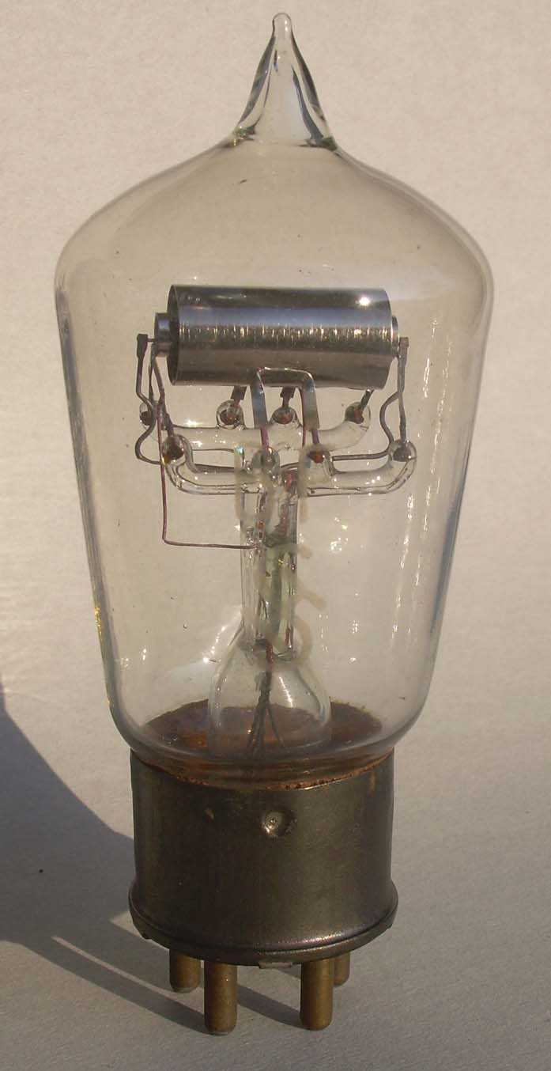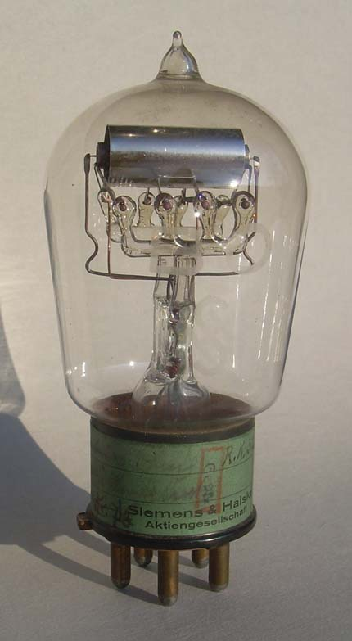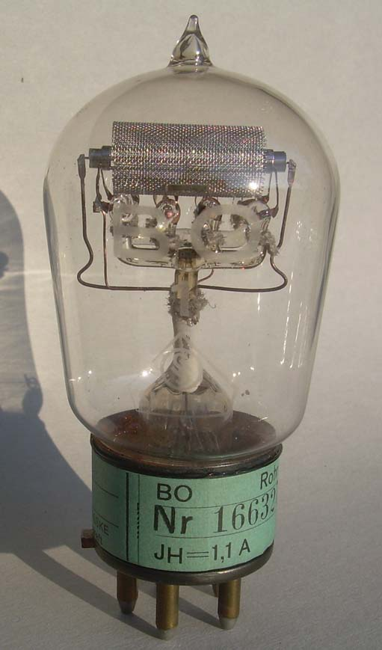

Figure 5: Siemens & Halske tubes BF , BO (with tin plate) and BO1 (with meshed plate)

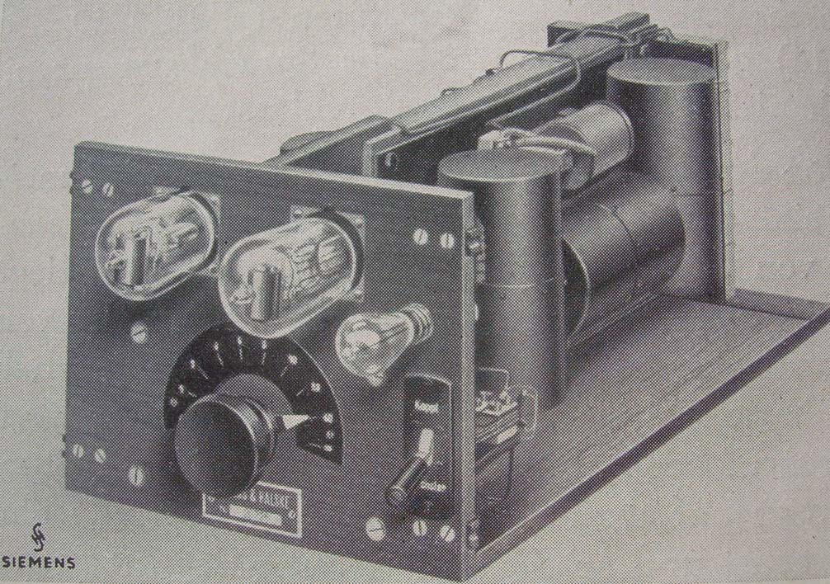

Figure 6: 2-wire amplifier type Gverst14 of Siemens & Halske (from [3])

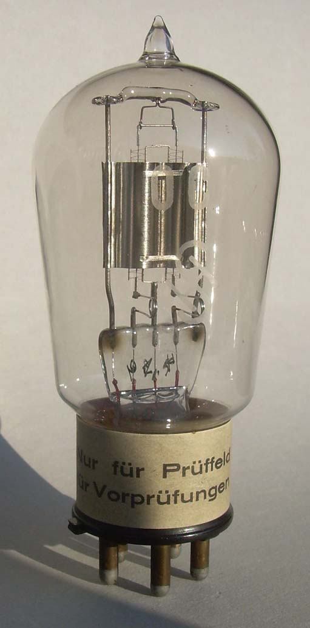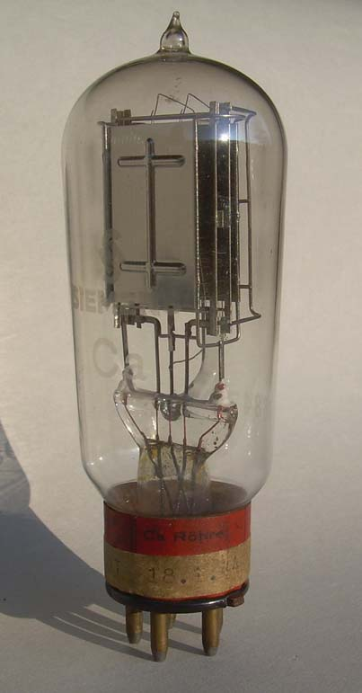

Figure 7: Siemens & Halske tube OCK and the Ca-tube which followed

4. Production of “Poströhren” at Siemens & Halske

By the invention of the LRS relay and the following high vacuum tube the german industry was confronted with new tasks. Telefunken, AEG and Felten & Guilleaume established for the development of the LRS relay a special “Röhrenlaboratorium” to prepare its industrial production. Siemens & Halske took over this task in its already existing laboratories for the development of an electronic amplification device. As soon as in Germany the success of the development of the high vacuum tube in the USA by Western Electric and by General Electric got known, Telefunken started under the leadership of Hans Rukop an initiative for research and development. Siemens & Halske followed in its “Gluehlampenwerk” (light bulb factory) under Professor Pirani. The first industrial production of high vacuum tube was started by Siemens & Halske at the “Pupin Labor” under the leadership of Dr. Thuermel and his colleagues Dr. G. Gruschke and P. Pohlmann. By the growing orders of high vacuum tubes by the military a more efficient production line was established in Berlin- Alt Moabit. However, by the end of WWI the demand of high vacuum tube decreased dramatically and the factory in Alt Moabit had to be closed. Siemens continued in its “Wernerwerk” in Berlin the production on a small scale. However, as soon as the “Reichspost” started to establish new repeater stations for the german telephone network it became clear, that a new factory for the industrial production of repeater-tubes was needed. Furthermore it was recognized that highly professional specialists in glass blowing were needed in the production.
Siemens & Halske decided to build a new factory in Berlin-Charlottenburg, the “Technische Glaswaren GmbH”, for short called TEGLA. Research and development stayed however in the Siemens laboratories, where Dr. A. Gehrts was responsible for tube research and Dr. Gruschke was in charge of repeaters. TEGLA produced from 1921 on for the systems of Siemens & Halske the high vacuum tubes which were needed in repeaters for long distance telephony and in other applications in telephony and telegraphy. All the tubes were manufactured by hand and they show high workmanship done by the glass blowers. To get an idea of production numbers, we give some figures from the Siemens report of the year 1921/22. In that period 17.094 tubes for repeaters have been produced by TEGLA. The number of employees was 300.
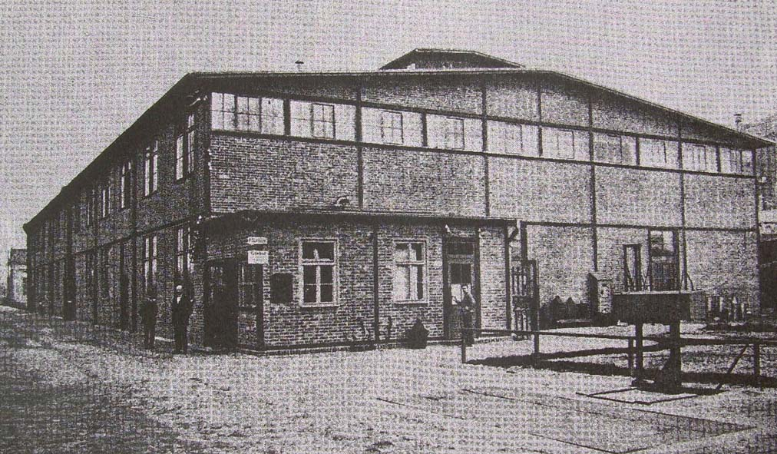

Figure 8: The TEGLA factory in Berlin-Charlottenburg (from [4])

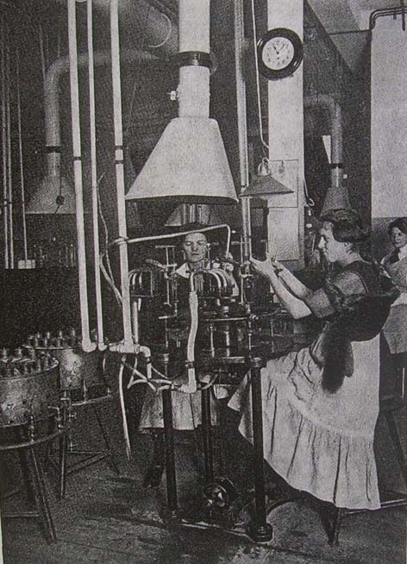

Figure 9: Manufacturing tubes at TEGLA (from [4])

TEGLA´s capacity was not fully used by the orders of the “Reichspost”. For this reason TEGLA made in addition radio-tubes for the Telefunken company. For distinction with the tubes which were made by Telefunken in its own factory, the Siemens-TEGLA tubes got red coloured on its top. German collectors call such tubes “Rotkaeppchen Röhren” after the fairy tale of the red hiding hood. From 1923/24 on TEGLA stopped the production of radio-tubes and the OSRAM GmbH took over. It is most likely that TEGLA manufactured also for other german companies high vacuum tubes which were needed there. A possible example is the high vacuum tube VE, which is shown in Figure 10, was used in the “Hochfrequenz Telefonie System” of the german company DeTeWe ( “Deutsche Telefonwerke und Kabelindustrie AG ). This system provided the transmission of telephone signals across high voltage power lines. Figure 11 shows the transportable version of this system. It shows besides of a Habann-tube with 2 magnets on each side, 2 tubes of type VE.

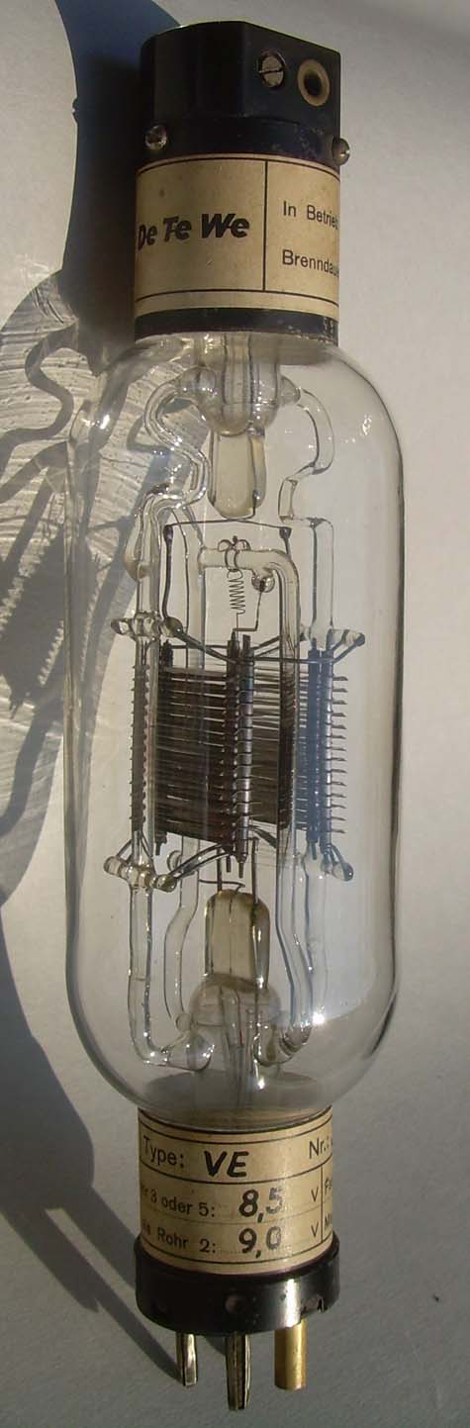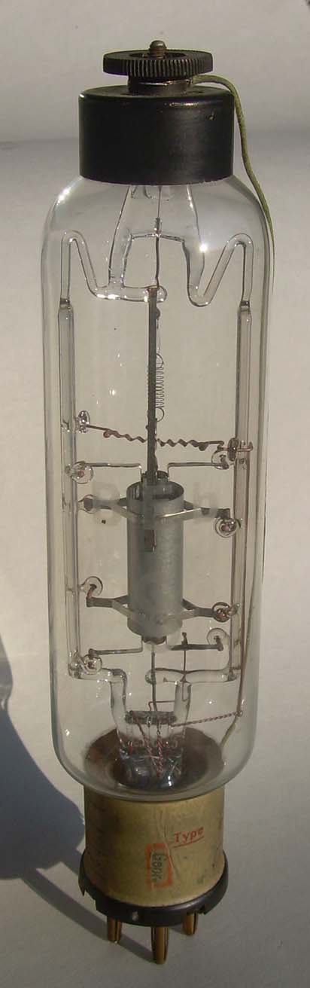

Figure 10: DeTeWe tube VE and Siemens & Halske tube BEb in comparison (made by TEGLA)

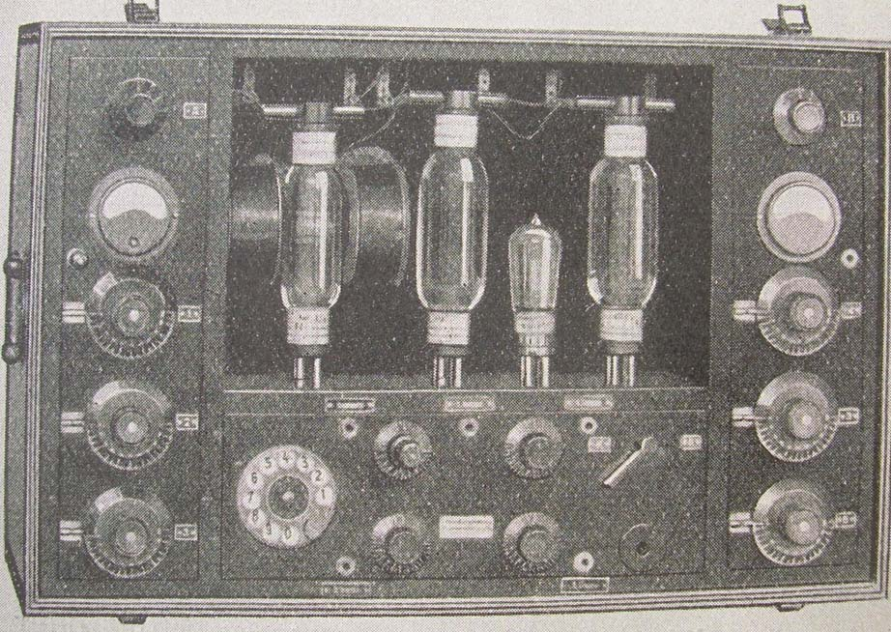

Figure 11: DeTeWe equipment for power line telephony “System Habann” (from [6])

This concludes our discussion of the production of high vacuum tubes for the repeaters in long distance telephony by the Siemens & Halske company in Berlin, Germany, where the glass blowers at TEGLA, made an outstanding contribution by their “artistic” handcraft. We like to add a few words to the further development of high vacuum tubes for repeaters at Siemens & Halske.

5. Repeater technology and high vacuum production until 1934

As discussed above, Siemens & Halske produced at TEGLA from the year 1921 on different types of high vacuum tubes which were needed for the telephone network of the “Reichspost” . However, at the Wernerwerk of Siemens in Berlin at the same time high vacuum tubes for radio transmitting stations and in Rudolstadt, near Erlangen, the Siemens Reinigerwerke manufactured high power rectifier tubes. In 1934 all three factories were closed and their activity was taken over by the new founded “Siemens Röhrenwerk” in Berlin. The Röhrenwerk continued in the tradition of TEGLA the manufacturing of “Poströhren” . However, by improved construction principles, the skilled handcraft of the glass blowers were not needed any more longer. As examples of tube types which were manufactured there in the first year we mention the types Aa (a audio frequency tube ), Ba (following BF and BO in repeaters ) Ca (following OCK), Da (substitute for CO) and Da
( a power triode).

The author shares his personal experience in working in the years 1961-1966 as a service technician in Salzburg and Innsbruck for the austrian long distance telephone system. At that time he was responsible for taking the regular measurements on the in that time still existing 4-wire transmission cable lines. In case that the change of the equilizing circuits or the amplification step gave not the wanted result, the repeater tubes had to be changed. The “bad” tubes had to be collected and sent to a central place in Vienna where they were destroyed. This may be the reason, that only a small number of such tubes, so badly desired by collectors, have survived.

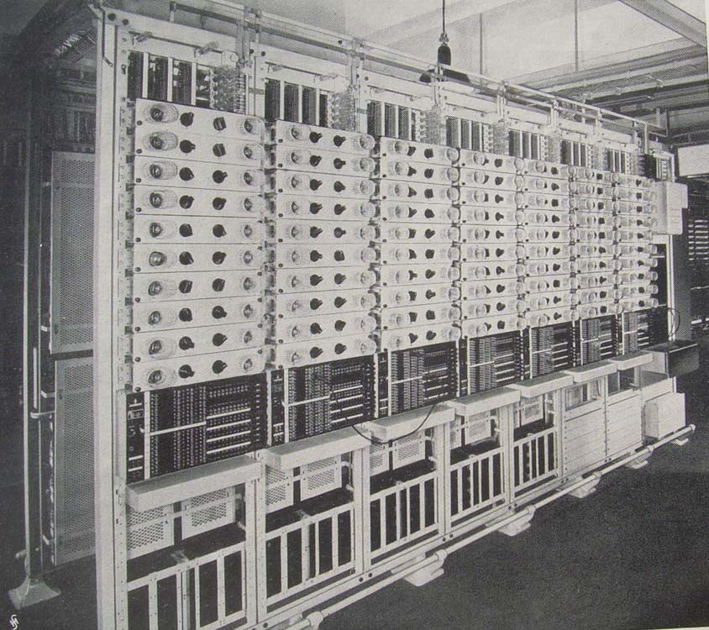

Figure 12: Racks of the repeater station model 1932 of Siemens & Halske (from [3])

The author thanks the Siemens Archiv München ( Ute Schiedermeier), Gerhard Bogner, Neu-Ulm, Germany and Hans Thomas Schmidt, Munich, Germany, for their valuable help in the search of literature. The homepage of Hans Thomas Schmidt http://www.hts-homepage.de is recommended for further information on the topic of “Poströhren”. All the tubes which are shown in this article are in the collection of the author. Ludwell Sibley helped to put the article in correct English, for which I am very grateful.

References

[1] B. Pohlmann und Dr. A. Gehrts: Die Verstärkerrohre der Fernmeldetechnik. Siemens Zeitschrift
2.Jahrgang, 5./6. Heft , 1922, pp. 282- 291.

[2] C. Nebel: Die Entwicklung der Siemens- Fernsprechröhre. Veröffentlichungen aus dem Gebiete
der Nachrichtentechnik, 1935, pp. 215- 226.

[3] Fr.Vogel und A. Haag: 30 Jahre Siemens- Fernsprechverstärker. Erweiterter Sonderdruck aus
Siemens- Zeitschrift 1941, Heft 1, S. 26 ( 20 pages).

[4] Franz Michel und Oskar Pfetscher: Siemens-Röhren haben Tradition. Erweiteter Sonderdruck
aus der Siemens-Zeitschrift 36. Jg. Feb. 1962, Heft 2, pp. 6- 21.

[5] Gerald F.J. Tyne: Saga of the Vacuum Tube: Howard W. Sams & Co.,Inc., Indianapolis,
Indiana, USA, Second Printing 1987.

[6] Erich Habann: Die neuere Entwicklung der Hochfrequenztelephonie und -telegraphie auf
Leitungen. Vieweg & Sohn, Braunschweig 1929.

[7] Franz Pichler: Robert von Lieben. 100 Jahre Patent Kathodenstrahlenrelais. Universitätsverlag
Rudolf Trauner, Linz, 2006.

[8] Franz Pichler: Von der Knatterfunken-Telegraphie zum Radio Broad-Casting. Die Entwicklung
der Funk- und Radiotechnik in Österreich 1898- 1928. Universitätsverlag
Rudolf Trauner, Linz, 2008.

