Remembering J. Edmund Gibbs

by Franz Pichler
Johannes Kepler University Linz, Austria (presented at the workshop „Dyadic Differentiation and Dyadic Analysis“, organized by Radomir Stankovic, Faculty of Electronics, University of Nis, Serbia, October 2007)

It was at the Symposium on the Applications of Walsh Functions held in Spring 1970 in Washington D.C. when I met Dr. Edmund Gibbs for the first time. Prof. Dr. Henning Harmuth, in that time Visiting Research Professor at the EE-Department of the University Maryland, College Park, USA had me before already informed about the work of Dr. Gibbs on Dyadic Analysis, a mathematical field in which I was interested. For the spring term 1970 I got by Prof. Harmuth the invitation to come to the University of Maryland and to fill there the position as a Visiting Assistant Professor and to help him in his research on the applications of Walsh functions. In that time I felt to be a mathematician, however by the need of the EE-Department, headed by Prof. Nicolas DeClaris, I had to run in the spring term 1970 a laboratory course on Electrical Power Engineering and also a laboratory on electrical circuits. By the help of my teaching assistants, who had already experience from earlier such courses, I “survived” and I got even a good evaluation by the students, a kind of success for a mathematician doing practical work in Electrical Engineering. From the teaching assistants, I remember Mr Chang best. He, as I learned, made later a career at the University of Seoul, Korea. But also my colleagues, especially Prof. Simon, gave me advises and help. In research I continued my work on the theory of dyadic invariant linear system , Walsh Fourier spectral representations of signals and systems and I did also study the “logical differentiation” which was introduced by Dr. Gibbs. The results which I achieved in that time got documented in two Technical Research Reports of the EE-Department. A highlight of my stay, besides of a visit of Dallas/Texas for a workshop and on the way back a stop in the fabulous New Orleans/Louisiana, was naturally the Washington Symposium on Walsh Functions in April 1970. It was held at the Naval Research Laboratory and there, as I remember, by the given rules the control of the participants from non-Nato countries were very strict. As a social highlight the European participants were invited for a dinner to the home of Prof. Joseph Walsh, then already in the age of 75. Since 1965, after his long career at Harvard from 1915-1965, Prof. Walsh lived in the Washington area and was still teaching at the University of Maryland. Prof Walsh was very happy that his paper of the year 1923, in which he introduced his functions to Mathematics, got now so much attention by communication engineers. He showed us also at his house a practical application of Walsh functions for daily needs: He was wearing a pair of socks ornamented in colour by Walsh functions. The “Walsh dinner” was also attended by Dr. Edmund Gibbs. By his kind of humour I am sure that Dr. Gibbs liked the socks of Prof Walsh. This was the first time that Dr. Gibbs and I had some discussions and learned so to know each other better.

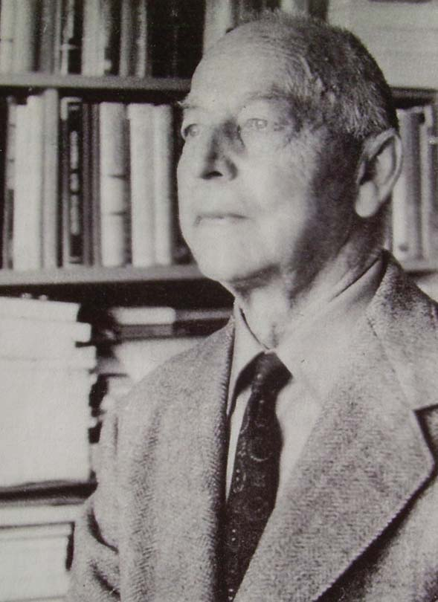

Professor Joseph L. Walsh ( 1970)
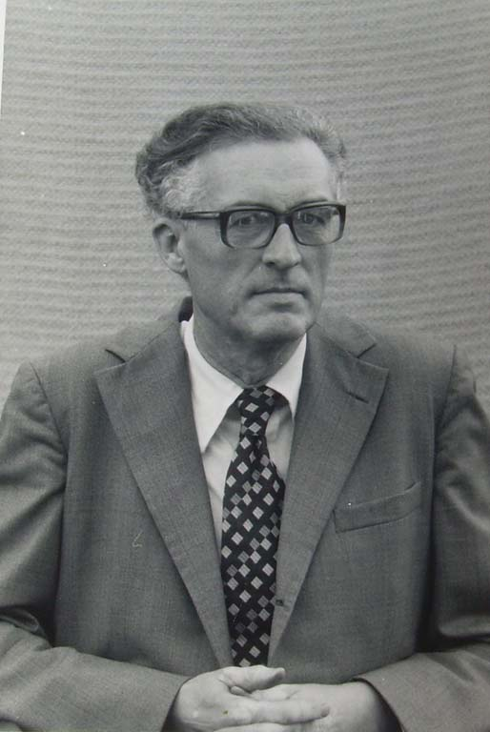

Dr. Henning F. Harmuth ( about 1970)

After the extension of my visit at Maryland to continue the research on dyadic correlation analysis until the end of August 1970 I returned to my family in Linz and to the University of Linz, where I had a permanent position as a Assistant Professor at the Institute of Mathematics. It was by a proposal of Dr. Gibbs that in fall 1970 the National Physical Laboratory ( NPL), located in Teddington, Middlesex, in close neighbourhood of London, invited me to present a lecture there, and I was very happy to accept this invitation. My wife Ilse accompanied me and we drove with our VW-bug from Linz to London. Dr. Gibbs and the NPL, Division of Electrical Science headed by Mr. Bail, received us with full hospitality. The following remembering on this visit will be not forgotten by me: (1) my lecture was scheduled for 2 p.m. a very bad time for listeners to concentrate. By this time, or by the content of my lecture one elderly gentleman got asleep and felt from his chair. Later he made everything good by his active participation in the discussion (2) when Dr. Gibbs saw our VW car he admired it fully and made us feel proudly. Later we discovered that he was in the possession of a silver-grey Jaguar sports-car which was parking outside of NPL in order to make his colleagues there not jealous. (3) when we arrived Dr. Gibbs called immediately for the NPL photographer to make pictures of me but also of himself. But not enough, he wanted also that we posted together having punched computer-tapes around our neck. Also pictures where we had to hold models of discrete structures in our hand had to be taken. (4) For the evening Dr. Edmund Gibbs invited us for an event but did not tell us what it would be. It turned out that he had tickets for us to see and listen to the opera Carmen. My wife was extremely fond of that, since so famous artists such as Joan Sutherland and Mario Del Monaco were acting.

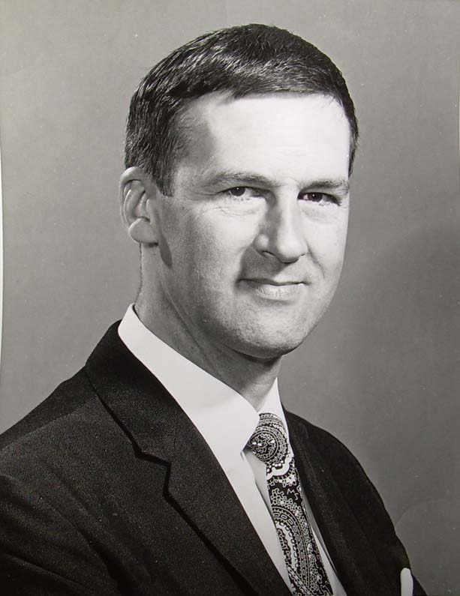

Edmund Gibbs ( Crown Copyright 1970)
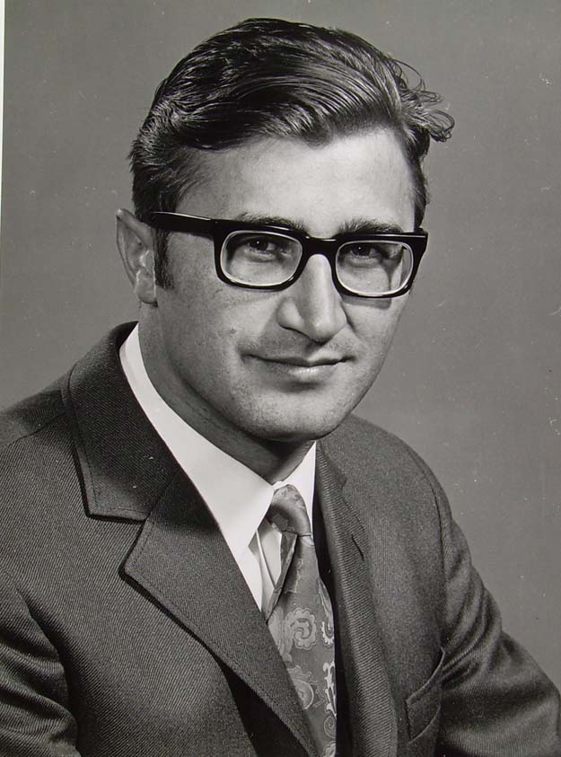

Franz Pichler (Crown Copyright, 1970)

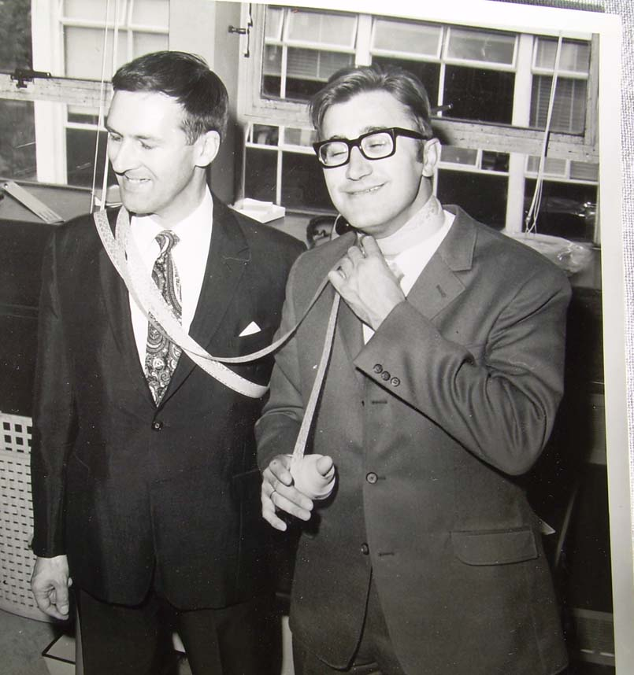I

Edmund Gibbs and Franz Pichler struggling with computer tapes ( Crown Copyright 1970)

In spring 1971 I returned to NPL to accept a Visiting Research Fellowship to stay there for one month. The goal was there to work together with Dr. Gibbs on a common book on the subject of Walsh functions and Dyadic Analysis. However to my surprise, upon arrival, Dr. Gibbs told me that he was ordered that firstly we had to work on a report of the application of Systems Theory in electrical measurements. This work took unfortunately most of the time of my stay and there was not enough time left for the preparation of the planned book. The result was just a Memorandum in which the content of the planned monograph with title “Theory of Bit Processes: A mathematical introduction” were covered. I returned to Linz joined by Dr. Gibbs since he was supposed to give a lecture at Linz University. We drove with his Jaguar sports-car all the way down from London to Linz. This took us two full days, mainly because Dr. Gibbs had to make a stop every hour to have a cup of tea. For that we usually had to leave the highway to find a restaurant in a nearby town. At the University of Linz the lecture of Dr. Gibbs was received with interest. In that time I was there a member of the Institute of Mathematics and Walsh functions. Besides of my interest in Walsh functions also my colleague Prof. Peter Weiss did some research in that field.. We both was with the group of Walsh functions research founded in the 60´s at the University of Innsbruck by Roman Liedl. In Linz I was in that time associated to the late Prof. Dr. Hans Knapp, who came also from Innsbruck. Knapp was in Innsbruck a member of the research group of Prof. Wolfgang Groebner doing important work in numerical analysis on the basis of Lie-series. Knapp and I showed Dr. Gibbs around the old city of Linz and we visited the different historical buildings and monuments which have a relation to Johannes Kepler, the most famous astronomer which lived in Linz during the time from 1612 to 1628. At the planetary fountain at the Linzer Landhaus, the old government building of the county of Upper Austria, Dr. Gibbs took pictures with his camera. He asked Knapp to move forward and again backwards until he found the right position for taking the picture. Later, when we received the picture from him it turned out that Prof. Knapp was put by him to a position such that it looked that a stream of water from the fountain poured out from his nose. As far as I remember Prof. Knapp did not like this kind of humour of Edmund Gibbs. Another point of our sightseeing program was the visit of the Grottenbahn and the Fairy Tale Land which is established in a artificial cave of the old fortress up at the Poestlingberg, the landmark of Linz. We drove together with the children by the little train which is pulled by a dragon around the cave and inspected the different german fairy tales as “ Snow White” , and others such as “Cinderella”,”Hansel and Gretel”,”Rumplestiltskin” all displayed by fantastic panoramic views. As far as I remember, Edmund, by his knowledge of the german language and german culture, knew all about it and enjoyed our tour very much. On our way to the Poestlingberg we had to cross the railway track of the local Linz-Aigen-Schlägl line, which connects Linz with the beautiful highland of the Oberes Mühlviertel in the northern part of Austria where also the famous “Böhmerwald” ( bohemian woods) is situated reaching far into the part of South-Bohemia, today a part of the Czech Republik. We had to stop at the crossing since a train was coming. There a wagon showed the sign ROTTENEGG, which is the name of one of the next villages on the way. When Edmund saw this, he would say “Oh, sensational, a wagon full of rotten eggs”. Certainly I had to drive Edmund next day to Rottenegg and he took many pictures there. It was wise, I guess, that I did not mention another village nearby with the funny name “Huehnergeschrei” which means in English language “chicken-cry”, since, I am sure, he would have wanted to go there, to listen there to crying chickens.



Fairy Tale Land in the Grottenbahn at the Pöstlingberg in Linz, Austria

Since the time of my close friendship with Dr. Edmund Gibbs, many years have passed. From 1973 on I took the appointment at Linz University as a Professor for Systems Theory at the department of Computer Science and I left the Institute of Mathematics. Naturally I had to put my interest in Walsh functions aside and to concentrate to the field of Systems Theory, a specific field of Applied Mathematics. So I lost also the close contact to Dr. Edmund Gibbs, a fact which I regret today that it happened. I owe Edmund Gibbs a great deal for his cooperation and friendship. It helped me in that time to get international experience and to start my career as a Professor. My stay at the famous NPL, where Alan Turing was holding once a position but also in recent time Donald Davies, well known as the inventor of packet switching and for his research in the field of Cryptography, had his office, kept always a place in my CV and I am thankful to have a remembering on the good time there together with Dr. Edmund Gibbs.

In this year 40 years of the existence of the field of Walsh and Dyadic Analysis is celebrated at the Department of Electronics and Information Technology of the University of Niŝ in Serbia by an international workshop. Unfortunately Edmund Gibbs is not with us anymore. We all regret this and I feel sad about that. His work, however, is with us and will give also in the future many opportunities for interesting mathematical research and related applications in Science and Engineering.

Author: Franz Pichler. Professor Emeritus, Johannes Kepler University, A-4040 Linz, Austria
E-mail: franz.pichler@jku.at

