Lecture presented at EUROCAST 2007, Las Palmas February 2007

A highly nonlinear cellular FSM-combiner for stream ciphers

Franz Pichler, University Linz, Austria

1. Requirements for cryptological strong pseudo random generators.

The realization of a a stream cipher device requires a specific kind of pseudo random generator which fulfils the following four properties

(P1) the generation of the pseudo random stream has to be fast such that high data rates
( e.g. 10- 100 MB/sec. ) are achieved.
(P2) the generated stream is statistical close to a pure random stream. This is proved by the passing
of a selected battery of statistical tests.
(P3) when modelling the pseudo random generator by a finite state machine then the initial state
is an essential part of the cryptographic key. Its computation from a parts of the generated
sequence has to be a provable difficult task.
(P4) for a pair of identical copies of the pseudo random generator there must exist an effective
algorithm to synchronize their cryptographic keys.

Let us give some comments for (P1) to (P4): (P1) has the effect that the generator requires the use of fast hardware for its realization. This means that the concept is based on fast algorithms which can be effectively implemented by current available hardware modules. (P2) requires that the generated sequences are “close” to pure random sequences. The “closeness” is determined by the passing of appropriate statistical tests. Failing of a test indicates the possibility that a deterministic component in the behaviour of the generator can be discovered. Since any test sequence has to be necessarily of finite length there is always the chance that a test fails. Even pure random sequences are candidates of failing in this situation. The required property (P3) is for cryptological reasons the most important one. It states that that the identification of the cryptographic key has to be provable a computational hard problem. If we assume that the pseudo random generator is modelled by a finite state machine this means that machine identification (the determination of the next state function and the output function) and state identification has to be computational difficult, regardless of the amount of data which are available to the opponent. In the cryptological praxis the consideration of a finite state model alone is not sufficient. It concerns only the mathematical functional level in modelling a real existing pseudo random generator. Additional models on the engineering microelectronic level of description have to be taken into account. Property (P4) which asks for the fulfilment of the “synchronisation requirement” depends strongly on the kind of applied technology. There exist very often different methods for its solution. In the case of the use of very fast hardware the concept that both generators are equipped with an exact clock the method “synchronization by state reset” can be used.

- Architecting a pseudo random generator.

It was already stated that the fulfilment of the property (P3), which guarantees that identification
of the generator is difficult is most important. In the praxis of stream cipher design the following approach in determining the architecture of the generator has proven to be successful: In the first step pseudo random generators prg(1). prg(2), … ,prg(m) are designed, which meet the properties
(P1),(P2) and (P4) but not necessarily (P3). In the second step a “combiner” C is designed, which computes from the sequences x₁,x₂, … ,x_{m} of prg(1),prg(2), … ,prg(m) a resulting sequence
y = C(x₁,x₂, … ,x_{m}) such that the overall pseudo random generator prg consisting of the aggregate
of prg(1),prg(2), … ,prg(m) in parallel in series with the combiner C meets also the property (P3).

Figure 1: Architecture of a pseudo random generator

- Combiner design

For the design of combiners C different methods have been investigated in the past. In the case that the sequences x₁,x₂, … ,x_{m} which are generated by the different pseudo random generators are binary data streams the combiner can be defined by a Boolean function C:B^{m}→B, where B denotes the set B={0,1}. Several authors have contributed to the design of boolean combiners C of such kind ([Rueppel 1986],[Meier-Staffelbach 1989],[González Cobas-López Brugos 2005]). As an extension of such “static combiners” C we can consider “dynamic combiners” C(t) which varies its function by the clock time t of the generator. A combiner of this kind has been investigated in an earlier work of the author, where for the modeling of the combiner a finite state machine of type “finite memory machine” has been used. In this case the design of a dynamic combiner can be reduced to the design of a static combiner [Pichler 1988]. In the following we describe the design of a dynamic combiner which is modeled by finite state machine which is realized by an array of identical finite state machines.

- Cellular FSM combiners

In general we want to investigate the construction of a dynamic combiner C(t) which is modelled by a finite state machine FSM as shown in Figure 2.

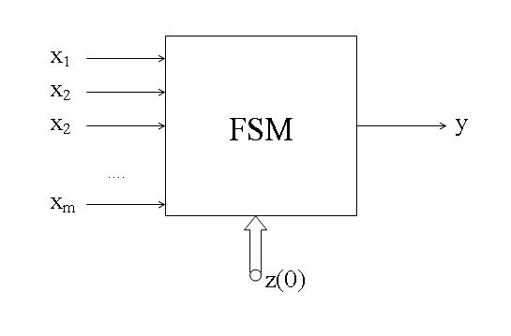
Figure 2: Block-diagram of a FSM combiner

The different input ports of the FSM combiner receives binary data streams x₁,x₂, … , x_{m}
generated by the associated pseudo random generators prg(1),prg(2), … prg(m). Starting from an initial state z(0) the FSM combiner computes the binary output stream y. It is required that the FSM combiner function is for most of the possible initial states z(0) as considered from the cryptological standpoint satisfying. Then z(0) can be used as an additional key parameter, the FSM combiner key.
A formal description of the FSM can be given as usual by FSM=(B^{m},B,Q, δ, λ) where δ:QxB^{m} →Q
and λ:QxB^{m} →B denote the next state function and the output function, respectively. For every time point t=0,1,2, … the FSM computes from the input values x₁(t),x₂(t), … ,x_{m}(t) and the state z(t) the output value of the FSM combiner y(t) = λ(z(t),x₁(t),x₂(t), … ,x_{m}(t)).

In our approach to construct the FSM combiner we use an array of m identical finite state machines fsm(1),fsm(2), … , fsm(m) as shown in Figure 3:

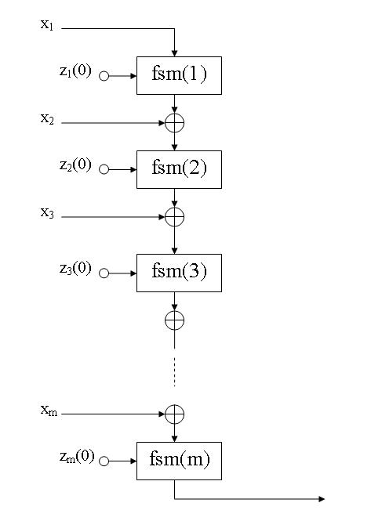

Figure 3: Realization of the FSM combiner by an array of m finite state machines fsm

The input streams x₁,x₂, … ,x_{m} enter the automata array of the FSM combiner level by level by an EXOR operation. This motivates us to call the architecture of the FSM combiner as shown in Figure 3 an “EXOR cascade” of finite state machines. Next we want to investigate the cryptological quality
of the FSM combiner. At first we have to determine the kind of finite state machine fsm we use for constructing the EXOR cascade. We consider the following types:

- fsm is a clock controlled maximal periodic binary linear feedback shift register CCMLFSR

- fsm is a clock controlled binary baker register machine CCBRM ([Jochinger-Pichler 2005],
[Jochinger 2006])

- fsm is a clock controlled binary cyclic linear feedback shift register CCCLFSR.

The investigation of the cryptological quality of the FSM combiner using the different fsm (1)-(3)
can be done by testing a simulation model and by mathematical analysis.

- Cryptanalysis of the FSM combiner by simulation

Simulation experiments have been performed for all three types (1)-(3) of finite state machines fsm. Registers of length 512 were chosen such that the key space of the combiner was big enough. The inputs to the combiner were generated by MLFSR´s beeing also of length 512. As test system served “CryptoBench 2006”, a method base system for cryptanalysis as developed by Jochinger ([Jochinger 2006]). CryptoBench 2006 compares with other existing test systems which are public available.The following tests have been applied:

T1 computation of the linear complexity profile
T2 mono-bit test
T3 two-bit test
T4 Walsh- spectral test

All test showed satisfying results ( [Jochinger August 2006 ]).

- Mathematical analysis of the FSM combiner

Mathematical analysis of the FSM combiner is done here only for the case (3) of a clock controlled cyclic linear feedback shiftregister CCCLFSR, as shown in Figure 4 to realize the EXOR cascade of the combiner.

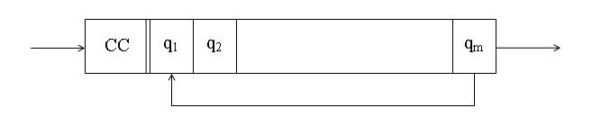

Figure 4: Block diagram of a clock controlled cyclic linear feedback shiftregister CCCLFSR

We state the result of the analysis already in advance. It is shown that the FSM combiner C can be expressed in algebraic form by the following term

C(x₁,x₂, … ,x_{m}) = p(0)+p(1)x₁+p(2)x₂+ … +p(m)x_{m} (1)

where x₁,x₂, .. ,x_{m} denotes the input streams and p(0),p(1), … ,p(m) are booelean polynomials in the state variables of different degree relating to the state machines fsm(1),fsm(2), … ,fsm(m) of the EXOR cascade. With + we denote here the EXOR operation (addition modulo 2).
We prove this result in the following:

Each CCCLFSR of the combiner can be represented by a finite state machine CCCLFSR =
(B,B,B^{n} ,δ, β) where the next state function δ is given by δ(q,a) = q for a = 0 and δ(q,a) = q→1 for a = 1. Here q→1 denotes the cyclic permutation of q = (q₁,q₂, … ,q_{n}) which is given by
q→1 = (q_{n},q₁, … ,q_{n-1}). By usual boolean algebraic notation δ can also be expressed by
δ= q + qa + (q→1)a. The output function β of CCCLFSR is given by β(q₁,q₂, … ,q_{n}) = q_{n}.

For each of the different finite state machines fsm(i), i = 1,2, … ,m, we therefore can express the next state function δ and the output function β by

δ(q_{i1},q_{i2}, …,q_{in},a_{i}) = (q_{i1},q_{i2}, … ,q_{in}) + (q_{i1},q_{i2}, … ,q_{in})a_{i} + (q_{in},q_{i1}, … ,q_{in-1})a_{i} (2)

and

β(q_{i1},q_{i2}, … ,q_{in}) = q_{in} (3)

We compute now for any time point t > 0 the output b_{m}:= y(t) of the last finite state machine fsm(m) of the cascade. We reach this stepwise, starting from the output b₁:= y₁(t) of the first machine fsm(1) of the cascade. We have

b₁ = q_{1,n} + q_{1n}a₁ + q_{1,n-1}a₁= q_{1,n} + (q_{1,n} + q_{1,n-1})a₁ or

b₁ = P₁₀ + P₁₁s₁ where P₁₀:= q_{1,n} and P₁₁:= q_{1,n} + q_{1,n-1} with s₁:= a₁ = x₁(t)

The output b₂:= y₂(t) of fsm(2) is given by

b₂ = q_{2,n} + q_{2,n}a₂ + q_{2,n-1}a₂ or since a₂ = b₁ + s₂, with s₂:= x₂(t) we have after ordering with regard to s₁ and s₂

b₂ = q_{2,n} + (q_{2,n} + q_{2,n-1})P₁₀ + (q_{2,n} + q_{2,n-1})P₁₁s₁ + (q_{2,n} + q_{2,n-1})s₂

Introducing the polynomials P₂₀,P₂₁ and P₂₂ by

P₂₀ := q_{2,n} + (q_{2,n} + q_{2,n-1})P₁₀
P₂₁ := (q_{2,n} + q_{2,n-1})P₁₁
P₂₂ := (q_{2,n} + q_{2,n-1})

we are able to write

b₂ = P₂₀ + P₂₁s₁ + P₂₂s₂

By mathematical induction we get after m steps for the output b_{m} = y(t) of fsm(m) the final result

b_{m} = P_{m0} + P_{m1}s₁ + P_{m2}s₂ + … + P_{mm}s_{m} (4)

where P_{m0},P_{m1}, … ,P_{mm} are boolean polynomials of the state variables of
fsm(1),fsm(2), … , fsm(m) given in the following form

P_{mm} = q_{m,n} + q_{m,n-1}
P_{mm-1}=P_{mm}(q_{m-1,n} + q_{m-1,n-1})
P_{mm-2}= P_{mm-1}(q_{m-2,n} + q_{m-2,n-1})
.
P_{m1} = P_{m2}(q_{1,n} + q_{1,n-1} )

and

P_{m0} = q_{m,n} + P_{mm}q_{m-1,n} + P_{mm-1}q_{m-2,n} + … + P_{m2}q_{1,n}

To get a more convenient notation we introduce the two-variable linear polynomials K_{i} by
K_{i}:= (q_{i,n} + q_{i,n-1}) for i=1,2, … ,m. Then we have

P_{mm} = K_{m}
P_{mm-1}= K_{m}K_{m-1}
..
P_{m1} = K_{m}K_{m-1} ... K₁

and

P_{mo} = q_{m,n} + K_{m}q_{m-1,n} + K_{m}K_{m-1}q_{m-2,n} + ... + K_{m}K_{m-1}...K₂q_{1,n}

The polynomials P_{mi} ( i=1,2, ... ,m) are, as it easy to see, of degree m-i+1. P_{mm} is of lowest degree 1 and P_{m1} is of highest degree m. The polynomial P_{m0} which appears in the sum of (4) does not effect the cryptological quality of the FSM combiner.

Practical implications

We investigate now the operation of the cellular FSM combiner as given as the result of our mathematical analysis by the formula (4). It will turn out that the combiner realizes in essential a EXOR combiner with clockwise varying number of EXOR operations. To show this in detail, we introduce the state variables z_{i} for i=1,2, … ,m by z_{2i} := q_{i,n} and z_{2i-1} := q_{i,n-1}. Since K_{i} = z_{2i} + z_{2i-1} the variables z₁,z₂, … ,z_{2m} are at the same time the variables of the polynomials P_{m0}, P_{m1}, …,P_{mm}.
In the case that a polynomial K_{i} ( i=1,2, … ,m ) has the value 0 then all of the polynomials P_{mj} with j ≤ i have also the value 0. Then the ouput b_{m} of the combiner is given by

b_{m} = P_{m}^{i+1}₀ + P_{mi+1}s_{i+1} + … + P_{mm}s_{m} (5)

where P_{m}^{i+1}₀ denotes the expression

P_{m}^{i+1}₀ = q_{m,n} + P_{mm}q_{m-1,n} + P_{mm-1}q_{m-2,n} + … +P_{mm-i+1}q_{m-i,n} (6)

If K_{m} = 0 then (5) reduces to b_{m} = q_{m,n} and if all K_{i} ( i =1,2, … ,m) are different from zero then the output b_{m} is given by (4) using the full length of the expression. It is obvious that the situation K_{m}=0 has to be avoided. This can be achieved by selecting the initial state of fsm(m) such that subsequent values 0,0 and 1,1 of the state variables are avoided. The reduction of the size of the key space of the combiner, which follows can be neglected if the length n of the register of fsm(m) is appropriately chosen. By the same method in selecting the initial states of fsm(m),fsm(m-1), … , fsm(m-k+1), k=1,2, … ,m, it can be guaranteed that the term x_{m-k+1} + x_{m-k+2} + … + x_{m} is contained in the expression (4) which represents b_{m}.

The values q_{1,n},q_{2,n}, … ,q_{m-1,n} as they appear in the polynomial P_{mo} are the output values of the different finite state machine fsm(1),fsm(2), …, fsm(m). In the formula (4) they have the effect that they are added to the input streams s₂,s₃, … ,s_{m} respectively. By the pseudorandom character of s₂,s₃, …s_{m} this does not change the cryptological quality of these data streams. Finally also the addition of q_{m,n} in formula (4) has no negative effect on b_{m} = y(t).

Figure 5 illustrates by a circuit diagram the construction of the computation of the output stream y of the cellular FSM combiner by the application of the formular (4) for each value b_{m} = y(t).

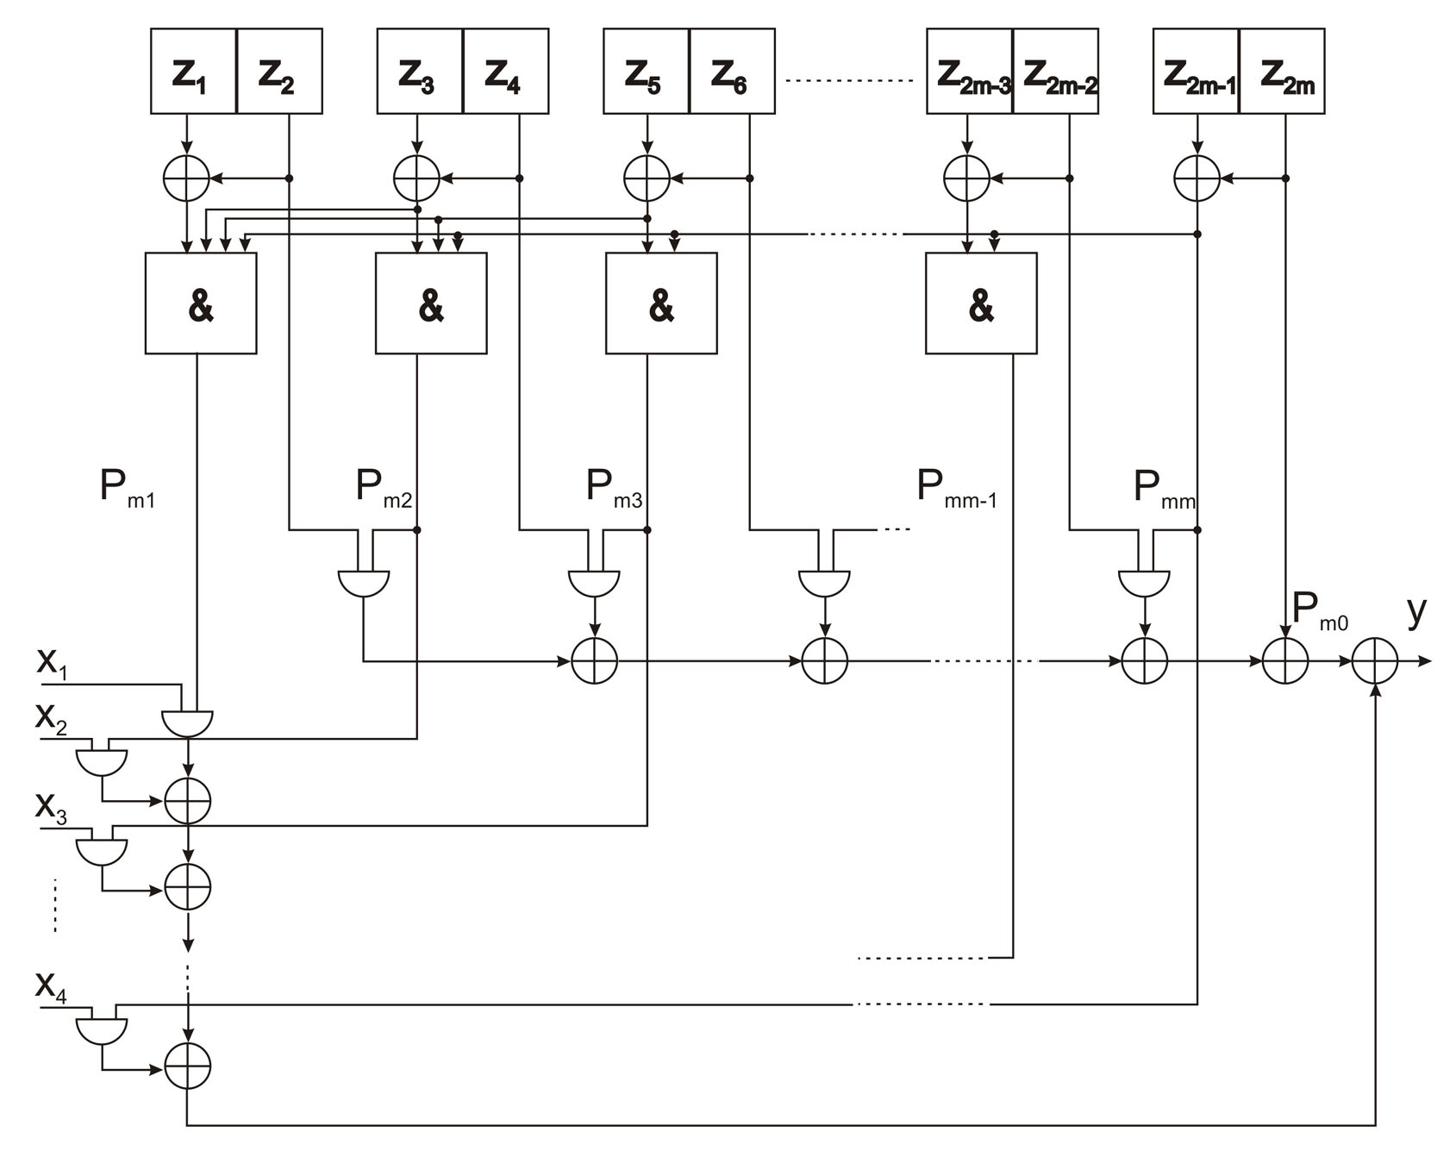

Figure 5: Circuit diagram for the computation of b_{m} = y(t)

Conclusion

The design of the combiner of a pseudo random generator is a crucial part of stream cipher construction. In the past, the design of static combiners which are realized by a boolean function have been discussed in the literature. However, mathematical details were often considered as trade secrets. The design of dynamic combiners have so far not received strong attention. The paper introduced a new type of dynamic combiner which uses an array of specific finite state machines.
For the cases that the array is realized by clock controlled maximal periodic linear feedback shiftregisters CCMLFSR, by clock controlled baker register machines CCBRM or by clock controlled cyclic linear feedback shift registers CCCLFSR dynamic combiners of this kind showed good results in testing. In the case of CCCLFSR a mathematical analysis has shown, that such a dynamic combiner realizes an EXOR´ing of variable length for the different input streams
x₁,x₂, … ,x_{m}.

References

[Pichler 1988] Franz Pichler: Konstruktion korrelationsimmuner Schaltfunktionen und Schaltwerke mittels Walsh- Fourieranalyse. In: Contributions to General Algebra 6 ( ed. G. Pilz), Verlag B.G. Teubner, Stuttgart, Wien 1988, pp. 213-222.

[Jochinger 2005] D. Jochinger and F. Pichler: A New Pseudo-Random Generator Based on Gollmann Cascades of Baker-Register-Machines. In: Computer Aided Systems Theory- EUROCAST 2005, Springer Verlag. Lecture Notes in Computer Science, LNCS 3643, 2005,
pp. 311-316, 2005.

[Jochinger 2006] Dominik Jochinger: Ein Pseudo- Zufallsgenerator für die Kryptographie mittels EXOR –Kaskaden von Bäcker- Register- Maschinen. PhD Thesis, Johannes Kepler University Linz 2006.

[Jochinger August 2006] Dominik Jochinger: Implementation of a FSM Combiner and Testing with CryptoBench 2006. Internal Report, Kukla Electronics, August 2006.

[Rueppel 1986] R. Rueppel: Analysis and Design of Stream Ciphers.Springer–Verlag Berlin 1986.

[Meier-Staffelbach 1989] Meier, W., Staffelbach O.: Nonlinearity criteria for cryptographic functions. In: Advances in Cryptology- EUROCRYPT ’89 Proceedings. Lecture Notes in Computer Science 434, Springer Verlag 1990, pp. 549-562.

[González Cobas-López Brugos 2005] Juan David González Cobas and Antonio López Brugos: Complexity-Theoretical Approaches to Design and Analysis of Cryptographical Booelean Functions. In: Computer Aided Systems Theory-EUROCAST 2005, Springer Verlag, Lecture Notes in Computer Science,LNCS 3643,2005, pp.337-345.

